**Core Spring Questions**

1. **What is Dependency Injection in Spring?**
   * Explanation of DI, types (constructor injection, setter injection), and how Spring achieves this.
2. **What are the different types of Spring Beans?**
   * Difference between singleton, prototype, request, session, and global session beans.
3. **What is the Spring Container?**
   * Explanation of the different Spring containers (BeanFactory, ApplicationContext) and their roles.
4. **What is the Spring Bean Lifecycle?**
   * Describe the phases from bean instantiation, initialization, and destruction.
5. **Explain the concept of Aspect-Oriented Programming (AOP) in Spring.**
   * Definition, how it works, use cases, and the role of @Aspect, @Before, @After, etc.
6. **What is Spring's Autowiring?**
   * Discuss autowiring types (@Autowired, @Qualifier, @Primary) and scenarios when to use each.
7. **What is Spring MVC?**
   * The architecture of Spring MVC, its components (Controller, ViewResolver, ModelAndView), and how it handles HTTP requests.
8. **Explain Spring’s transaction management.**
   * Types of transaction management (programmatic and declarative), and the role of @Transactional.
9. **What is Spring Security?**
   * Basic concepts such as authentication, authorization, and how Spring Security handles security concerns in web applications.
10. **What is a Spring Profile?**
    * How to define different configurations for different environments (e.g., dev, prod) using @Profile annotation.

**Spring Boot Specific Questions**

1. **What is Spring Boot, and how does it differ from the traditional Spring framework?**
   * Advantages of Spring Boot: auto-configuration, embedded servers, starter dependencies, etc.
2. **How does Spring Boot’s auto-configuration work?**
   * Explanation of how Spring Boot automatically configures beans based on the project's dependencies.
3. **What are Spring Boot Starters?**
   * Discuss commonly used starters (e.g., spring-boot-starter-web, spring-boot-starter-data-jpa) and how they simplify dependency management.
4. **What is Spring Boot’s Embedded Web Server?**
   * Discuss embedded servers like Tomcat, Jetty, and Undertow and how Spring Boot eliminates the need for a separate web server.
5. **What is the role of the application.properties or application.yml file in Spring Boot?**
   * Discuss how Spring Boot handles configuration properties and profiles using these files.
6. **How do you create and deploy a Spring Boot application?**
   * Explain the process of building an executable JAR file and deploying it to different environments.
7. **How does Spring Boot handle error handling?**
   * Explanation of @ControllerAdvice, @ExceptionHandler, and default error pages.
8. **What are Spring Boot Actuators?**
   * Describe the role of Spring Boot Actuators in monitoring and managing the application (e.g., health checks, metrics, environment info).
9. **What is Spring Boot DevTools?**
   * How does Spring Boot DevTools help in faster development and debugging?
10. **How can you configure logging in a Spring Boot application?**
    * Explain the different logging mechanisms (e.g., Logback, SLF4J) and how they can be customized in Spring Boot.

**Advanced Questions**

1. **What are Spring's different data access mechanisms?**
   * Discuss JDBC, JPA, Hibernate, and Spring Data, explaining how Spring simplifies database interaction.
2. **What are microservices in Spring Boot, and how do they interact with each other?**
   * Key concepts of Spring Boot microservices, inter-service communication, and using Spring Cloud for service discovery, configuration, etc.
3. **What is Spring Cloud?**
   * Understanding of Spring Cloud’s features such as Eureka, Config Server, and Ribbon for building cloud-native applications.
4. **Explain how Spring Boot supports asynchronous processing.**
   * How to implement asynchronous processing using @Async and TaskExecutor.
5. **What is Spring Batch?**
   * Discuss Spring Batch’s use cases, steps, jobs, and its role in batch processing.

**Behavioral/Practical Questions**

1. **Can you describe a challenging project or problem you solved using Spring/Spring Boot?**
   * Be prepared to discuss a specific scenario from your experience, the challenges faced, and the solutions implemented.
2. **How do you ensure good performance and scalability in Spring Boot applications?**
   * Discuss aspects like caching, profiling, and optimizing database queries.
3. **What are the security practices you follow while developing Spring applications?**
   * How you secure endpoints, handle authentication/authorization, and prevent vulnerabilities like CSRF, XSS, etc.

**Mock Coding/Scenario-based Questions**

1. **Write a Spring Boot REST API that handles CRUD operations for a given entity (e.g., Employee).**
   * Implement a simple REST controller, service, and repository layer.
2. **Explain how to test Spring Boot applications.**
   * Discuss the use of @SpringBootTest, @MockBean, and @WebMvcTest for unit and integration testing.

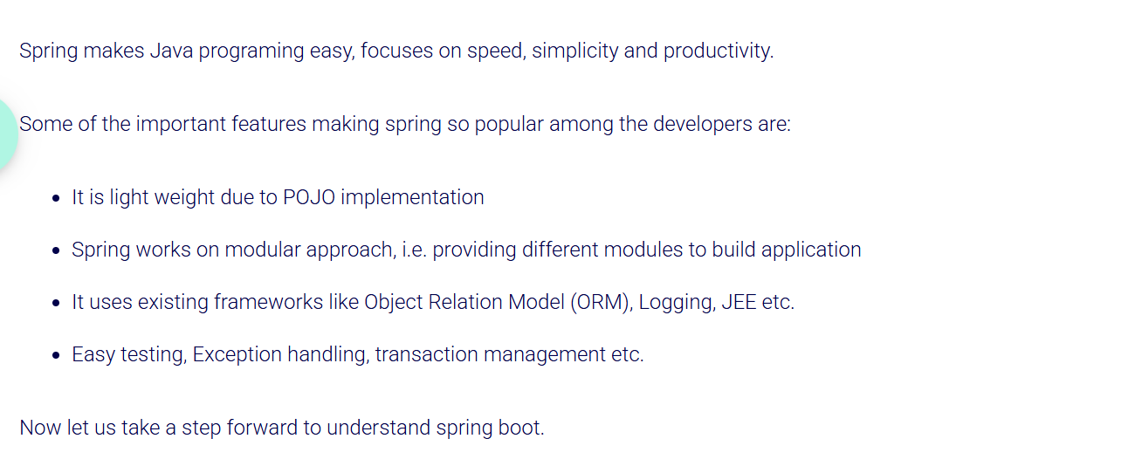

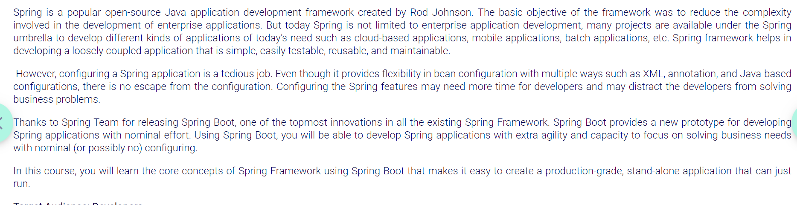

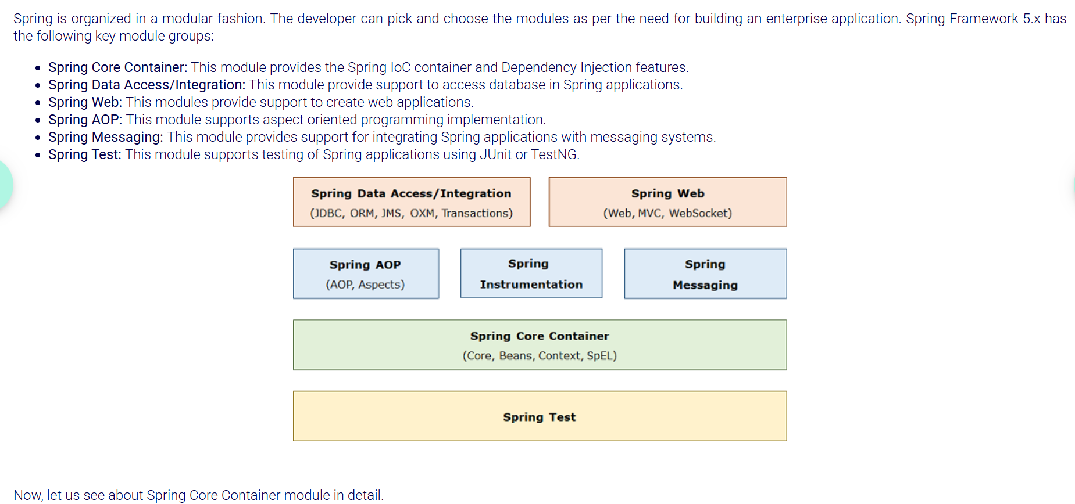

Developer can choose one or more modules as per the need for building application as modules are loosely coupled.

*AOP Promotes separation of supporting functions(concerns) such as logging, transaction, and security from the core business logic of the application.*

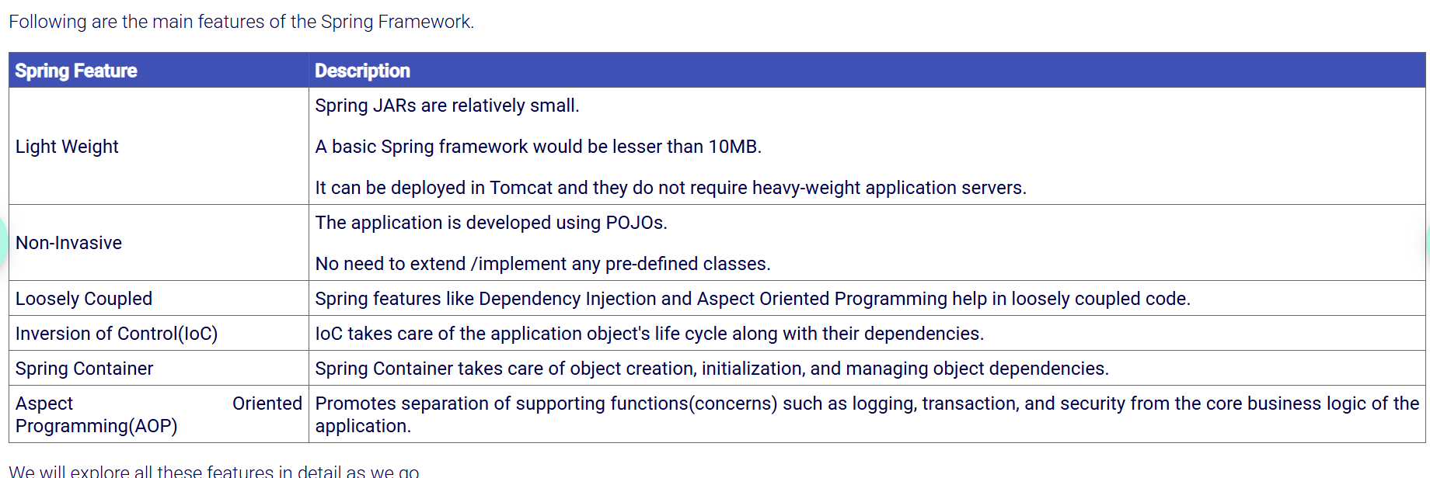

**Core container** has the following modules:

* Core: This is the key module of Spring Framework which provides fundamental support on which all other modules of the framework are dependent.
* Bean: This module provides a basic Spring container called BeanFactory.
* Context: This module provides one more Spring container called ApplicationContext which inherits the basic features of the BeanFactory container and also provides additional features to support enterprise application development.
* Spring Expression Language (SpEL): This module is used for querying/manipulating object values.
* Aspect Oriented Programming (AOP) and aspects: These modules help in isolating cross-cutting functionality from business logic.

**Web module** - provides basic support for web application development. The Web module has a web application context that is built on the application context of the core container. Web module provides complete Model-View-Controller(MVC) implementation to develop a presentation tier of the application and also supports a simpler way to implement RESTful web services.

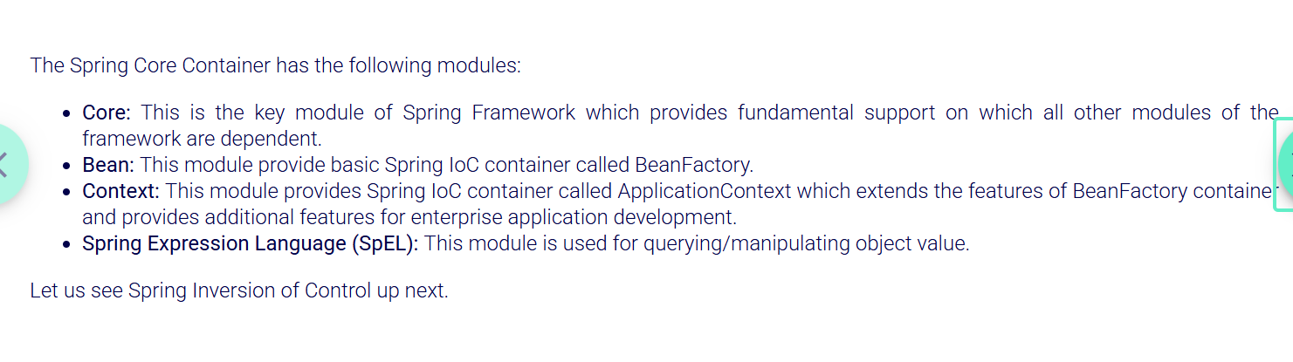

Spring 5.x – jdk 8+

**Inversion of Control (IoC)** is a design principle where the control of object creation, dependency management and the flow of a program is transferred from the application to an external framework or container. Instead of the application managing its own objects and their dependencies, the control is "inverted," and the framework manages the objects and their lifecycles.

This principle is typically implemented using **Dependency Injection (DI)**, where the framework injects dependencies into the objects rather than the objects creating their own dependencies.

**IoC in Spring** enables the framework to take control of the application flow, especially object creation and dependency management, which improves flexibility and modularity in the code.

**Dependency Injection (DI) is a design pattern that is used to implement Inversion of Control (IoC).** in which the responsibility of creating, assembling, and wiring the dependencies of a dependent class is given to an external framework. These external frameworks are known as dependency injection (DI) frameworks. There are many third-party frameworks which are available for dependency injection such as Spring Framework, Google Guice, Play Framework, etc.

In DI, Injects dependencies into classes instead of classes creating them themselves. **DI** is one way to achieve **IoC**

In **Dependency Injection**, instead of a class creating its own dependencies (like services or repositories), those dependencies are **"injected"** into the class by an external system or container (like the Spring Framework).

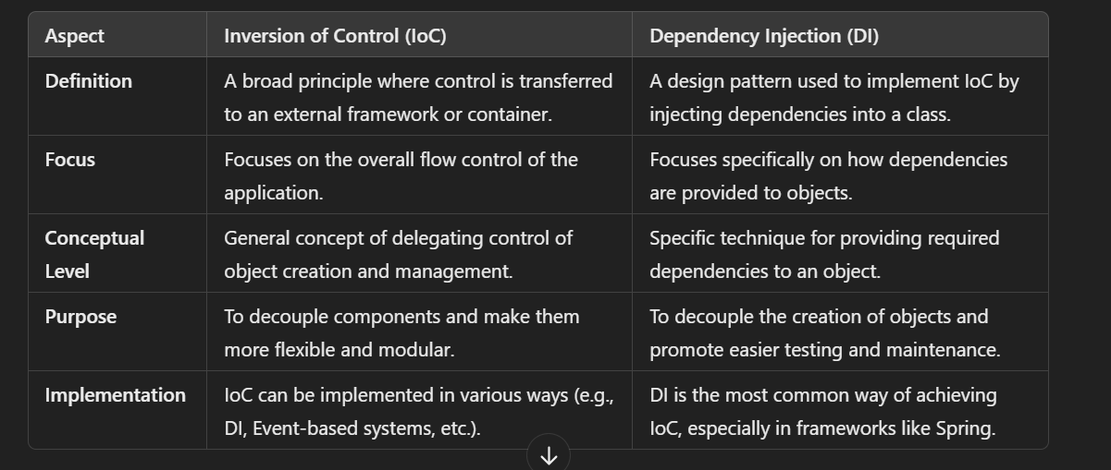

**How do we initialize beans with some specific values in Spring?**

This can be achieved through Dependency Injection in Spring.

Inversion of Control pattern is achieved through Dependency Injection (DI) in Spring. In Dependency Injection, the developer need not create the objects but specify how they should be created through configuration.

Spring container uses one of these two ways to initialize the properties:

* Constructor Injection: This is achieved when the container invokes a parameterized constructor to initialize the properties of a class
* Setter Injection: This is achieved when the container invokes setter methods of a class to initialize the properties after invoking a default construct

Spring container managed application objects are called **beans**in Spring.

We need not create objects in dependency injection instead describe how objects should be created through configuration.

Spring IOC is the container provided by Spring for the creation, initialization and instantiation of the required objects.

The Spring container knows which objects to create and when to create through the additional details that we provide in our application called **Configuration Metadata.**

The Spring IoC Container reads the Application Logic with the help of Configuration Metadata, which we provide, to create the required objects constituting the Application.

The application logic is implemented using **POJO** (Plain Old Java Objects) classes.

The **Configuration** **metadata** can be provided through

XML-based,

Java-based

or Java-Annotation-based configuration. And the objects, thus created and managed by the Spring Container are known as Spring Beans or Beans.

In Spring Framework,  IoC Container is represented by the following interfaces:

* **BeanFactory**: This represents a basic Spring container, which provides basic features such as instantiation, configuration and management of beans. BeanFactory instantiates the bean using getBean() method, and the bean is instantiated only when the getBean() method is invoked.
* **ApplicationContext**: This is the more commonly used Spring container, which inherits the BeanFactory features and provides added features to support enterprise application development.

ApplicationContext interface is implemented by:

* + **ClassPathXMLApplicationContext**, which is used to process the XML-based configuration metadata,
  + **AnnotationConfigApplicationContext**, which is used to process the Java-based and Java Annotation-based configuration metadata.

In **XML configuration**, the configuration metadata is provided as a simple XML file describing bean definitions that the Spring container has to manage.

The basic XML based configuration structure is as follows:

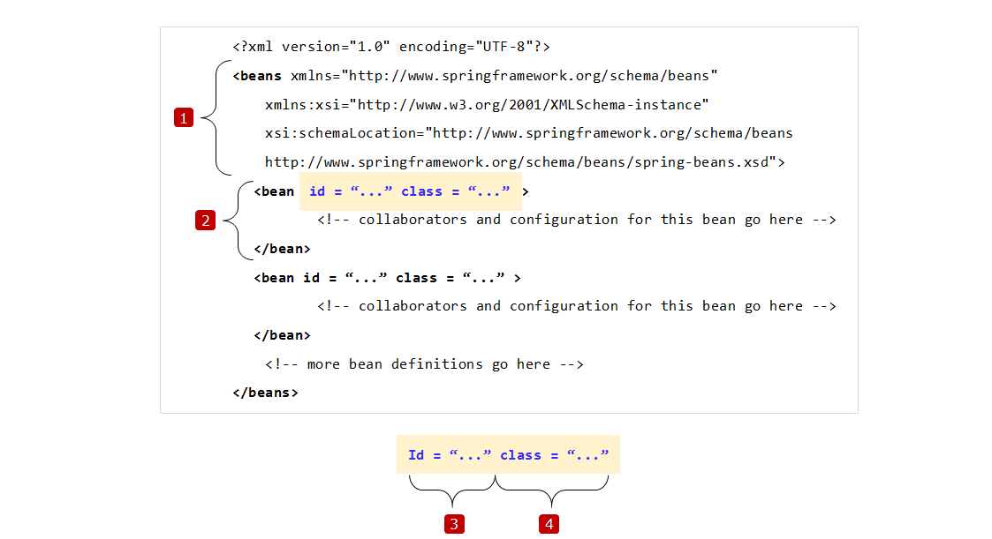

1. **<beans>** is the root element & also includes **namespace declarations**
2. Bean definition
3. **id** attribute represents a unique **bean identifier**
4. **class attribute** represents a **fully qualified** class name

In  **Java-based Configuration**, the configuration metadata is provided using a Java class and two annotations: **@Configuration** and **@Bean**.

A Java-Based Configuration class looks something like this: Here you can see @configuration annotation is provided at the top of config class and @Bean on top of method returning bean object. Here Name of the Bean will be same as that of Method containing Bean definition

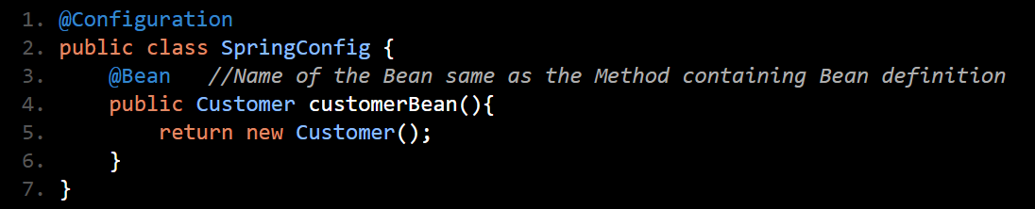

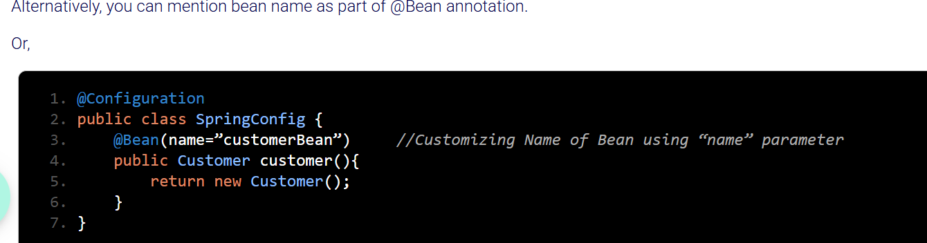

The @Configuration annotation identifies the Java class as the Configuration class. And this class is  expected to contain details on beans that are to be created in the Spring application context.   
And @Bean annotation is used for bean declaration. The methods of configuration class that create instances of the desired bean get annotated with this annotation. These methods are invoked by Spring container during bootstrap and the values returned by these methods are treated as Spring beans.

Next, we use the ApplicationContext interface and its AnnotationConfigApplicationContext implementation to instantiate the bean like this:

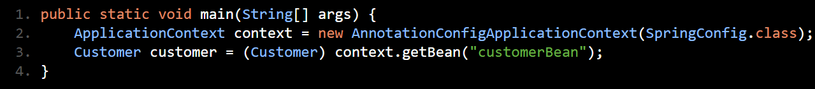

Where, ApplicationContext container is loaded with the configuration metadata from SpringConfig.class.   
And, bean with name "customerBean" is retrieved and typecast from Object type to Customer type.    
With this , we have successfully instantiated beans using Java-based configuration.

In **Java Annotation-Based Configuration**, the need for explicit configuration of bean gets eliminated. Instead, Spring automatically scans, detects and instantiates the beans from the specified package through component scanning. Thus, it looks for classes annotated with @Component, @Controller, @Service and @Repository annotations.

**@Component** is a general purpose annotation used to mark a class as Spring bean.

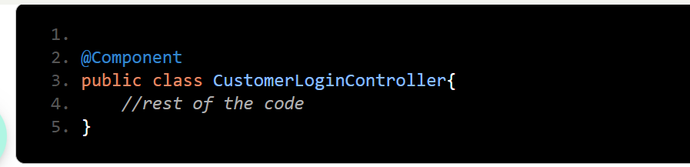

**@Service** is a specialization of @Component annotation, which is used to define a Service layer Spring bean.

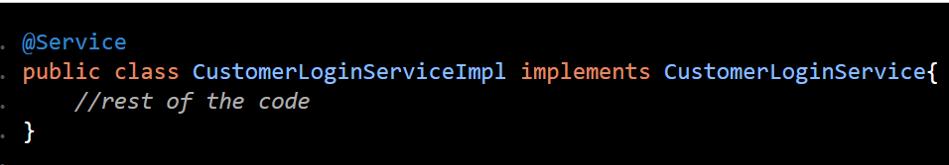

**@Repository**is a specialization of @Component annotation, which is used to define a Persistence layer Spring bean.

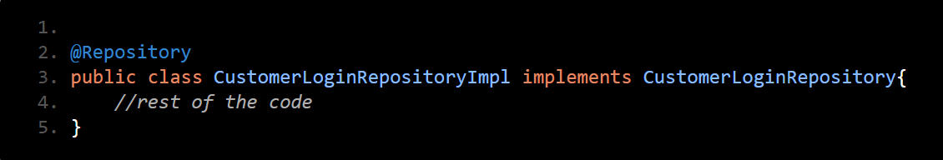

**@Controller** is a specialization of @Component annotation, which is used to define a Presentation layer Web component.

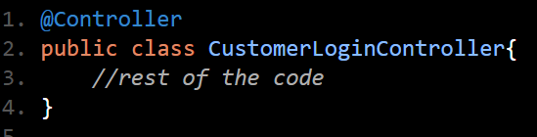

Next, to enable auto-scan of the components we use the **@ComponentScan** annotation in the configuration class. This annotation scans only the package containing the configuration class and its sub-packages for beans.

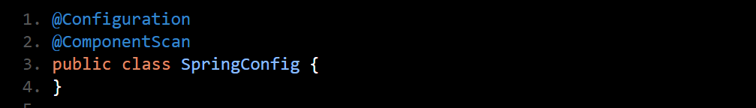

So, we can also specify different or multiple packages for scanning using basePackages parameter:

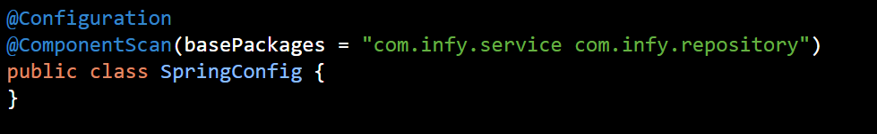

Finally, we use the ApplicationContext interface and its AnnotationConfigApplicationContext implementation to instantiate the bean:

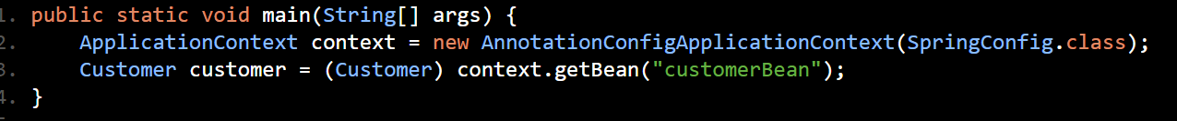

Here the ApplicationContext container is loaded with the configuration metadata from SpringConfig.class. And, the "customerBean" is retrieved and typecast from Object type to Customer type. Hence, we successfully instantiated beans using Java Annotation-based configuration.

Dependency Injection, as we discussed previously, helps us tackle tight coupling. And this is done a process of combining the two beans, called wiring.

But, what is **Wiring** precisely?

The process of combining beans within the Spring IoC Container is called **Wiring** or Bean Wiring. When we use wiring, we inform the Spring IoC Container which beans will be required and how the container should combine them using dependency injection.

Let us see how we can achieve wiring manually in Spring, with the following scenario:

In our Infytel scenario, our Customer class is dependent on Plan. Hence, we need to create an object of either Prepaid class or Postpaid class when the Customer registers. To achieve this, first we need to create a bean of Plan interface, which returns an object of Prepaid class and a bean of Customer class in the configuration class:

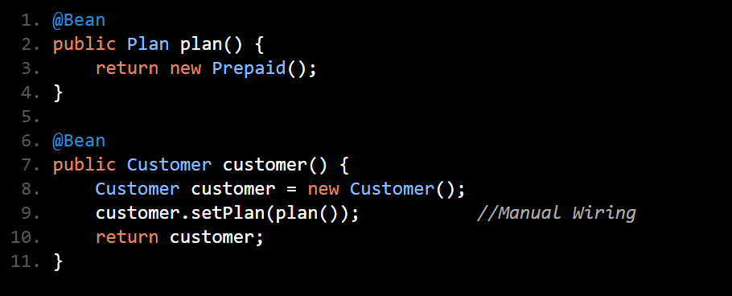

Here we have manually connected the two beans and explicitly define the bean dependencies in the Spring Configuration class. This is Manual wiring.

But this approach is cumbersome.

In Spring, **annotation-based configuration** allows for **dependency injection (DI)** in various ways without using @Autowired. You can still inject dependencies using other methods, such as **constructor injection**, **setter injection**, and **manual bean wiring**.

**JAVA ANNOTATION CONFIGURATION WITHOUT AUTOWIRING:**

**1.Define the Engine and Car Classes with @Component Annotations.**

These classes will be automatically registered as beans due to @Component annotations, but we'll manually inject the dependencies in the main class after the context is created.

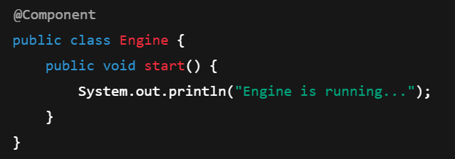

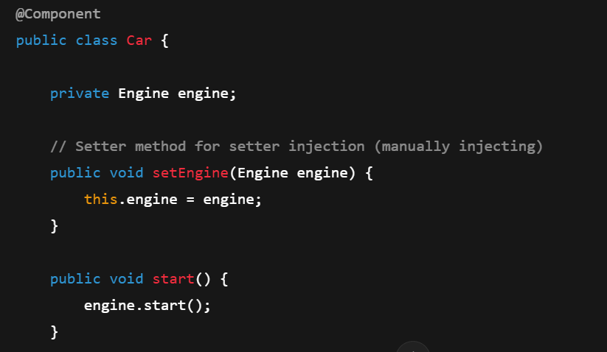

Here:

* @Component is used to mark both Engine and Car as beans that Spring will manage.
* The Car class has a setter method setEngine(Engine engine) where we will manually inject the Engine bean.

**2. Create the Configuration Class with @ComponentScan.**

The @Configuration class will scan the package for components (i.e., @Component annotations), but no beans will be manually declared here with @Bean.

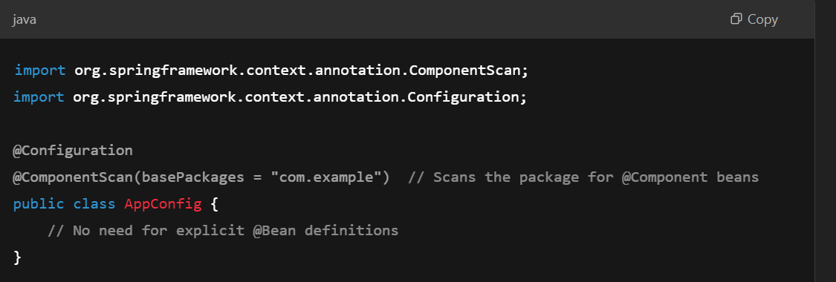

@ComponentScan tells Spring to scan the specified package (in this case, com.example) for beans annotated with @Component and register them automatically.

**3.Manually Inject Dependencies in the Main Application.**

In your main application, you will retrieve the beans from the Spring context and manually inject the Engine into the Car instance by calling the setter method.

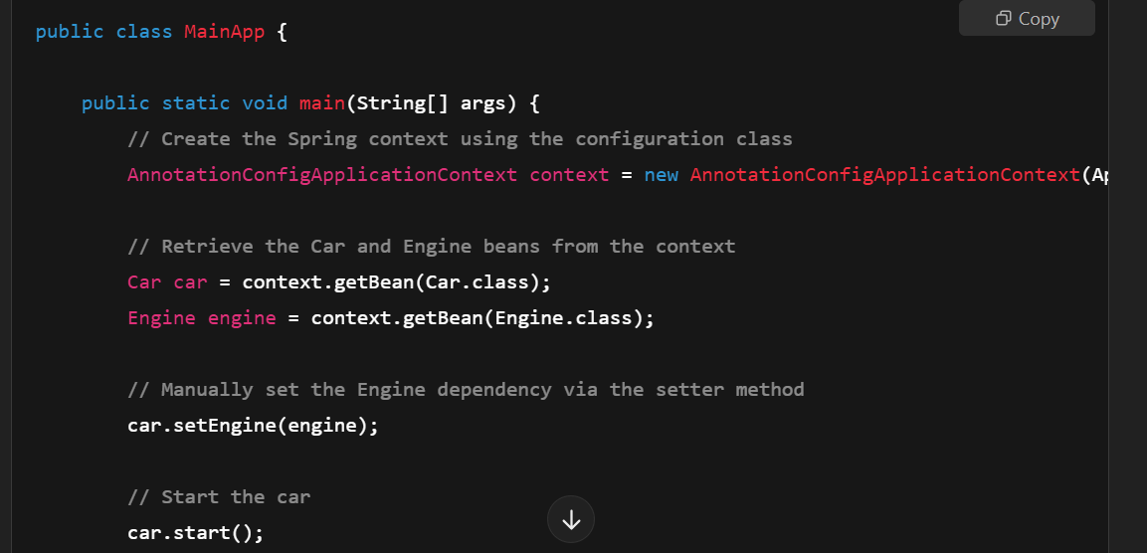

**Explanation:**

* In the AppConfig class, @ComponentScan tells Spring to automatically detect and register beans annotated with @Component (i.e., Engine and Car).
* **No @Autowired is used** anywhere.
* In the MainApp class, we manually retrieve both Engine and Car beans from the Spring context using context.getBean().
* Then, we explicitly set the Engine bean into the Car bean using the setter car.setEngine(engine). This is **manual setter injection** without autowiring.

**Summary of Key Points:**

* **@ComponentScan** is responsible for scanning the package for beans annotated with @Component, @Service, @Repository, etc., and registering them as beans in the Spring container.
* You can manually inject dependencies without using **autowiring** by explicitly calling the setter methods to inject dependencies (like car.setEngine(engine)).
* The **beans are still created automatically** through component scanning, but **the dependency injection happens manually** without relying on @Autowired.

**Why This Approach Works:**

* In **annotation-based configuration**, the Spring container will manage the beans based on @Component, but the actual wiring of the dependencies (i.e., calling the setter methods) is done manually in your main application.
* This avoids using @Autowired or relying on **autowiring** while still benefiting from Spring's component scanning and automatic bean management.

This approach gives you more **manual control** over how the beans are injected, which can be useful if you want to avoid Spring's automatic wiring behavior but still want Spring to manage the lifecycle of your beans.

**JAVA BASED CONFIGURATION WITHOUT AUTOWIRING:**

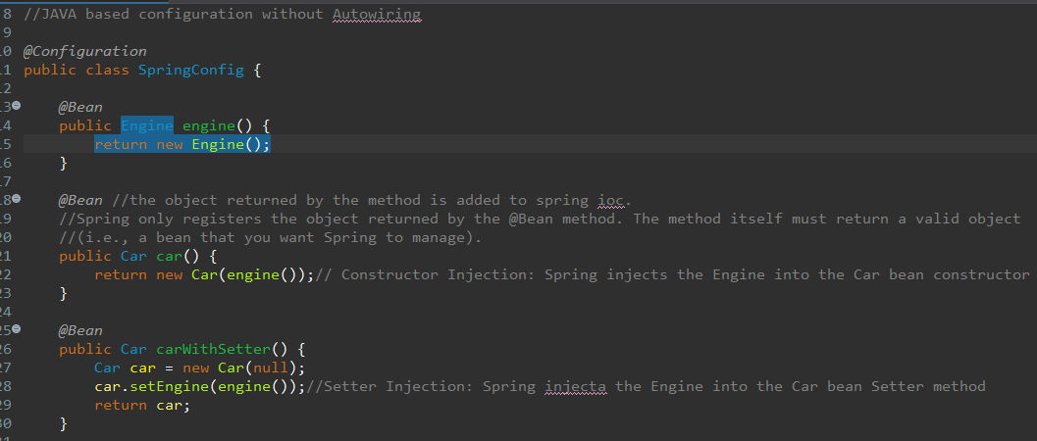

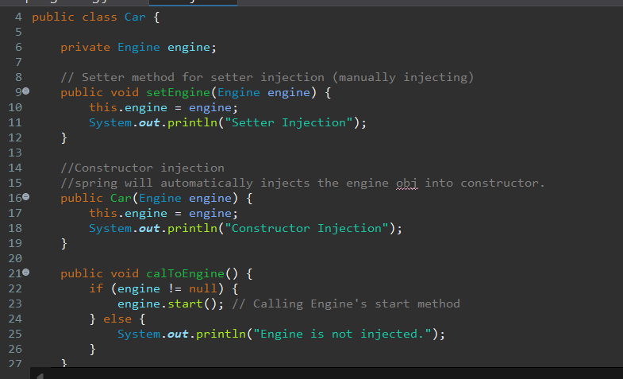

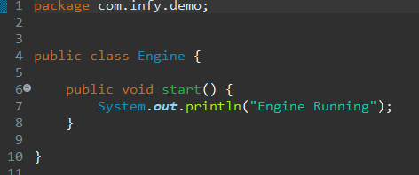

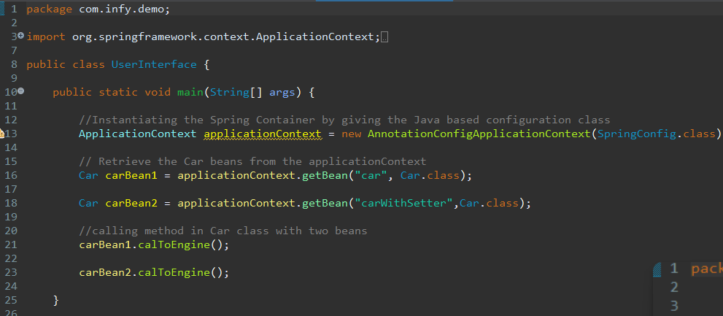

**Autowiring** in Spring is a feature that allows Spring to automatically inject dependencies into beans without the need for explicit configuration. It simplifies the process of managing dependencies by letting the Spring container take care of wiring them together, thus reducing the boilerplate code in your application.

When @Autowired is encountered by the application context, it tells the container to wire the customer bean with a bean of Plan. In other words, the plan bean is injected into the customer bean, without manual intervention.

The different types of Autowiring and how to use them.

Autowiring can be achieved in three different ways:

* **Using @Autowired on properties:** Like our previous implementation of autowiring, @Autowired annotation can be used directly on instance variables or properties.

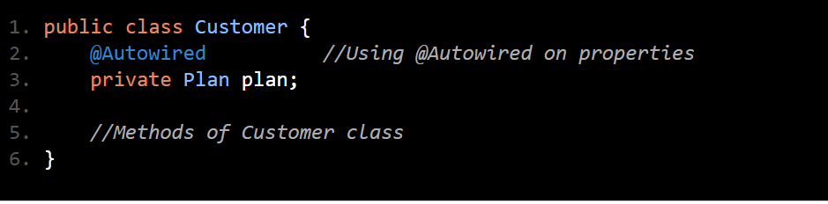

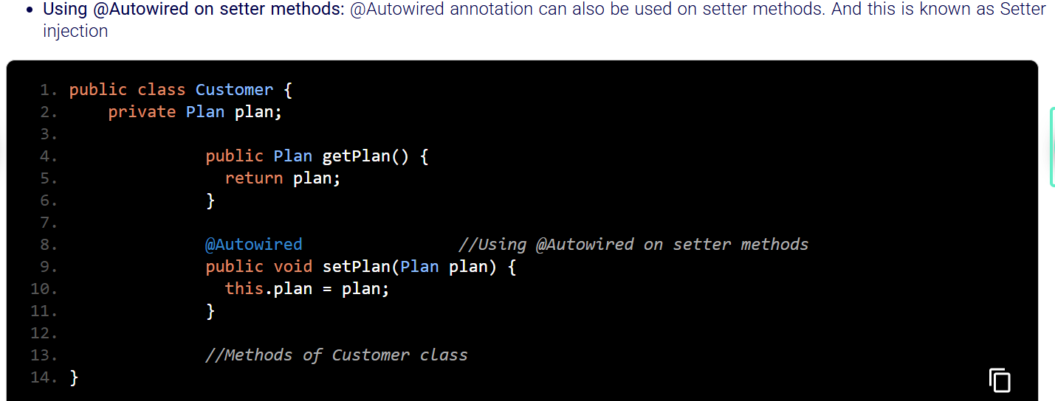

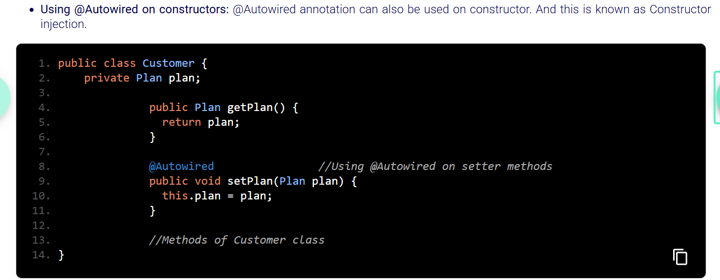

When you have multiple implementations of the same interface or multiple beans of the same type, the container doesn't know which one to inject by default. The **Qualifier annotation** helps to specify **which exact bean** should be injected.

**@Qualifier**annotation can be used to specify which bean has to be wired, based on the bean name.

Use of @Qualifier will make @Autowired resolve dependency based on the name of bean specified with @Qualifier.

If two beans of same type are added in the configuration class to register in spring ioc..

Eg:1( @Qualifier on field)

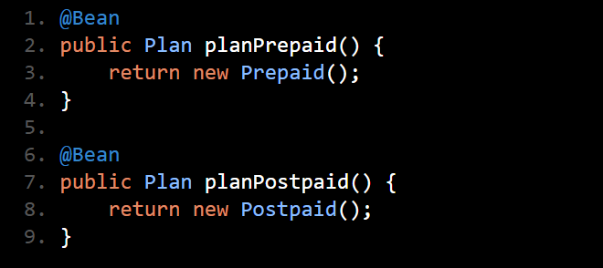

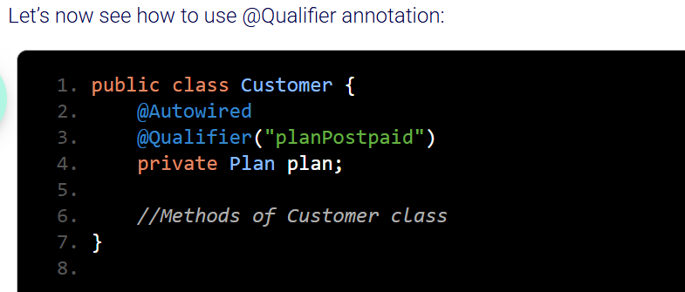

Eg:2 @Qualifier in constructor.

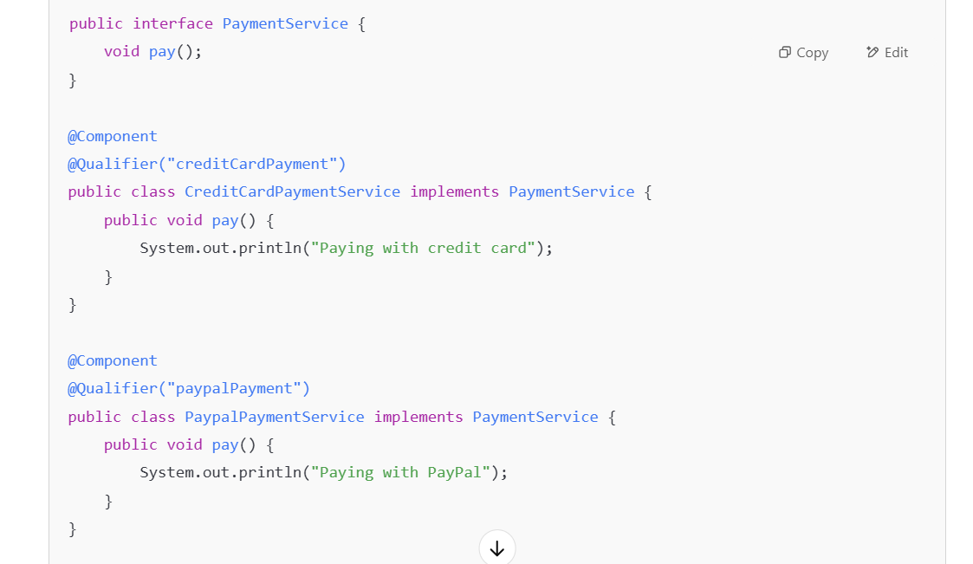

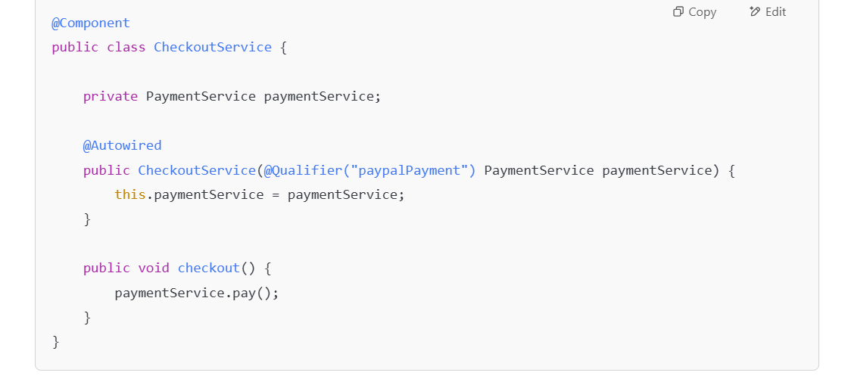

Here, **@Qualifier("paypalPayment")** tells Spring to inject the PaypalPaymentService bean.

We cannot directly add a "core container" dependency in pom.xml file because the Spring Framework is modularized to give you fine-grained control over which parts you use. Each submodule, like spring-context, spring-beans, and spring-core, has specific purposes. By adding only the necessary dependencies, you keep your project lean and avoid pulling in unused code.

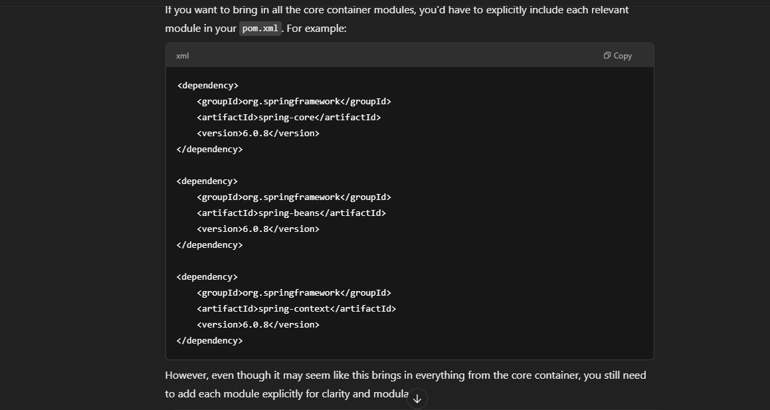

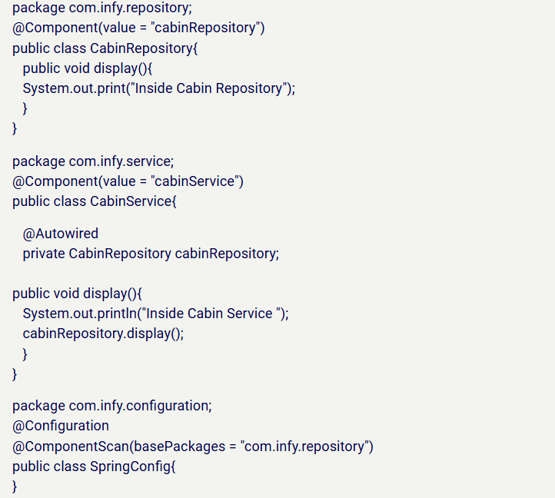

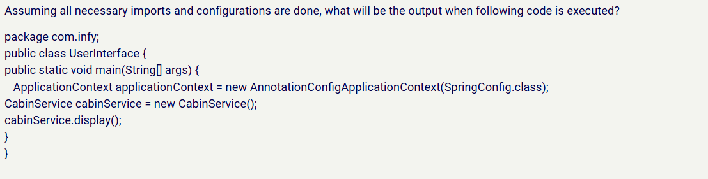

Explanation for above code: o.p: **Inside Cabin Service is printed and then NullPointerException is thrown**

**Why??** Autowiring doesnt happen here because we created an obj of CabinService class with new keyword manually and spring didn’t create a bean of CabinService class in ioc. Spring's dependency injection doesn't apply to objects created outside of the Spring container. To allow Spring to inject the CabinRepository into CabinService, you need to **obtain the CabinService bean from the Spring container** (using applicationContext.getBean(CabinService.class)).

**Bean Scope:**

The term "bean scope" refers to the lifecycle and visibility of beans (objects managed by a container, such as Spring's IoC container) within a given context.

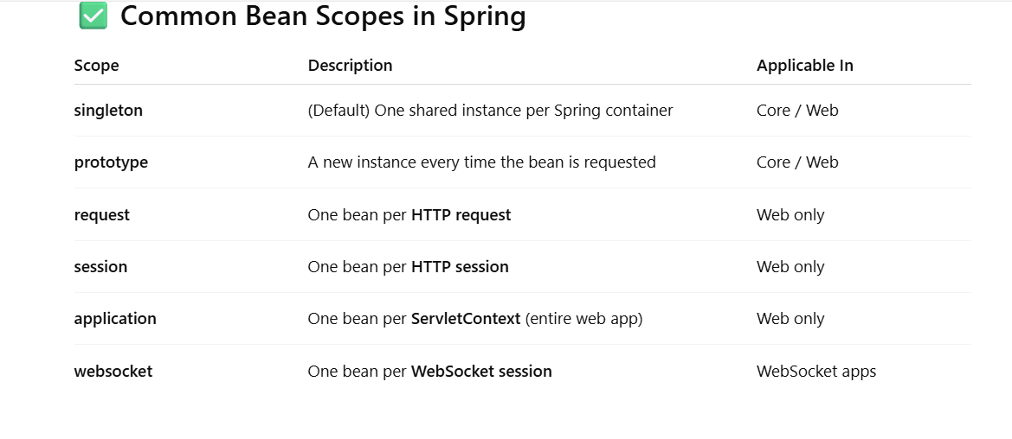

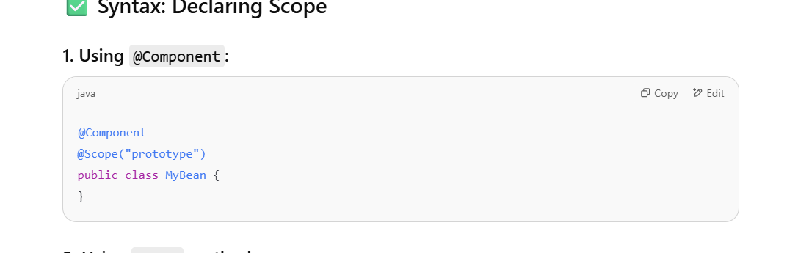

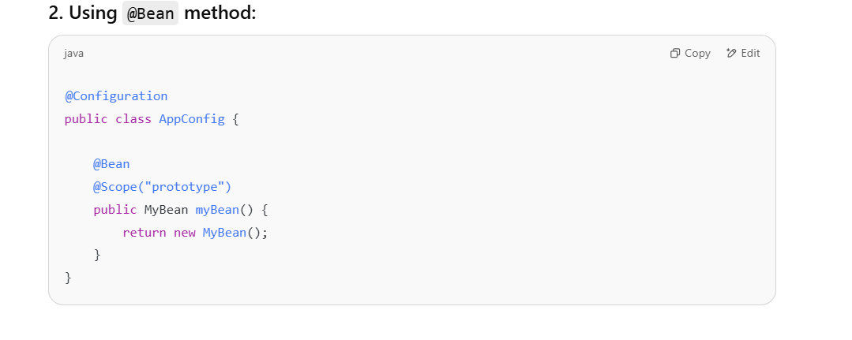

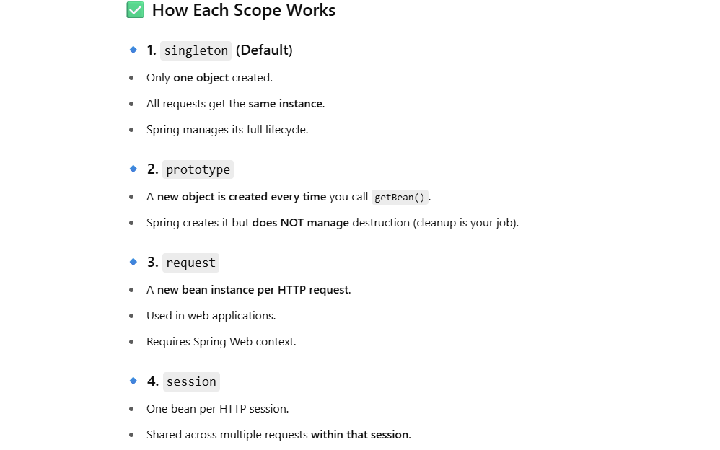

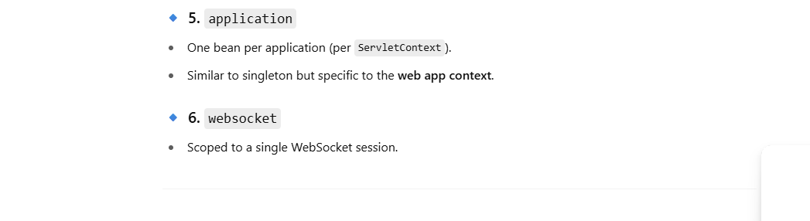

Bean scopes implement two important design patterns:

**Singleton Pattern** is a design scheme where only one object is created per class. In a Spring Application, this design scheme is implemented by the “singleton” bean scope.

It’s the default scope in Spring where only one instance of the bean is created for the entire Spring container (application context), and that instance is reused whenever it is requested meaning every time you request the bean, you’ll get the same instance.

This bean is typically created during **context initialization** — when the Spring context is loaded or when the configuration class is processed.

The constructor is called **once**, and the same instance is reused across the application.

• Useful for **stateless** beans or shared resources.

• It is **thread-safe** as long as the bean is stateless (does not store any mutable state).

Since it’s a default scope we don’t need to explicitly specify it unless we want to be clear in your code.

Explicit declaration:

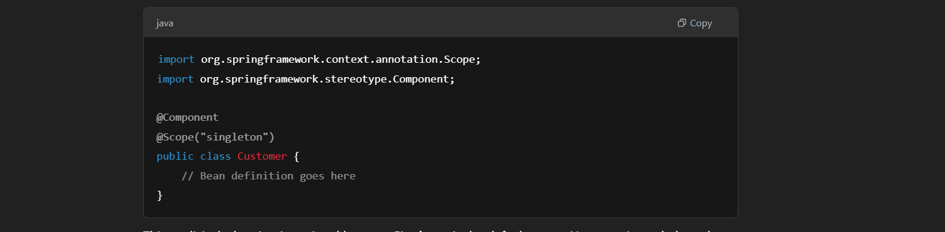

**Prototype Design Pattern** is a design scheme where classes having one existing instance/object is cloned to provide the feature of multiple instantiation. The existing object acts as the prototype, which contains the default state of the object. And the cloned object can change the state of the object as and when required. This design pattern is especially used in situations where creation of new instances/objects is a costly process but logically required.

In a Spring Application, this design scheme is implemented by the “prototype” bean scope.

When a bean is defined with the **prototype** scope, a new instance is created every time it is requested.

Prototype bean scope instructs the Spring IoC Container to create multiple instances of the bean, and there will be a new bean created for every request from the application..

Suitable for **stateful** beans, where each instance of the bean should maintain its own state. However, it’s important to handle the lifecycle management of such beans since Spring does not manage their destruction after they are created.

In Java Based Configuration:

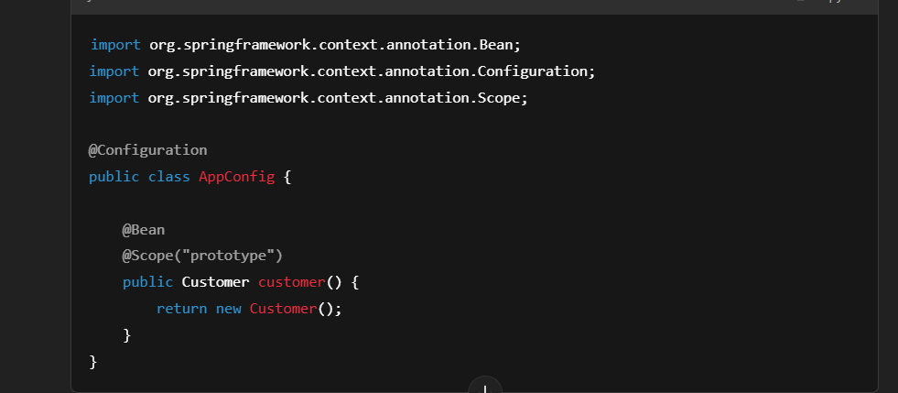

In Annotation Based Configuration:

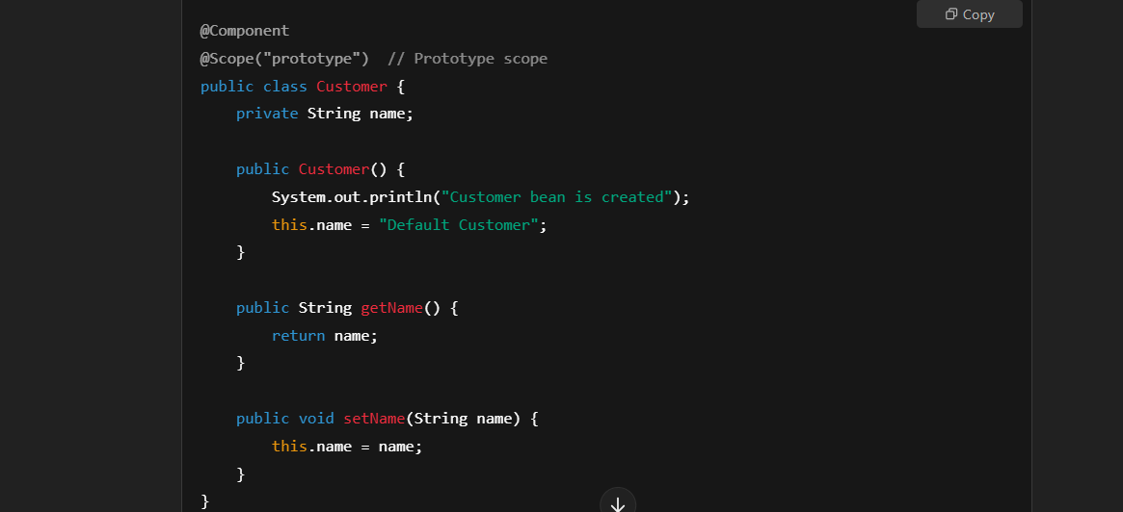

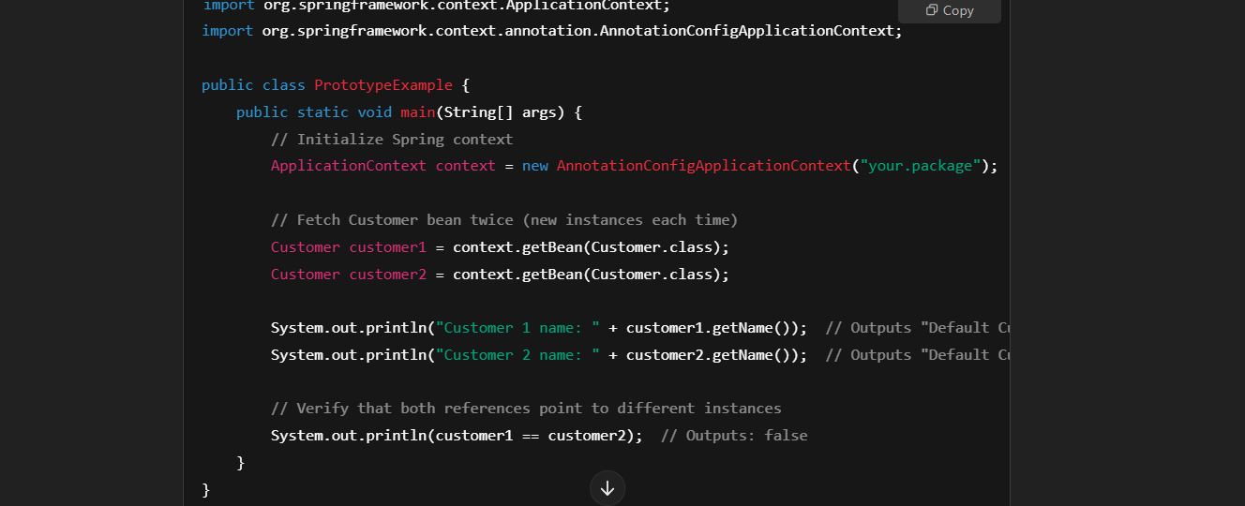

**getBean()**: Each call to getBean() results in a **new instance** of the Customer bean being created.

• **Prototype**: These beans are created on demand (when getBean() is called) not when context is initialized. *When scope of a bean is set to prototype, object of that class is created only when it is requested in application.*

The constructor is called **every time** an instance is created, resulting in different objects each time.

**SPRING PROFILES:**

An Environment is a collection of software such as operating system, database and hardware tools such as RAM , expansion cards that help to build software. Every enterprise application will have multiple environments.

Example:

* Development
* Testing
* Staging
* Production

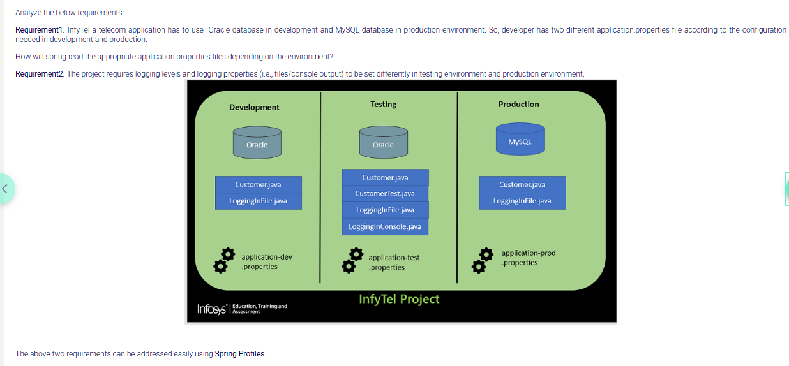

Spring Profiles helps to classify  the classes and  properties file for the environment. You can create multiple profiles and set one or more profiles as the  active profile. Based on the active profile spring framework chooses beans and properties file to run.

Let us see how to configure different profiles using spring profiles in our projects.

Steps to be followed:

1)      Identify the beans which has to be part of a particular profile [Not mandatory]

2)      Create environment-based properties file

3)      Set active profiles.

You can identify the Spring beans which have to be part of a profile using the following ways

1) Annotation @Profile

2) Bean declaration in XML

@Profile helps spring to identify the beans that belong to a particular environment.

1. Any class which is annotated with stereotype annotations such as @Component,@Service,@Repository and @Configuration can be annotated with @Profile .
2. @Profile is applied at class level except for the classes annotated with @Configuration where @Profile is applied at the method level.

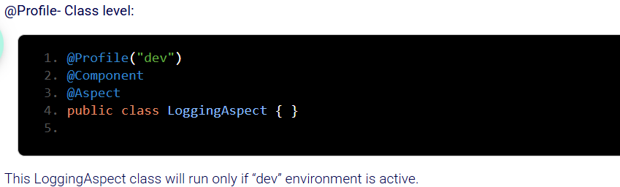

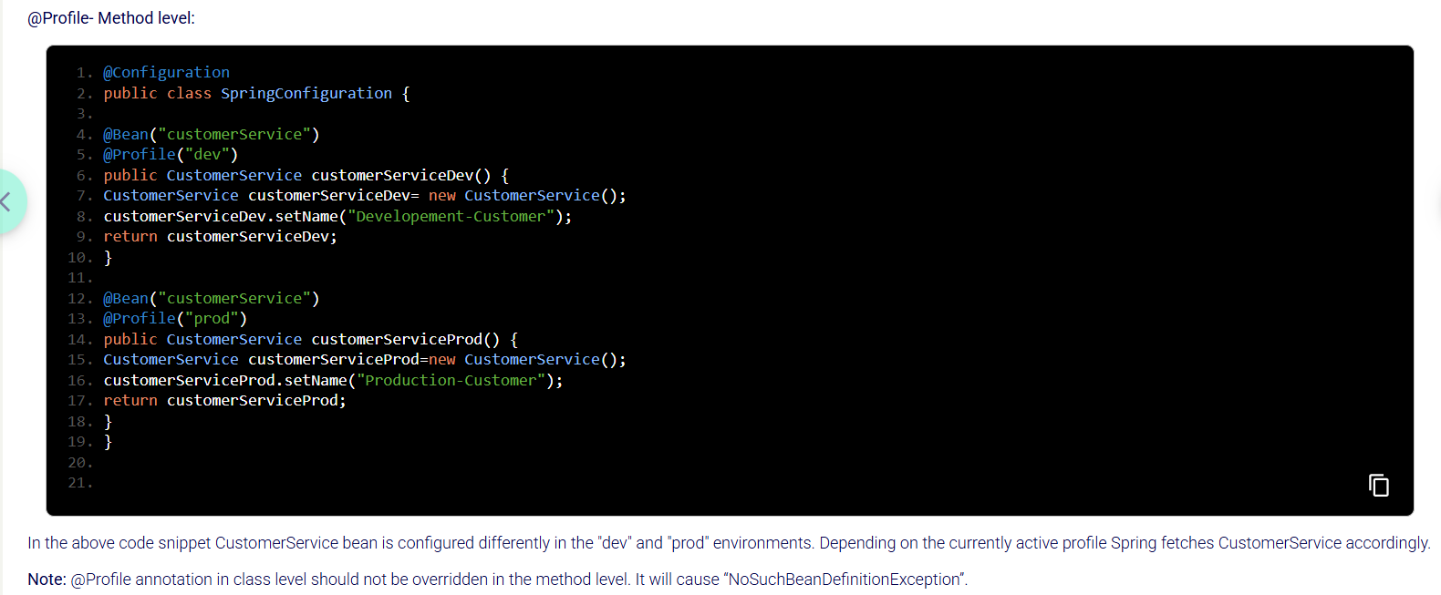

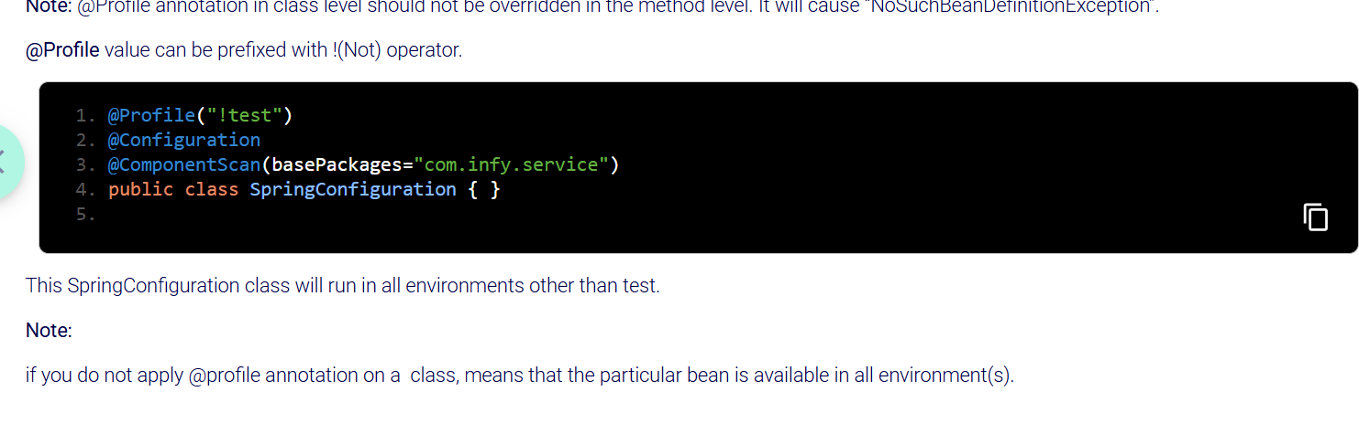

**application.properties :**

Spring boot automatically loads an **application.properties** file if we create manually and handles the configuration.

If you want to configure things like database connection, server port, or other settings, you can manually create an **application.properties** file in the src/main/resources directory.

**Spring Boot automatically loads this file** and uses the configurations you specify. If you specify properties for things like the data source or server port, Spring Boot will pick them up and configure your application accordingly.

If you create a second custom properties file (e.g., **custom.properties**), Spring Boot will not load it automatically unless you explicitly tell it in VM Arguments.

Eg: -Dspring.config.name= myapp

In this case, Spring Boot will first try to load myconfig.properties or myconfig.yml and also loads default application.properties file.

Properties from the custom file will override those in the default application.properties if there are any conflicts, but both sets of properties will be available.

In a **traditional Spring Framework** (non-Spring Boot) project, if you create an application.properties file, it **won't be automatically loaded** by Spring. You would need to manually configure Spring to load the properties from the file.

In **Java-based configuration** (using annotations), you can use the @PropertySource annotation to load the properties file.

In **XML-based configuration**, you can use PropertyPlaceholderConfigurer or PropertySourcesPlaceholderConfigurer to load the properties file.

***SPRING DATA ACCESS LAYER::***

To implement spring data access layer developer can choose either spring JDBC or spring ORM modules which are submodules of spring data module.

Spring data simplifies the persistence layer development.

Layers of an application: Presentation, Service, Persistence

Persistence : The layer which communicates with db and service layer. It takes data from service layer performs db operations and then sends the results back to service layer.

**What is an Enterprise Application?**

An enterprise application is a large, complex software system used by organizations to make day-day business operations and processing easier.

For Example: Amazon, Flipkart, Myntra, CITI Bank, InfyMe , Lex , etc.

Let us now understand the evolution from traditional JDBC to Spring Data JPA, covering the key concepts and technologies along the way:

**JDBC (Java Database Connectivity):**

* A Java API for connecting and executing queries with a database.
* Requires developers to write a lot of boilerplate code for database operations.
* Prone to errors due to manual handling of connections, statements, and result sets.
* Lacks object-relational mapping capabilities.

**Spring JDBC:**

* To overcome the limitations of raw JDBC, and to simplify database operations, spring framework introduced Spring JDBC which was built on top of JDBC to simplify database access.
* Reduces boilerplate code through templates and callback interfaces.
* Provides better exception handling and resource management.
* Still requires manual mapping between Java objects and database tables.

Spring JDBC simplifies JDBC but has limitations for complex applications, leading developers to switch to ORM solutions. Spring ORM addresses these limitations, offering a bridge to technologies like Hibernate, while Spring Data JPA further simplifies repository implementations by leveraging ORM specifications internally.

ORM – It’s a technique/concept that allows developers to map java classes to tables in db, instance variables to columns, objects to rows.

Supports HQL,JPQL query approaches.

**JPA** is the specification for using ORM to communicate with db in applications.

It defines a set of standards/rules for mapping Java objects to relational database tables, but **JPA itself is not a framework**. It is just a specification, and it provides an API for interacting with databases. It provides annotations and interfaces to allow developers to map Java objects to database tables.

**JPA doesn't provide the actual implementation**; it just defines the API (like interfaces and annotations) that ORM frameworks can follow. It defines how persistence should work but leaves the actual implementation up to other framework like hibernate.

JPA Specification providers in the market – Hibernate.

**Hibernate** is a specific ORM framework and also the most widely used implementation of the JPA specification. Hibernate is an ORM tool which simplifies the interaction between Java applications and relational databases by mapping Java classes to database tables without needing to write sql queries manually by developers. It not only implements JPA but also extends it with additional features that aren't part of the JPA specification.

**What Hibernate Does:**

* Maps Java objects to database tables.
* Creates the table in db corresponding to the entity class
* Translates Java objects into SQL queries for storing/retrieving data in MySQL.
* With the JpaRepository, Hibernate handles **Create**, **Read**, **Update**, and **Delete** operations on java objects and translates those operations to sql without needing you to write SQL queries.
* SQL generation and execution behind the scenes.
* Manages object states: **transient**, **persistent**, **detached**.
* Supports **transaction management**, **caching**, **lazy loading**, and more.

Eg: For example, calling save() on a Student entity results in an INSERT SQL query being executed to insert the student into the database.

**Real-World Benefit:**

Without Hibernate, you'd need to manually write SQL to interact with the database. Hibernate abstracts all of that and makes it easier to perform operations on the database, while also offering performance optimizations and reducing boilerplate code.

JPA Annotations:

@Entity - An Entity class is a class in Java that is mapped to a database table in a relational database.

@Id - Defines the primary key of an entity.

@Table(name = “”)

@Column(name=””)

@Transient - indicate that a particular field in a class should **not be persisted** to the database.

@GeneratedValue - Specifies how the primary key of entity class should be generated automatically. It is used in conjunction with the @Id annotation, which marks the field as a primary key.

Hibernate use a **default physical naming strategy**, which:

* Converts **camelCase** field names → to **snake_case**
* Then uppercases them (in some dbs like h2)

private Integer rollId;

In db – ROLL_ID

**EntityManager** is the interface responsible for interacting with the persistence context and managing the lifecycle of entities in JPA.

void persist(Object Entity) – Adds a new row

find(Class entityclass, object primary key) – returns rows by finding the db with primary key.

Remove(object entity)

SPRING BOOT START 🡪

Spring is a lightweight framework for developing enterprise Java applications but using Spring for application development is challenging for developers because of the following reasons:

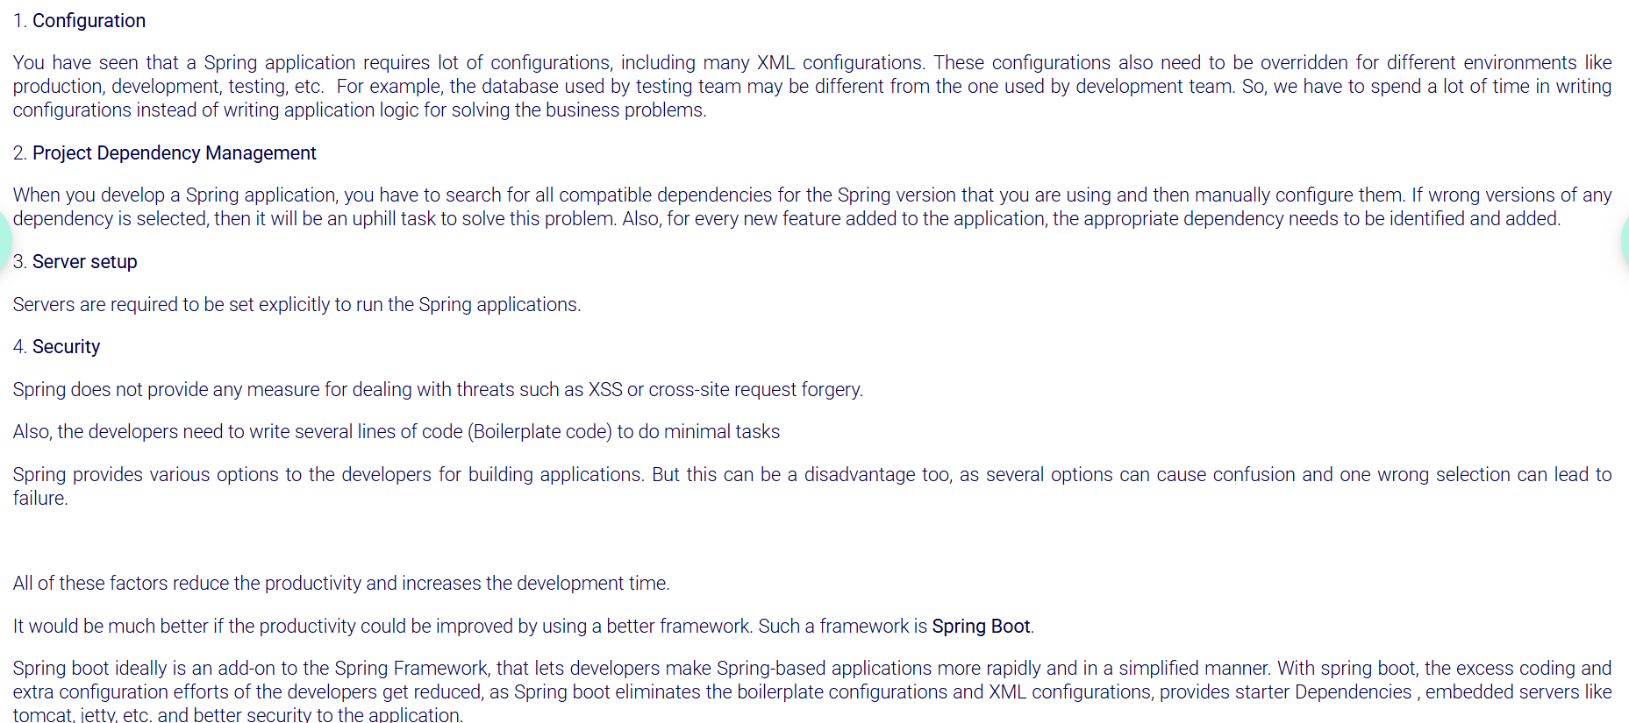

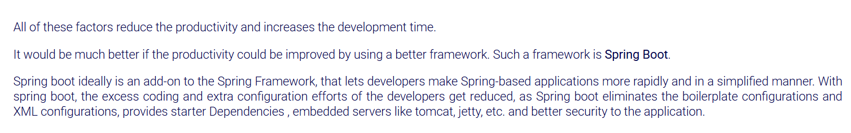

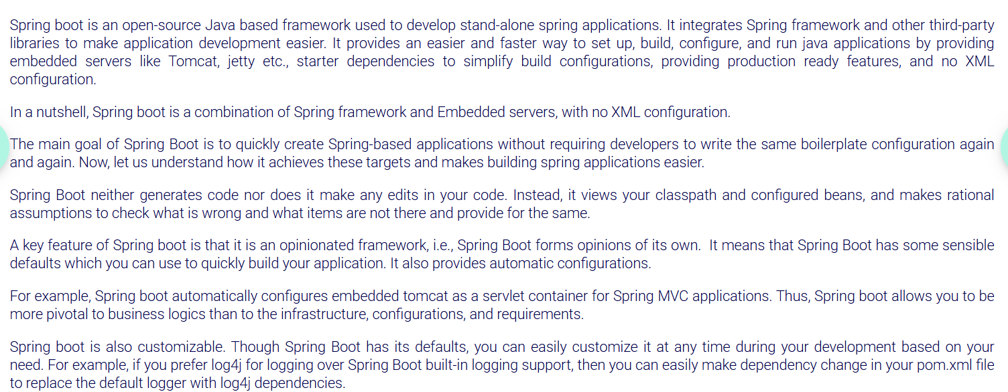

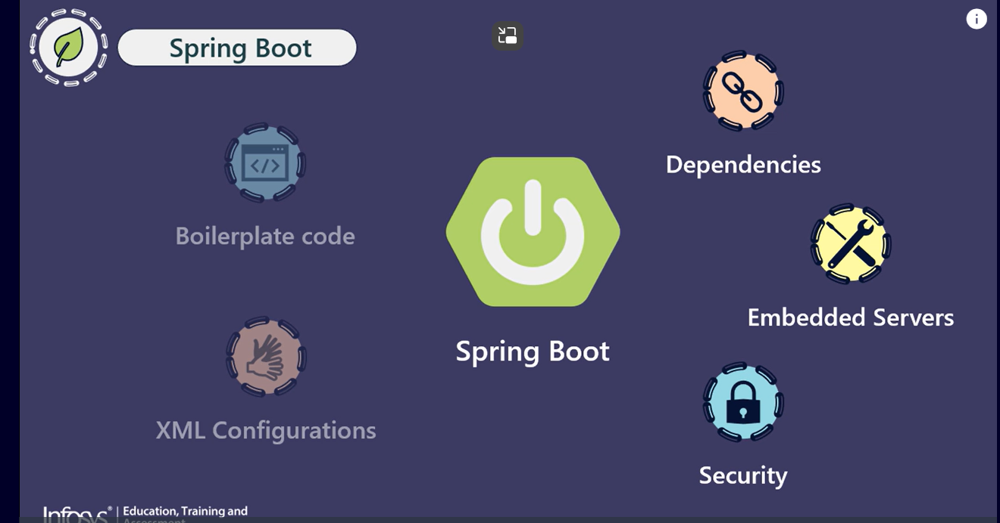

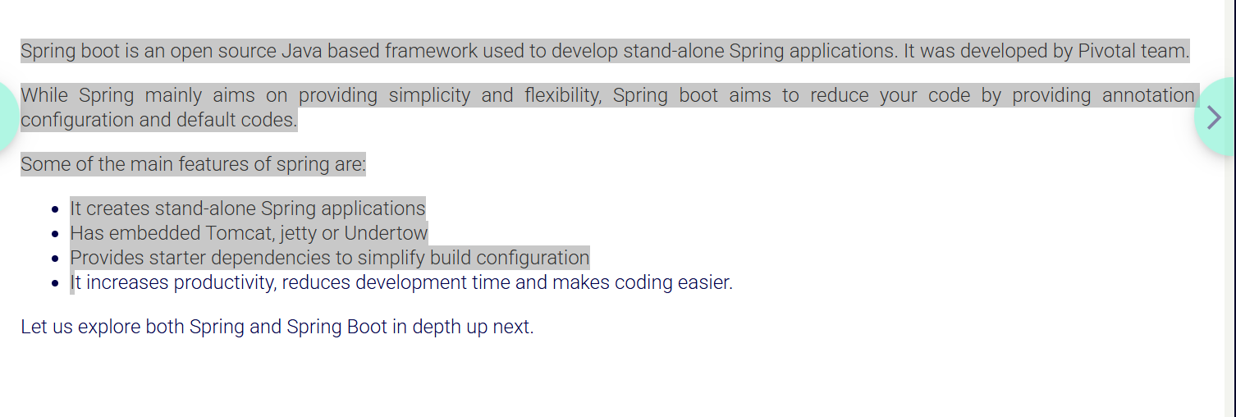

**Spring boot** is an open source Java based framework used to develop stand-alone Spring applications. It was developed by Pivotal team.

While Spring mainly aims on providing simplicity and flexibility, Spring boot aims to reduce your code by providing annotation configuration and default codes.

Some of the main features of spring are:

* It creates stand-alone Spring applications
* Has embedded Tomcat, jetty or Undertow
* Provides starter dependencies to simplify build configuration
* It increases productivity, reduces development time and makes coding easier.

Spring Boot comes with many starters. Spring Boot starters are pre-configured dependency descriptors with most commonly used libraries that you can add in your application.

So, you don't need to search for compatible libraries and configure them manually. Spring Boot ensures that the necessary libraries are added to the build. To use these starters, you have to add their dependencies in the pom.xml file.

When Spring Boot starts up, it scans the classpath and detects the presence of various libraries and their configurations.

Let us see some of the popular starters provided by spring boot and their dependencies:

* **spring-boot-starter**- This is the core starter which includes support for auto-configuration, logging and YAML.
* **spring-boot-starter-aop** - This starter is used for aspect-oriented programming with Spring AOP and AspectJ.
* **spring-boot-starter-data-jdbc** - This starter is used for Spring Data JDBC.
* **spring-boot-starter-data-jpa** - This starter is used for Spring Data JPA with Hibernate.
* **spring-boot-starter-web -**This starter is used for building web application using Spring MVC  and Spring REST. It also provides Tomcat as the default embedded container.
* **spring-boot-starter-test -** This starter provides support for testing Spring Boot applications using libraries such as JUnit, Hamcrest and Mockito.
* **spring-boot-starter-log4j2**- This starter provides support for using Log4j2 for logging. It is an alternative to spring-boot-starter-logging.
* **spring-boot-starter-actuator** - This starter provides support for using Spring Boot Actuator.

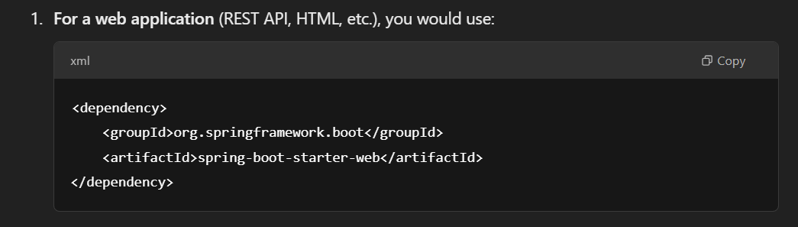

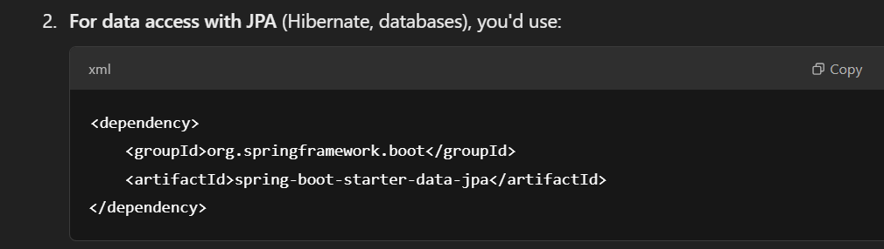

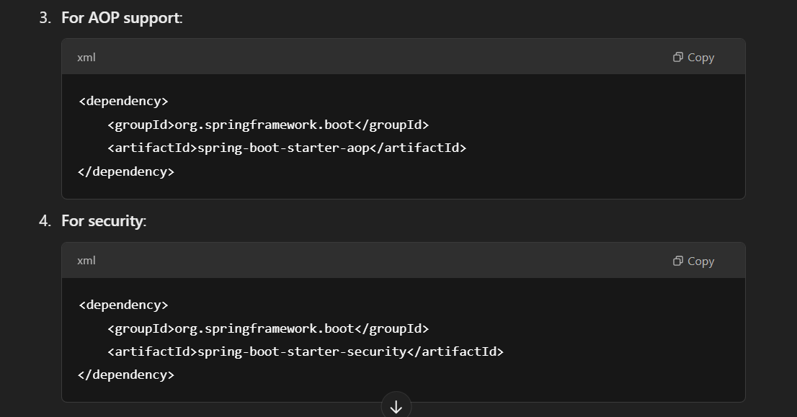

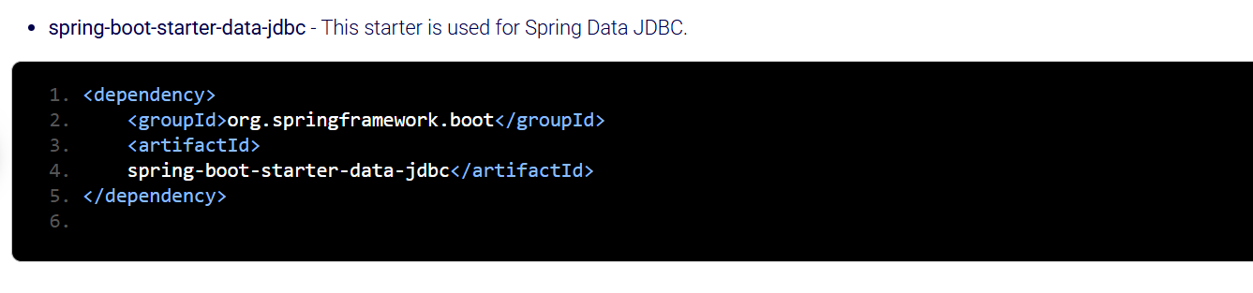

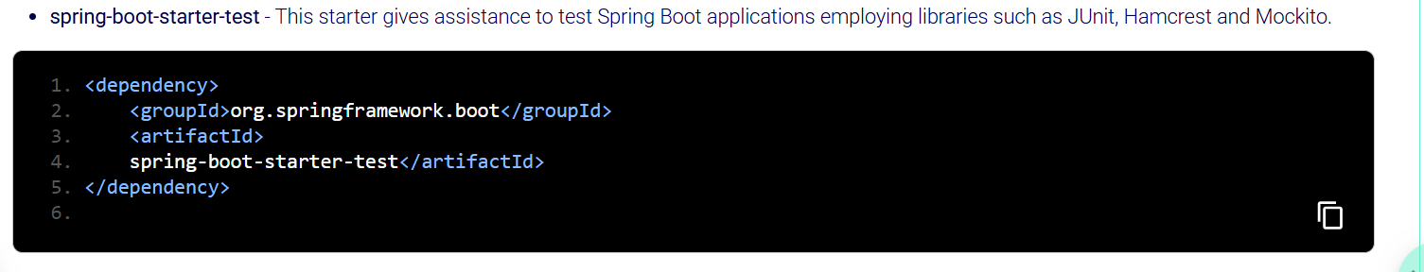

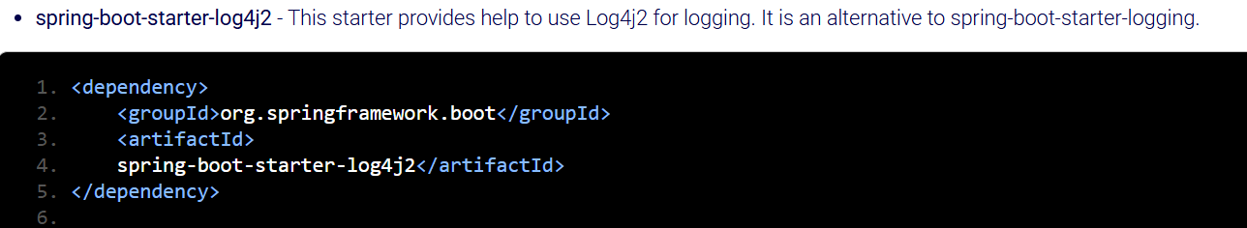

The Spring Boot Starter Parent defines key **versions** of dependencies and default plugins for quickly building Spring Boot applications. It is present in the pom.xml file of application. A sample Spring Boot Starter Parent is shown below:

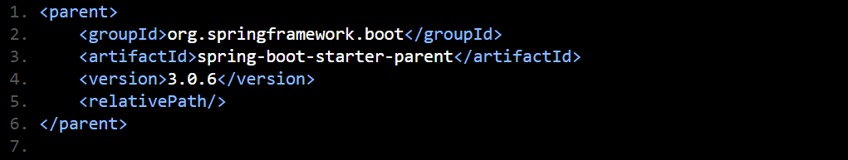

**Configuration in Spring:**

**Steps to configure a Database Connection using JPA in Traditional Spring:**

1. **Dependencies:** You'll need to add the necessary dependencies for **Spring**, **Spring Data JPA/Spring JDBC**, and the **database driver** in your pom.xml. This will not be as automated as with Spring Boot.

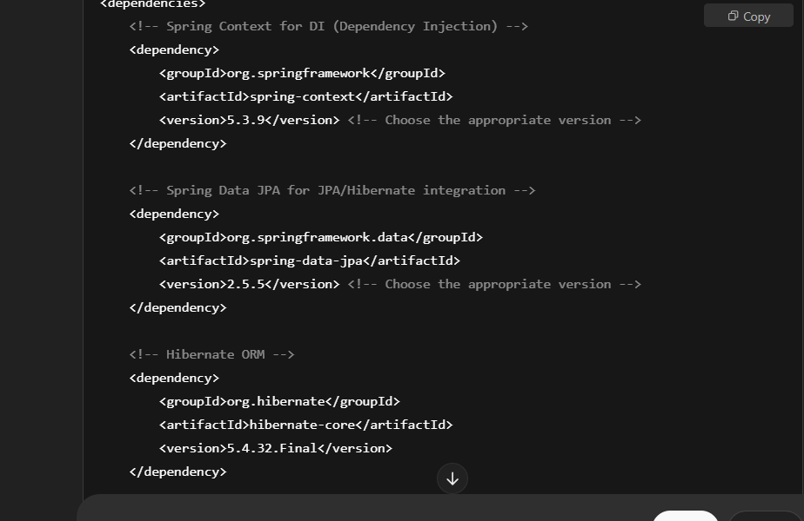

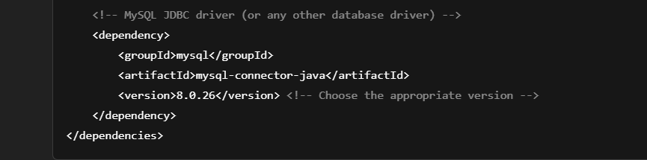

**Step 2: Define applicationContext.xml (XML Configuration)**

In traditional Spring (without Spring Boot), you'll configure the necessary beans in the applicationContext.xml file(in case of xml configuration). This file tells Spring how to create and configure the beans.

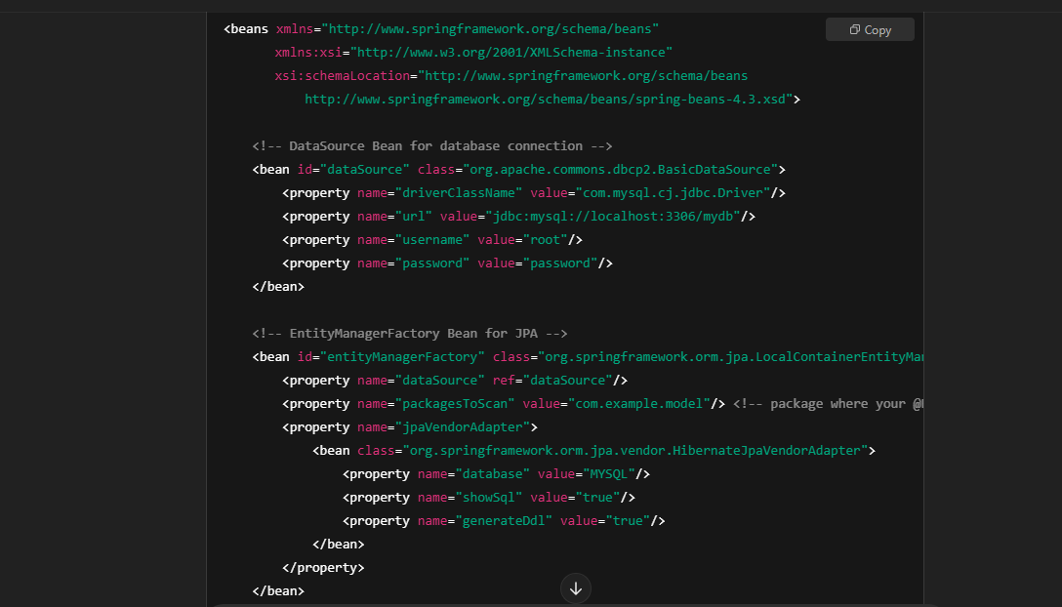

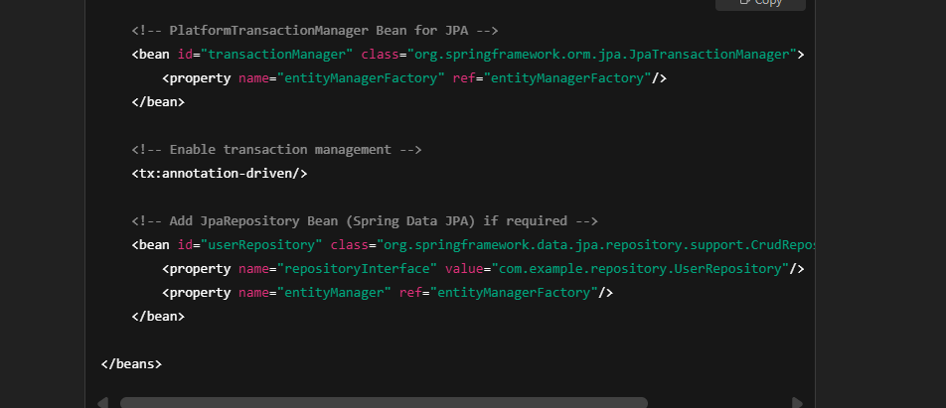

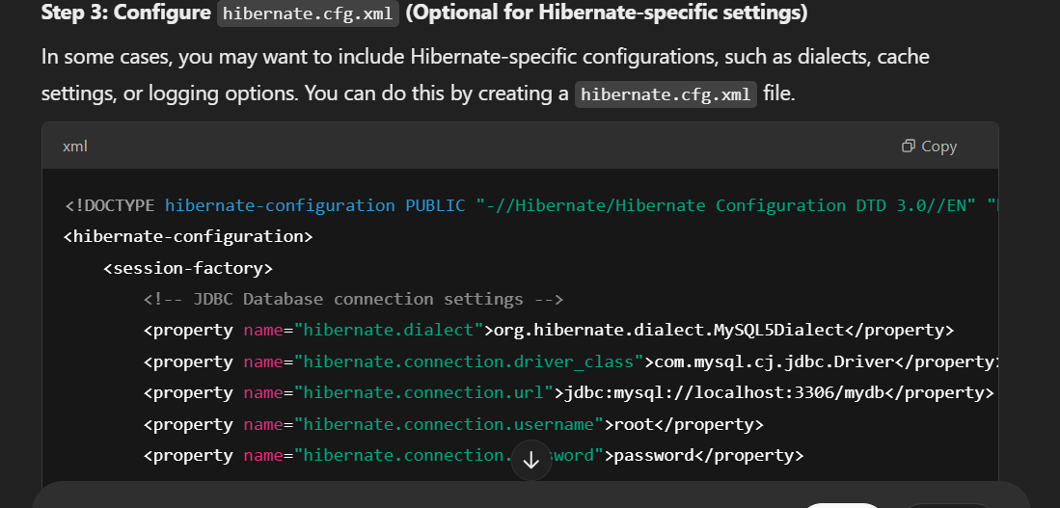

• **Manual Configuration**: In Spring, you need to manually set up everything, including the DataSource, EntityManagerFactory, and TransactionManager in XML configuration files. In contrast, Spring Boot automatically configures most of this for you.

• **Application Context**: In traditional Spring, you load your application context using ClassPathXmlApplicationContext, while Spring Boot handles context loading automatically, so you don’t need to explicitly load the context.

• **Database Configuration**: In Spring Boot, database configuration is typically done in application.properties or application.yml, which is much simpler. In Spring, you have to manage the configuration in XML files, which can become more cumbersome.

**Auto-Configuration in Spring Boot:**

**Auto-configuration** is a core feature of Spring Boot that automatically configures your application based on the dependencies present in your classpath. This means **When you add the starter dependency eg: (spring-boot-starter-data-jpa), Maven or Gradle downloads all the required libraries and adds them to the classpath automatically.**

• **Externalized Configurations**: Spring Boot allows you to **externalize configurations** for various environments (like development, testing, production, etc.). This means you can keep your application's configuration separate from the code (e.g., in application.properties or application.yml files, environment variables, etc.) and modify it without changing the code itself.

in **Spring Boot**, if you simply add the spring-boot-starter-data-jpa dependency to your pom.xml, it makes a significant portion of the database configuration automatic. Here's a breakdown of how this works:

**1. Adding the Dependency:**

When you add the spring-boot-starter-data-jpa dependency to your pom.xml, you're essentially bringing in all the necessary libraries and configurations for **Spring Data JPA** (which is a part of the Spring Data project that simplifies database access with JPA). The **starter** dependency is a collection of useful libraries that Spring Boot automatically configures for you.

Here’s how it looks in pom.xml:

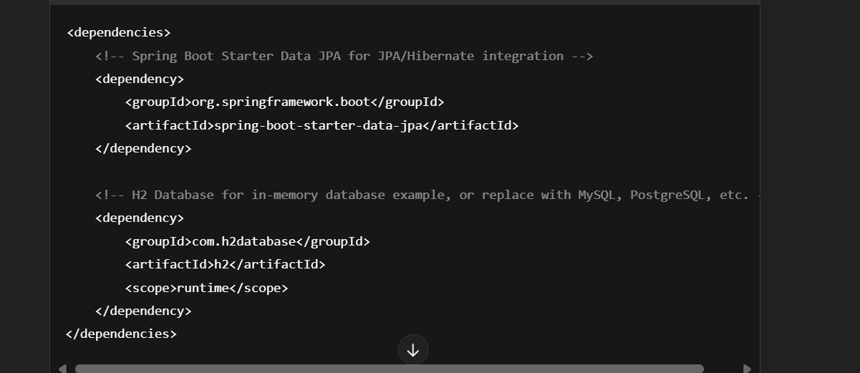

When you add the starter, **Spring Boot** adds the following key dependencies automatically:

* **Spring Data JPA** (spring-data-jpa): Provides the JPA (Java Persistence API) support for interacting with databases.
* **Hibernate** (default JPA implementation): Handles ORM (Object-Relational Mapping) functionality.
* **H2, MySQL, PostgreSQL, etc.** (depending on what you're using): Database drivers (you'll configure the database connection in the application.properties or application.yml).

**2. How It Gets in Classpath:**

When you add the **starter dependency** (spring-boot-starter-data-jpa), Maven or Gradle downloads all the required libraries and adds them to the **classpath** automatically.

* **Classpath** refers to the set of directories or JAR files that the Java runtime uses to find classes and resources needed for your application.
* When Spring Boot starts up, it scans the classpath and detects the presence of various libraries and their configurations.

For example, Spring Boot will automatically detect the spring-data-jpa dependency, and if it sees that you have a database-related dependency (like h2 or mysql-connector-java), it will automatically configure JPA settings, data source, and connection pooling.

**Spring Boot’s Auto-Configuration** mechanism kicks in here. Spring Boot uses its **auto-configuration** feature to make intelligent guesses about what needs to be set up based on the libraries present in the classpath.

* It detects **Spring Data JPA** and provides configuration for:
  + **DataSource** (Database connection pool)
  + **EntityManagerFactory** (for managing JPA entities)
  + **TransactionManager** (for managing transactions)

You **don’t need to explicitly define these beans** unless you want to customize the behavior. Spring Boot handles it behind the scenes.

**4. Database Configuration (application.properties or application.yml):**

Even though Spring Boot does most of the configuration for you, you'll still need to provide a few properties like database connection details (e.g., database URL, username, password).

For example, in the application.properties file, you might define your database connection settings like this:

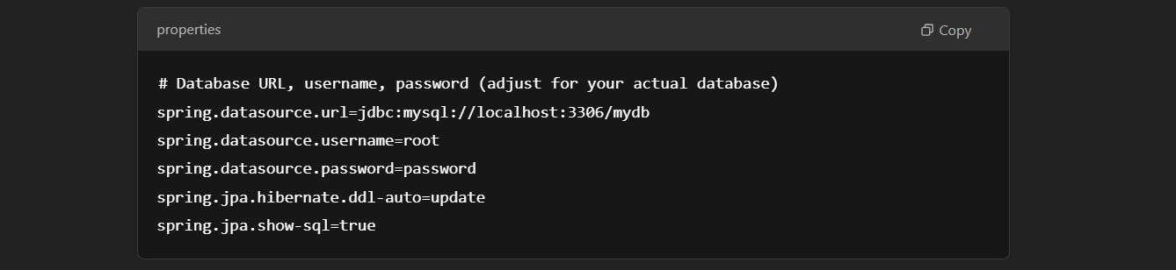

Here’s what each property does:

* **spring.datasource.url**: Specifies the JDBC URL to connect to the database.
* **spring.datasource.username**: The username for the database.
* **spring.datasource.password**: The password for the database.
* **spring.jpa.hibernate.ddl-auto = update**: Configures Hibernate’s DDL generation (e.g., update means it will update the schema based on your entity classes without dropping the schema/tables and cannot rename the tables or columns ).
* **spring.jpa.hibernate.ddl-auto = create :** Drops existing schema/tables and creates new one evrytime app restarts
* **spring.jpa.show-sql**: Prints SQL queries to the console (for debugging).

**5. How the Auto-Configuration Works:**

Here’s how Spring Boot’s **auto-configuration** works when you add spring-boot-starter-data-jpa:

1. **Spring Boot detects the JPA libraries** in the classpath (via spring-boot-starter-data-jpa).
2. It automatically creates beans for DataSource, EntityManagerFactory, and TransactionManager based on the properties you defined in the application.properties file.
3. **Spring Data JPA** is also automatically configured to manage the persistence layer, so you can simply create @Entity classes and JpaRepository interfaces to interact with the database.
4. The **DataSource** and **EntityManagerFactory** beans are used internally by Spring Boot to wire up database interactions for you.

Spring Boot uses **auto-configuration** to automatically configure application by providing the basic configuration required to run the application based on the jar dependencies available on the classpath. This eliminates the need of manually configuring Spring applications.

For example, if you are using **JDBC** in your Spring Boot application then there is no need to configure any database connection beans. As soon as Spring Boot  detects that you have JDBC library in application’s classpath it will automatically configure database connection beans.

**How It All Works Together:**

* When Spring Boot starts, it configures your **data source**, **JPA entities**, and **repositories** automatically based on the starter dependency and the properties you set.
* You can now use your JpaRepository interface to perform CRUD operations without having to configure much manually.

**Conclusion:**

To summarize, adding the spring-boot-starter-data-jpa dependency to your pom.xml brings in all the necessary libraries and configurations for JPA-based database access by build. Spring Boot detects these libraries, auto-configures them for you (including creating beans for DataSource, EntityManagerFactory, etc.), and all you need to do is configure the database connection in application.properties (or application.yml). This makes working with databases much easier and reduces the boilerplate configuration you'd normally need to do in a traditional Spring application.

There are multiple approaches for creating Spring Boot application. You can use any of the following approaches to create application:

* Using Spring Initializr
* Using the Spring Tool Suite (STS)
* Using Spring Boot CLI
* Using Spring Maven Project

The generated project contains the following files:

**1. pom.xml**

This file contains information about the project and configuration details used by Maven to build the project.

​​​​​​​**2. application.properties**

This file contains application-wide properties. Spring reads the properties defined in this file to configure your application. You can define a server’s default port, server’s context path, database URLs etc, in this file.

**3. DemoSpringBootApplication.java**

This class is by default generated by Spring Boot to bootstrap Spring application

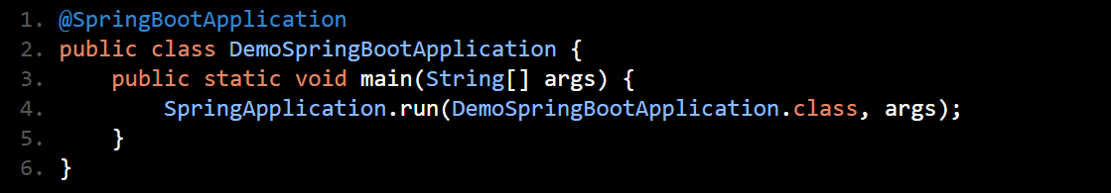

It is annotated with **@SpringBootApplication** annotation which triggers **auto-configuration and component scanning** and can be used to declare one or more @Bean methods also. It contains the main method which bootstraps the application by calling the run() method on SpringApplication class. The run method accepts DemoSpringBootApplication.class as parameter to tell Spring Boot that this is the primary component.

**@SpringBootApplication** - Combination of 3 annotations @Configuration, @EnableAutoConfiguration, @ComponentScan

**Configuration Class**: It marks your class as a configuration class (i.e., where you can define beans and configuration properties).

**@EnableAutoConfiguration -** Spring Boot automatically configures the application based on the libraries available in the classpath (e.g., database configuration, embedded web server, etc.).

**@ComponentScan** : Enables Spring’s component scanning, which tells Spring to look for other components, configurations, and services in the same package or sub-packages.

This is important because Spring Boot needs to scan your project for various Spring components such as @Component, @Service, @Repository, @Controller, etc., and register them as beans in the Spring context.

**SpringApplication.run()** is used to start the application, setting up the Spring context and triggering the auto-configuration.

**4. DemoSpringBootApplicationTest.java**

In this file test cases are written.

**Executing Spring Boot application**

To execute the Spring Boot application run the **DemoSpringBootApplication** as a standalone Java class which contains the main method. On successful execution you will get following output in console

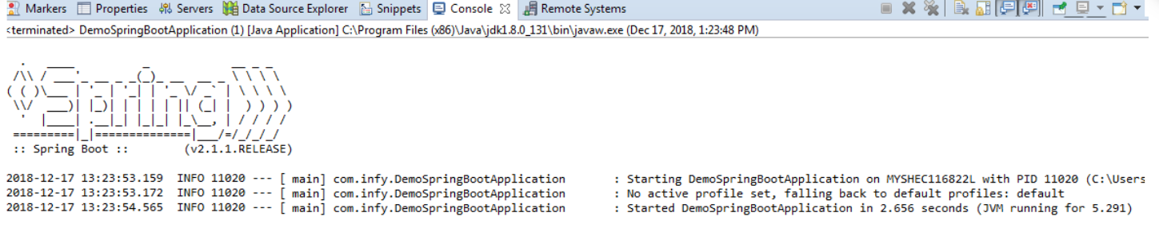

 Spring Boot provides following two interfaces:

* CommandLineRunner
* ApplicationRunner

CommandLineRunner is Spring Boot interface with a run() method. Spring Boot automatically calls this method of all beans implementing this interface after the application context has been loaded. To use this interface, you can modify the DemoSpringBootApplication class as follows:

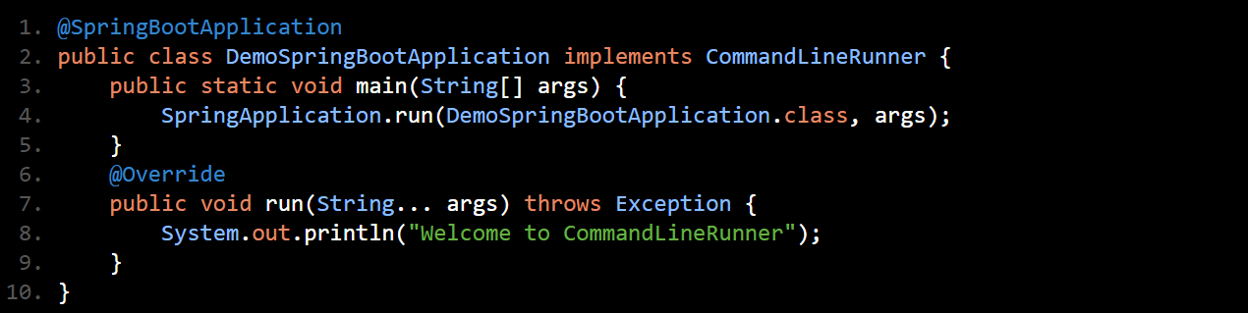

Spring Boot application is configured using a file named **application.properties**. It is auto detected without any Spring based configurations and is placed inside "**src/main/resources**" directory.

This file is used for configuring various settings and properties for your Spring Boot application, such as **database connections, server configurations, logging**, etc.

**spring.jpa.properties.hibernate.format_sql=true** - only to format the SQL queries(with proper indentation and line breaks) generated by hibernate for better readability in the logs.

**spring.jpa.database-platform=org.hibernate.dialect.H2Dialect**: Tells Hibernate to generate SQL queries compatible to the specific database(here it is H2 db)

In this file various default properties are specified to support **logging, AOP, JPA** etc. All the default properties need not to be specified in all the cases. We can specify them only on-demand. At startup, Spring application loads all the properties and adds them to the Spring**Environment**class. To use a custom property add it to the application.properties file. Then autowire the Environment class into a class where property is required and read the property from Environment using **getProperty()** method.

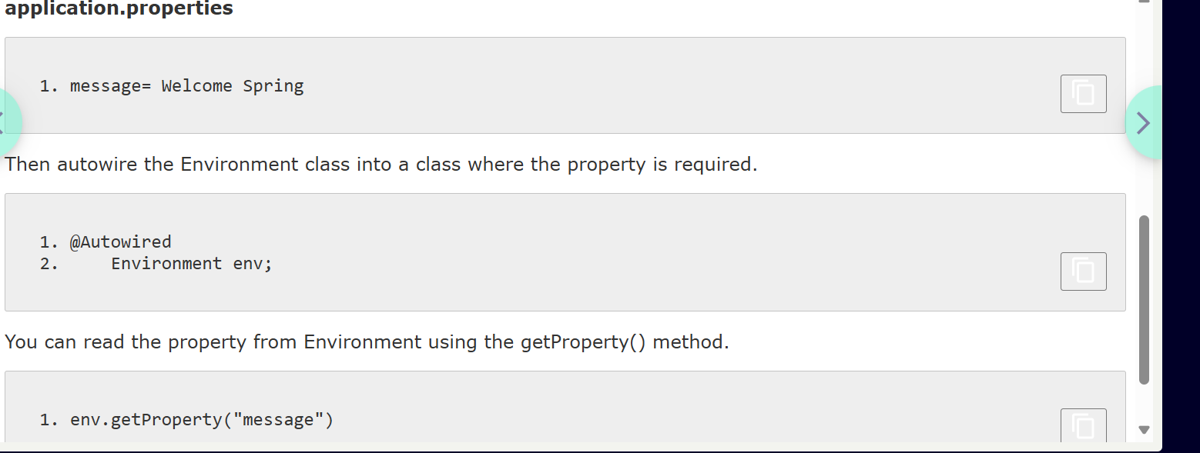

We can use other files to keep the properties. For example, InfyTelmessage.properties.

But by default Spring Boot will load only the application.properties file. So how you will load the **InfyTelmessage.properties** file?

In Spring **@PropertySource** annotation is used to read from properties file using Spring’s Environment interface. The location of the properties file is mentioned in the Spring **configuration file** using @PropertySource annotation.

So InfyTelmessage.properties which are present in classpath can be loaded using @PropertySource as follows:

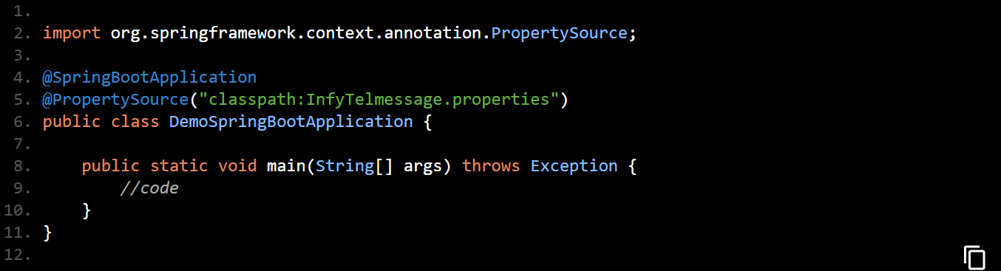

 The**@SpringBootApplication** annotation indicates that it is a configuration class and also triggers auto-configuration and component scanning. It is a combination of following annotations with their default attributes:

* **@EnableAutoConfiguration** – This annotation enables auto-configuration for Spring boot application which automatically configure our application based on the dependencies that you have added.
* **@ComponentScan** – This enables Spring bean dependency injection feature by using @Autowired annotation. All application components which are annotated with @Component, @Service, @Repository or @Controller are automatically registered as Spring Beans. These beans can be injected by using @Autowired annotation.
* **@Configuration** – This enables Java based configurations for Spring boot application.

The class that is annotated with @SpringBootApplication will be considered as the main class, is also a bootstrap class. It kicks starts the application by invoking the SpringApplication.run() method.  You need to pass the .class file name of your main class to the run() method.

**SpringBootApplication- scanBasePackages**

By default, Spring Boot scans the package containing the @SpringBootApplication class and its subpackages. If your @SpringBootApplication class resides in the "com.eta" package, it 4 4 4 will not automatically scan packages like "com.infy.service" or "com.infy.repository." To address this, you can utilize the scanBasePackages property within the @SpringBootApplication annotation.

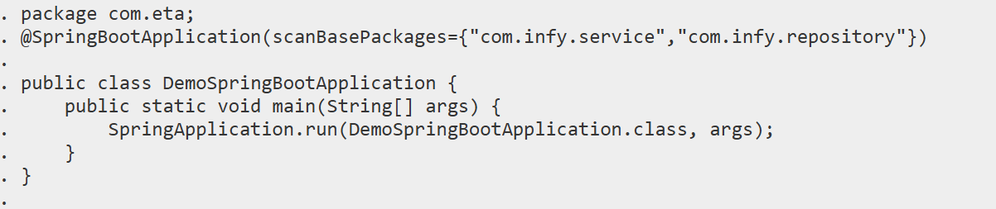

@Valid

The @Valid annotation is used in Java (often with frameworks like Spring) to trigger validation of objects based on the validation constraints you've set on their fields.

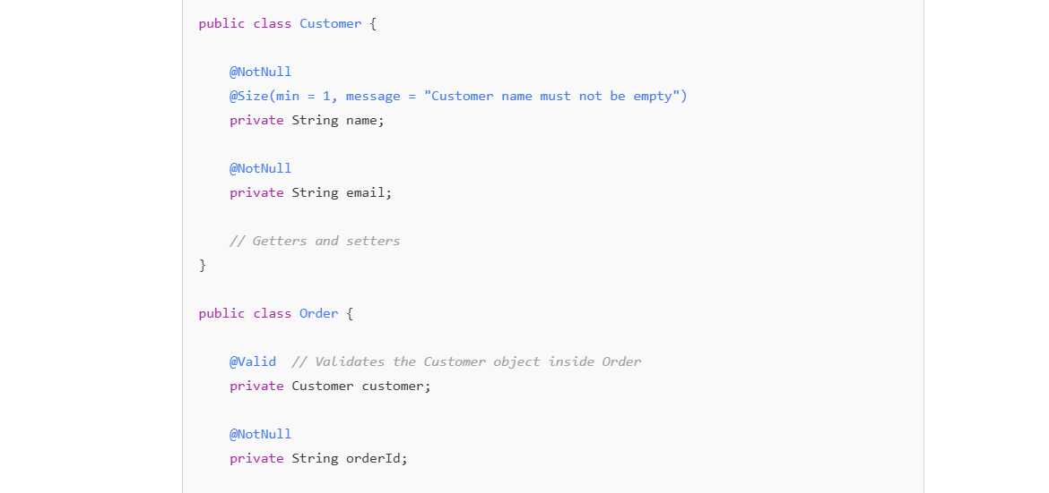

1. **Validating Method Parameters in Spring Controllers**

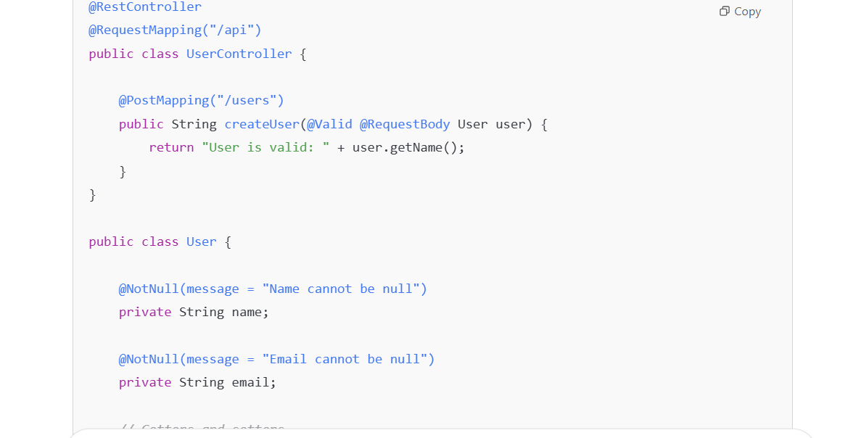

3. **Validating Method Return Value**

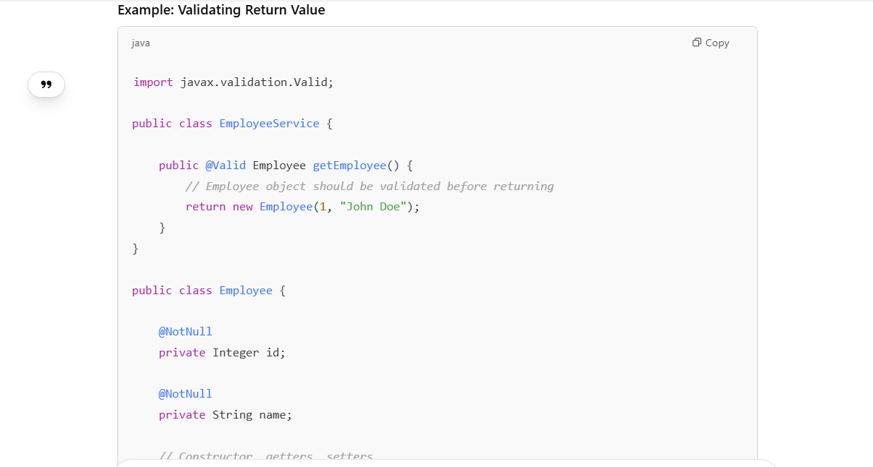

**LOGGING**:Logging in Spring Boot refers to the process of recording information, warnings, errors, and debugging messages from an application as it runs. It helps developers understand the behavior of the application, troubleshoot issues, and maintain code.

Spring Boot uses a default logging framework, which is **SLF4J (Simple Logging Facade for Java)** combined with **Logback** This allows you to easily log messages at different levels such as TRACE, DEBUG, INFO, WARN, and ERROR.

**SLF4J (Logging API)**:

* SLF4J is the **logging API** used by default in Spring Boot.
* It provides a **common interface** for logging, which can be used with different logging implementations.
* Spring Boot's use of SLF4J allows you to swap out the underlying logging framework without changing your application code (e.g., switching from Logback to Log4j2 or java.util.logging).

We can change the default logging implementation by including another library, such as **Log4j2**.

Logging levels - Spring Boot supports the following logging levels, which control the verbosity of logs:

* **ERROR**: Only error messages are logged.
* **WARN**: Warnings and errors are logged.
* **INFO**: Information, warnings, and errors are logged (default level).
* **DEBUG**: Debugging messages along with the info, warnings, and errors.
* **TRACE**: Detailed tracing messages for deep debugging.

In a typical Spring Boot application, logging can help you track:

* Errors or exceptions that happen in the system.
* Key events (e.g., when a user logs in).
* Performance bottlenecks (e.g., time taken to process a request).
* Debugging information (e.g., variable values, method calls).

**Default Behavior:**

By default, Spring Boot will log messages to the **console** and will use the **INFO** log level, which means:

The **spring-boot-starter** dependency includes **spring-boot-starter-logging** dependency, which configures logging via **Logback** to log to the console at the INFO level.

* Logs of level INFO, WARN, and ERROR will appear.
* Logs of level DEBUG and TRACE won’t appear unless you explicitly change the log level to a more detailed one.

You can also configure it to write logs to **files**, **databases**, or external systems, such as Logstash or Splunk.

Spring Boot uses Commons Logging API with default configurations for Java Util Logging, Log4j 2, and Logback implementation. Among these implementations, Logback configuration will be enabled by default.

Logging levels, Logging format, and Log file location can be easily configured according to the requirement in “**application.properties**” file.

**Custom log level**

Logging levels can easily be configured just by setting up the following property in application.properties file.

logging.level.com.infy=INFO

logging.level.root=WARN

logging.level.com.infosys.ars=ERROR

**Configuring logging pattern**

You can change the logging pattern for console by setting logging.pattern.console property in application.properties file.

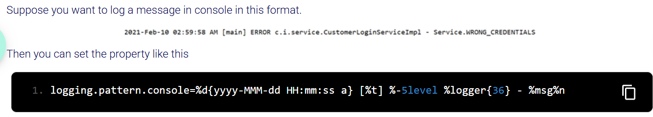

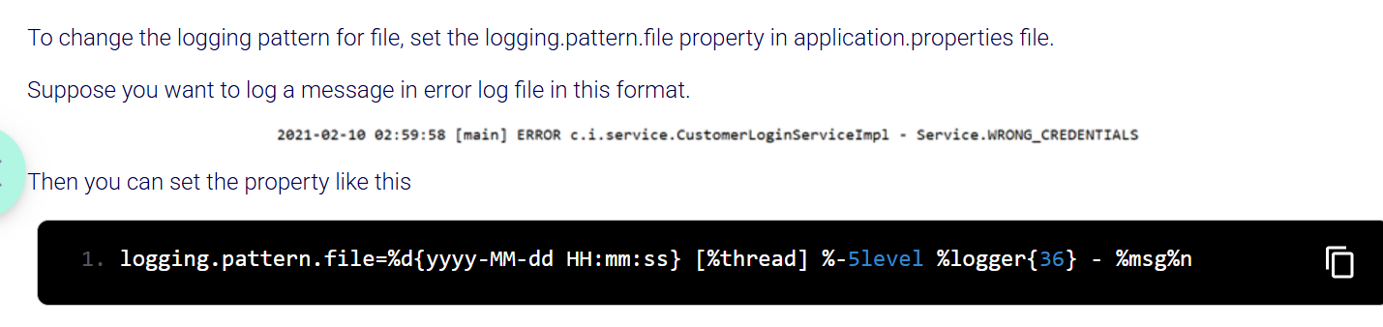

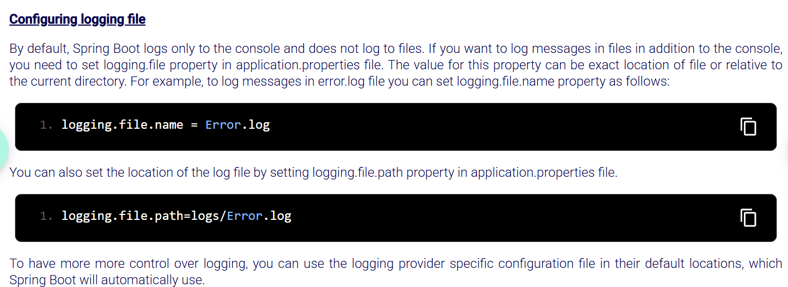

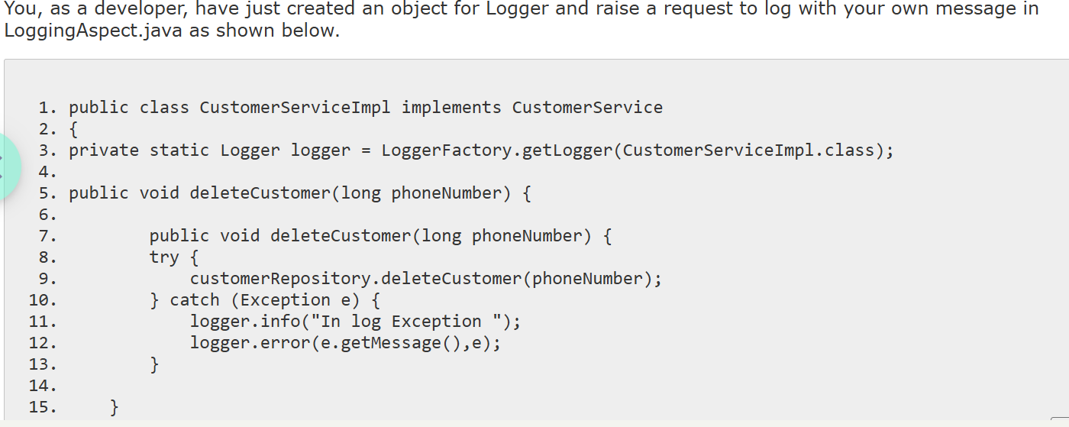

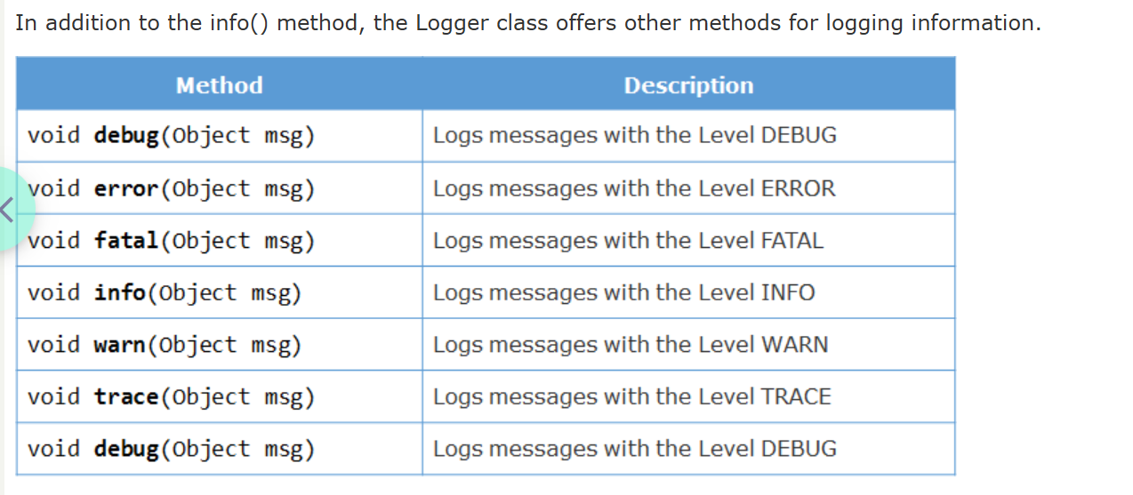



**2025-03-30 17:45:53.502** – Date and Time

**INFO** – Log level

**25820** – process id

**---** Separator

**[main]** – thread name

**com.infy.AbcToTraineeApplication** – Logger name

**Starting AbcToTraineeApplication** – Log message

Can change this default configuration if you want to,

* log the message in a file rather than console
* log the message in your own pattern
* log the messages of a specific level
* use Log4j instead of Logback

**Log4j instead of Logback**

Spring Boot defaults to using Logback for logging. To replace Logback with Log4j 2, you must exclude Logback and include Log4j 2 as a dependency in the pom.xml file.

1. <dependency>
2. <groupId>org.springframework.boot</groupId>
3. <artifactId>spring-boot-starter</artifactId>
4. <exclusions>
5. <exclusion>
6. <groupId>org.springframework.boot</groupId>
7. <artifactId>spring-boot-starter-logging</artifactId>
8. </exclusion>
9. </exclusions>
10. </dependency>
11. <dependency>
12. <groupId>org.springframework.boot</groupId>
13. <artifactId>spring-boot-starter-log4j2</artifactId>
14. </dependency>

**1. Structured Logging vs. Simple Output**

* **System.out.println(e.getMessage())** prints the message to the console as plain text, and it doesn't offer any structure for better debugging or analysis.
* **logger.error(e.getMessage(), e)** provides more structured logging. This line uses SLF4J (or any other logging framework) to log the error, along with the exception stack trace. This is far more useful in production because:
  + The log includes the **exception message** (e.getMessage()).
  + It also includes the **stack trace** (e), which provides detailed information about where the error occurred in the code.

**logger.error(e.getMessage(), e)** gives you structured, detailed, and manageable logs, including exception stack traces, which are incredibly useful for debugging, error tracking, and production monitoring.

**1.** Log LOGGER = LogFactory.getLog(this.getClass()); **(Apache Commons Logging)**

This line uses **Apache Commons Logging** (ACL) to log messages. Here’s what’s happening:

**Components:**

* **LogFactory.getLog(this.getClass())**:
  + LogFactory is a class from the Apache Commons Logging library. It provides a way to create a logger object.
  + this.getClass() dynamically gets the current class, so the logger will be associated with the class in which this line is used.
  + Log is an interface provided by Apache Commons Logging, which allows you to log messages at various levels (INFO, DEBUG, ERROR, etc.).

**How it works:**

* Apache Commons Logging is a **logging facade**, meaning it doesn’t implement logging by itself but delegates to an underlying logging framework such as **Log4j**, **Logback**, or **JDK Logging**.
* When you use **Apache Commons Logging**, the actual logging behavior depends on which backend logging framework is configured to be used (e.g., Log4j or Logback).

**Example:**

Log LOGGER = LogFactory.getLog(this.getClass());

LOGGER.info("This is an info message.");

* This will use whatever logging framework is configured in the project to output the message.
* You can switch between different logging implementations (Logback, Log4j, etc.) without changing the application code, as long as they support the Apache Commons Logging interface.

**2.**

private static Logger logger = LoggerFactory.getLogger(AbcToTraineeApplication.class); **(SLF4J + Logback or other implementations)**

This line uses **SLF4J** (Simple Logging Facade for Java) with a **specific implementation** of the logging backend (such as **Logback** or **Log4j2**).

**Components:**

* **LoggerFactory.getLogger(AbcToTraineeApplication.class)**:
  + LoggerFactory is a utility class provided by SLF4J (Simple Logging Facade for Java).
  + getLogger(AbcToTraineeApplication.class) is used to create a logger for the AbcToTraineeApplication class.
  + SLF4J provides an abstraction layer for logging, similar to Apache Commons Logging but is more modern and widely used in the Java ecosystem.

**How it works:**

* **SLF4J** is a logging facade, just like Apache Commons Logging, but it is **more commonly used** and **better integrated** with modern logging frameworks like **Logback** or **Log4j2**.
* In this case, SLF4J is used for logging, and **Logback** is typically the default backend logging implementation, but you can switch to other logging frameworks like **Log4j2** if needed.

**Example:**

private static final Logger logger = LoggerFactory.getLogger(AbcToTraineeApplication.class);

logger.info("This is an info message.");

* This uses SLF4J's API to log the message, and the actual logging will be handled by the logging backend (often Logback, but it can be other frameworks).
* The benefit of SLF4J is that it is simpler, cleaner, and more robust compared to Apache Commons Logging.

**Apache Commons Logging** is an older logging abstraction framework that allows flexibility by using different logging frameworks but is less commonly used today.

**SLF4J** is the modern logging abstraction layer, and it’s typically paired with **Logback** or **Log4j2** as the logging backend. It is more efficient and widely used in modern Java applications.

In most cases, **SLF4J** with **Logback** is the preferred choice today, as it's the default logging system for **Spring Boot** and widely used in the Java ecosystem for its performance, simplicity, and flexibility.

To log the **stack trace** and **line number** where an exception occurs, always pass the exception object as the second parameter to logger.error().This will give you the necessary context (like class name, method, and line number) and the stack trace.

For simple log messages, you only get the message and the date/time. To get the stack trace and location of where things fail, the exception object is needed.

Eg: try {

// Some logic that might throw an exception

throw new IllegalArgumentException("Invalid Employee ID");

} catch (Exception e) {

*logger*.error(environment.getProperty("Validator.INVALID_EMPLOYEEID"), e); // Logs the message and the exception's stack trace

*logger*.error(environment.getProperty("SUCCESS")); //Logs just the message but no stack trace like lineno. Or method

}

**With Log4j2 -** To log information, you first need to get a logger object. This logger object is obtained by invoking getLogger() method of the **org.apache.logging.log4j.LogManager** class**.**

private static final Logger LOGGER = LogManager.getLogger(DemoSpringBootLog4jApplication.class);

Excluding Logback and adding spring-boot-starter-log4j2 will switch your logging framework to **Log4j2** in Spring Boot, and **it will work without a custom log4j2.xml file**. You'll just get the default behavior that Log4j2 provides. If you need more control or customization later, you can create a log4j2.xml file.

**LogManager.getLogger()** is specific to **Log4j2** and will lock you into Log4j2 for logging. It directly creates a logger instance using Log4j2.

**LoggerFactory.getLogger()** is an SLF4J method that provides a generic logger, which can be backed by any logging framework, such as Logback, Log4j2, or others.

LoggerFactory.getLogger() allows you to easily switch between different logging frameworks (Logback, Log4j2, etc.) without changing your code.

• **Apache Commons Logging is not the default logging framework** in Spring Boot. **SLF4J** is the default logging facade, and **Logback** is the default logging implementation.

• If you want to use **Apache Commons Logging**, you would need to manually add it as a dependency, but it is **not the default**.

• If you're using **Spring Boot**, the default logging setup is **SLF4J with Logback**.

If you see **log4j-api** in the classpath but didn’t explicitly add it to your pom.xml, it’s likely coming from a **transitive dependency**. You can use mvn dependency:tree to trace which dependency is bringing it in or check in classpath. To properly use **Log4j2**, ensure you add the **Log4j2 core** (log4j-core) and possibly exclude **Logback** (default in Spring Boot) if you intend to use **Log4j2** exclusively. Also, ensure that your log4j2.xml or other configuration file is present in src/main/resources for proper setup.

**SPRING DATA ACCESS LAYER**

**Traditional(Plain) JDBC (Java Database Connectivity):**

* A Java API for connecting and executing queries with a database.
* Requires developers to write a lot of boilerplate code for database operations.
* Prone to errors due to manual handling of connections, statements, and result sets.
* Lacks object-relational mapping capabilities.

**Spring JDBC –** Oldest database framework introduced and used by spring which was built on top of plain JDBC to simplify database access and solved many problems posed by plain JDBC. It’s a layer of abstraction on top of JDBC.

* It gives jdbctemplate which makes jdbc easy to use.
* It handles opening and closing of DB connections.
* Provides better exception handling and resource management.
* Still requires manual mapping between Java objects and database tables.
* Provides overloaded methods to run sql queries like

update()

query() – runs select queries to return multiple rows in results

queryForObject() – runs select queries to return single row of results.

Spring JDBC simplifies JDBC but has limitations for complex applications, leading developers to switch to ORM solutions. Spring ORM addresses these limitations, offering a bridge to technologies like Hibernate, while Spring Data JPA further simplifies repository implementations by leveraging ORM specifications internally.

**ORM** – It is a technique that allows developers to map java objects to database tables so that object model can be translated to relational model and viceversa.

It abstracts the database interactions and lets developers interact with the database using object-oriented concepts instead of SQL.

It converts data between incompatible type systems in object-oriented programming languages and relational databases. Some of the key features of ORM are:

* It is a solution to all object-relational impedance mismatches and simplifies db operations in object oriented way.
* NO need of manual sqlqueries.
* It is database independent.
* All database vendors provide ORM support.
* Supports HQL and JPQL query approaches.

Several frameworks **implement ORM**, which means they provide the tools, infrastructure, and features to perform object-relational mapping efficiently. These frameworks follow the principles of ORM and make it easier for developers to map Java objects to database tables.

Examples of ORM Frameworks : Hibernate, EclipseLink, MyBatis, Spring Data JPA

**Hibernate** is a JPA implementation and an ORM framework that provides low-level control over database operations.

**Spring Data JPA** is considered a **framework** but not an ORM Framework, but more specifically, it is a **data access framework** built on top of JPA that simplifies working with **JPA** (Java Persistence API) and provides an abstraction layer over the JPA implementation (like **Hibernate**).

**JPA**

It is used to implement or use ORM in java applications. Spring provides API’s to integrate with ORM frameworks like **Hibernate** , Mybatis, Oracle toplink.

JPA – It is a specification that defines a standard rules and guidelines for how Java objects should be mapped to relational database tables and how data should be managed in the persistence layer using ORM framework.

It doesn’t provide implementation. It provides a way to map java objects to relational database. The actual implementation of JPA is provided by ORM framework called **Hibernate**.

JPA provides a **set of interfaces**, **annotations**, and **guidelines**, defining how persistence-related tasks are handled across different frameworks. But to use these features, you need a **JPA implementation** (such as **Hibernate** or **EclipseLink or OpenJPA**) to handle the actual logic(carry out the operations) like saving, updating, and retrieving entities from the database.

**JPA = Rules**;

**Hibernate (or other ORM libraries)** **=** **Implementation**.

**Key Features of JPA:**

* **Standardization:**It defines a standard interface for ORM implementations and also ensures consistency across different ORM frameworks.
* **Object-Relational Mapping:** It facilitates the mapping between Java objects and relational database tables and also manages the persistence of Java objects to database records.
* **Entity Management:**It introduces the concept of entities (Java objects that represent database records) and also provides mechanisms for CRUD (Create, Read, Update, Delete) operations on entities.
* **Query Language:** It defines JPQL (Java Persistence Query Language), a platform-independent query language and also allows for object-oriented querying of entities stored in a relational database.
* **Relationship Handling:** It provides annotations for defining and managing relationships between entities (e.g., @OneToMany, @ManyToOne).
* **Transaction Management:** It offers support for managing database transactions.

**Spring ORM** is a module that integrates various ORM frameworks (e.g., Hibernate, JPA, MyBatis) with Spring applications. It doesn't implement its own ORM solution but serves as an integration layer, providing comprehensive support for these persistence frameworks.

Spring ORM can be used **without JPA** as well just use hibernate directly for db interaction using hibernate session’s API.

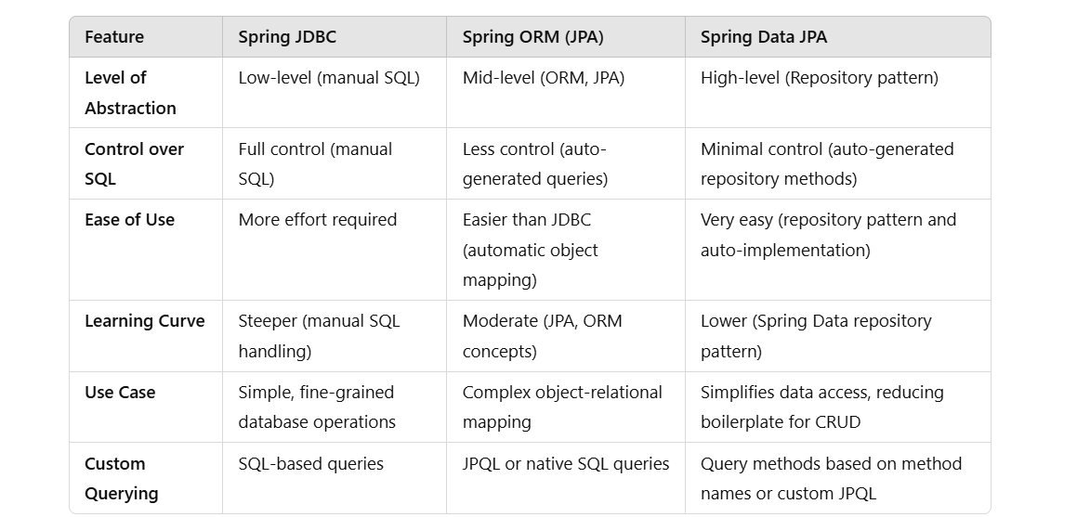

**Spring ORM with Spring Boot**

**you’ll need the following dependencies:**

* **Spring Boot Starter Web:** Only needed if you're building a web app or exposing REST APIs.
* **Spring Boot Starter ORM:** For JPA/Hibernate support.
* **Hibernate**: For JPA support (which is the default JPA provider in Spring ORM).
* **Database Driver:** For your specific database (e.g., MySQL, PostgreSQL, H2, etc.).

**Spring ORM Configuration:** You have to manually configure the EntityManager and TransactionManager beans in the configuration class by having @Bean (no Spring Data JPA auto-configuration) but **Spring Boot** will still handle the **DataSource** configuration automatically based on your application.properties or application.yml.

**Entity Class**

You can create your entity class like usual, with JPA annotations (@Entity, @Table, etc.):

**No Repositories** : You would need to manually handle the data access layer with the EntityManager. Unlike **Spring Data JPA**, where repositories are auto-generated, with **Spring ORM**, you will write your own CRUD operations using EntityManager where we inject it using @Autowired in the repository class to perform db operations like

• **entityManager.persist()**: Saves an entity to the database.

• **entityManager.find()**: Retrieves an entity by its ID.

• **entityManager.remove()**: Deletes an entity.

**Yes**, **Spring Data JPA** can be used with **traditional Spring** applications, and it works similarly to how it's used in Spring Boot. The main difference is the **configuration** — in traditional Spring, you manually configure all the components (like EntityManager, TransactionManager, and DataSource), while in Spring Boot, these configurations are handled automatically through **auto-configuration**.

**Spring Data JPA**

* **Abstraction Level**: Highest-level
* **Description**: Spring Data JPA is a part of the larger Spring Data project and provides a higher level of abstraction over JPA. It makes it easier to implement data access layers by reducing boilerplate code. With Spring Data JPA, you can create repository interfaces for CRUD (Create, Read, Update, Delete) operations without writing any SQL queries or even needing to write custom methods.
* **Usage**: You define interfaces for your repositories, and Spring Data JPA automatically generates the implementation at runtime. It also provides built-in support for more complex queries using method names or custom JPQL (Java Persistence Query Language) queries.
* **Pros**:
  + No need to write boilerplate code for CRUD operations.
  + Repository interfaces abstract the data access layer.
  + Makes it easy to integrate with other parts of the Spring ecosystem.
* **Cons**:
  + While it reduces boilerplate, it also adds another layer of abstraction that can make it harder to debug if things go wrong.
  + Some performance concerns for very complex queries or when needing custom SQL.

**********************************************************************************

EntityClasses *–* The classes which are mapped to table and whose instances are the rows in the db table are entity classes.

JPA provides annotations to create entity classes which are present in java are:

**@*Entity***

**@*Id*** – Every object of class must have attribute which uniquely identifies it. This is primary key attribute. It maps to the primary key column of db.

By default entity class is mapped to the table having the name same as entity class name but if entity class has to be mapped to the table having diff name from entity class name then **@*Table*** annotation is used.

If attribute name is diff from column name in db can use **@Column** attribute.

***@Transient*** - Marks a field that should **not** be persisted in the database (i.e., it won’t be mapped to any column in the database). This is useful when you need a field in your entity class that you don’t want to store in the database, such as calculated or transient data that should not be part of the database schema.

**Relationship :**

@OneToOne

@OneToMany

@ManyToOne

@ManyToMany

***@GeneratedValue*** – is used to **automatically generate the value of a primary key field** for an entity class.

The strategy element in @GeneratedValue specifies how the primary key value is generated.

It is used in conjunction with the @Id annotation, which marks the field as a **primary key**. Here **id** is a primary key.

@Id

@GeneratedValue(strategy = GenerationType.AUTO)

private Long **id**;

**GenerationType strategies:**

**AUTO (default)**  
JPA chooses the strategy — it may use sequence or identity or table based on DB.

@GeneratedValue(strategy = GenerationType.AUTO)

**IDENTITY**  
Relies on the database to auto-increment the ID.

@GeneratedValue(strategy = GenerationType.IDENTITY)

//Database generates the ID when the record is inserted (e.g., AUTO_INCREMENT in MySQL).

**SEQUENCE**  
Uses a database sequence object (best for Oracle, PostgreSQL).

@GeneratedValue(strategy = GenerationType.SEQUENCE)

**TABLE**  
Uses a separate table to generate primary key values (less common).

@GeneratedValue(strategy = GenerationType.TABLE)

**@OneToOne –** Has one-one relationship between two entities.

Lets say Employee and Address are two entities then we can think of each Employee has one address.

For that

***@Enumerated*** - used to specify how an enum type should be persisted in the database.

By default, Java enums are **stored as their ordinal values** (i.e., the integer value corresponding to the enum's position in its declaration).

**EnumType.ORDINAL (Default behavior)**:

For example, if you have an enum with values RED, GREEN, BLUE (where RED is at position 0, GREEN is at position 1, and BLUE is at position 2), the values will be stored as 0, 1, and 2 in the database.

**EnumType.STRING**:

* The enum is stored as its **name** (the string representation of the enum constant).
* For example, RED, GREEN, and BLUE will be stored as 'RED', 'GREEN', and 'BLUE' in the database.

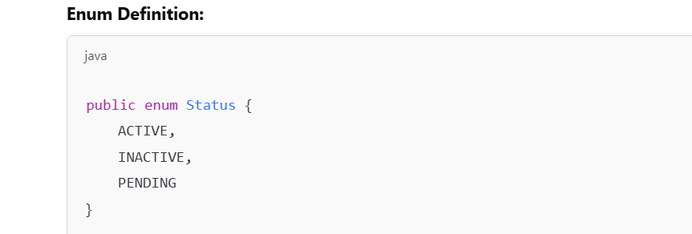

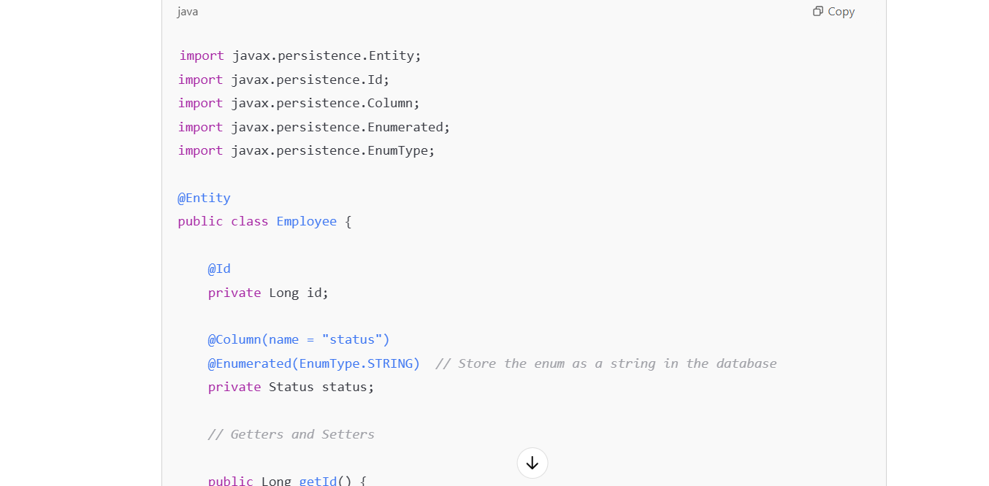

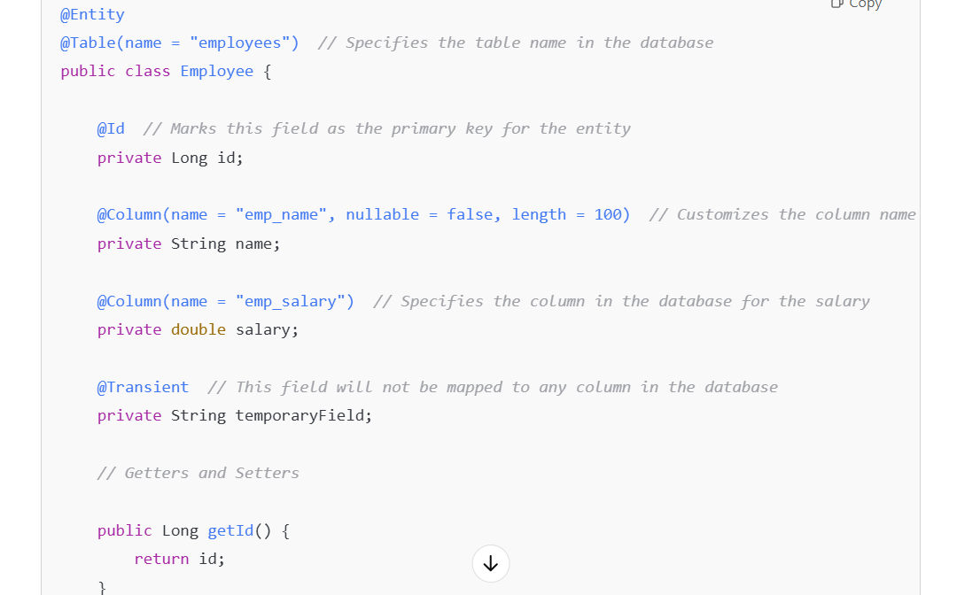

For managing and working with entities in JPA we need Entity Manager and Persistence Context:

* **EntityManager:**
  + Interface used to interact with the persistence context.
  + Managed by the EntityManagerFactory.
* **Persistence Context:**
  + Set of managed entity instances that exist in a specific data store.

**SPRING DATA:**

While accessing data using JDBC or ORM Solution in the applications, we face a lot of challenges i.e.,

* Code redundancy
* Difficulty in handling exceptions

With Spring Orm solutions using JPA , for every entity class the repository class and its implementation class needs to be created which would create so much classes and repetitive code in enterprise apps to perform basic crud operations.

To reduce it Spring Data is introduced.

Spring Data simplifies the data access layer by removing the repository or data access object implementations entirely from the application. Only interface is explicitly defined by developer.

We just create an interface like this and spring data automatically generates implementation class at runtime. Provides default implementation of methods of the CrudRepository interface for entity classes.

public CustomRepository extends CrudRepository<Customer, Integer>

With help of Spring Data we can easily create database queries just by giving method names.

Makes transactions easy by allowing developers to implement transactions via annotations and configurations.

**Pagination** in Spring Data is a method used to divide large datasets into smaller, more manageable chunks or pages. This method benefits effectively in retrieving and showing data without much time being consumed. In pagination, all the records are not fetched at same time, rather a subset of records is fetched first and then the next subset of records in fetched if required and so on. This subset of records is called as Page. Every page has two fields – the **page number** and **page size**. The page number represents the individual subset of records and page size represents the number of records in a page.

Supports both relational and non relational dbs.

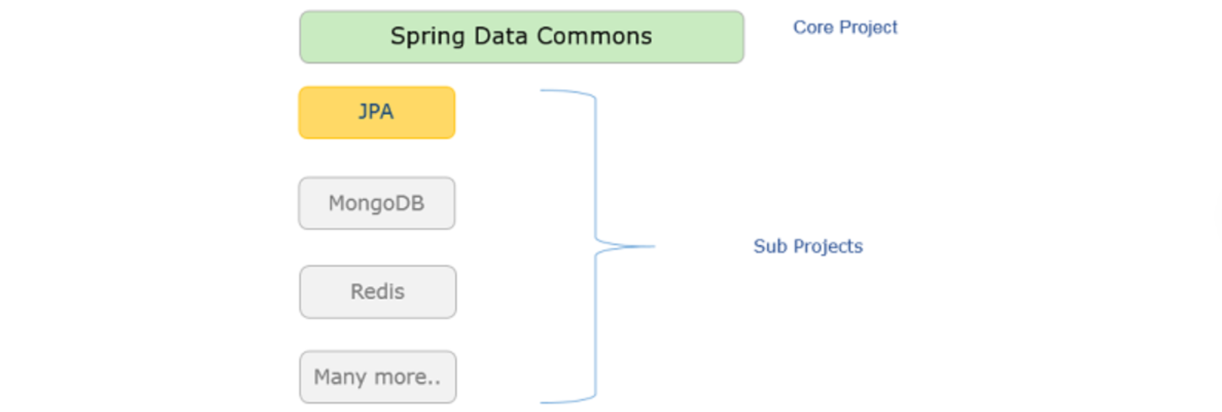

**Core Project** provides concepts applicable to all Spring Data projects. It contains **Spring Data Commons**. It contains interfaces which are technology independent and supports commonly used database operations

SpringData provides various modules that allow integration with different types of databases and data sources like **Spring Data JPA(**for relational db), **Spring Data MongoDB**, **Spring Data Redis**, **Spring Data JDBC**

Spring Data provides the flexibility to choose the correct module for the type of data store you are working with.

* **Hibernate/JPA**: These are commonly used for relational databases, where data is stored in tables, and Spring Data provides support for ORM-based interaction using JPA and Hibernate.
* **MongoDB**: Spring Data MongoDB is for interacting with **MongoDB**, a NoSQL database.
* **Other technologies**: Spring Data also supports other data sources, such as **Cassandra**, **Elasticsearch**, **Redis**, etc.

The repositories provided by spring data are i**nterfaces**, which can be used by the developers to interact with the database. These repositories provide us with several methods, making coding easy and hassle free.

The two main repositories which aid in performing CRUD operations are :

Repository, CrudRepository.

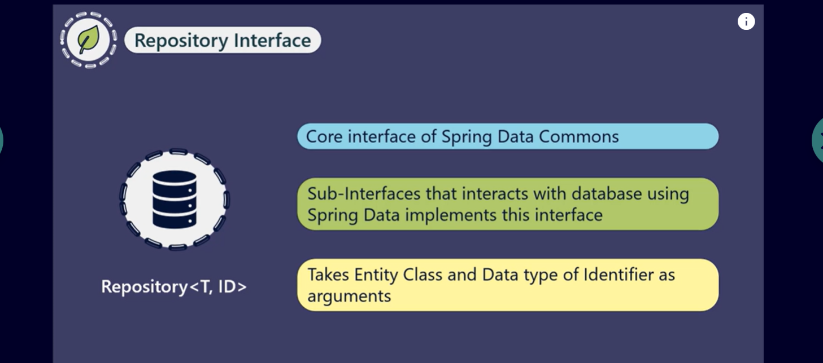

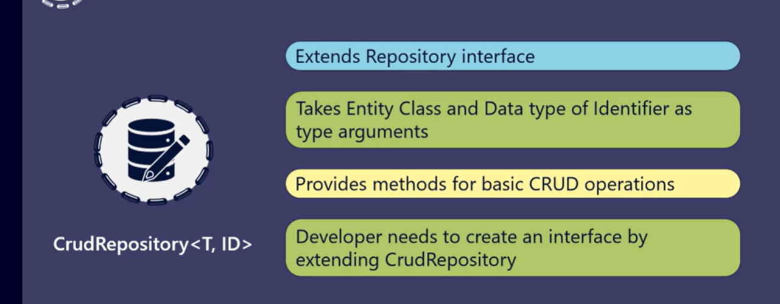

No need to create an implementation class as it is automatically generated at runtime to perform database operations.

We can use @**Repository** annotation at the user-defined interface as the Spring provides repository implementation of this interface. However, it is optional to mention the annotation explicitly because Spring auto-detects this interface as a Repository.

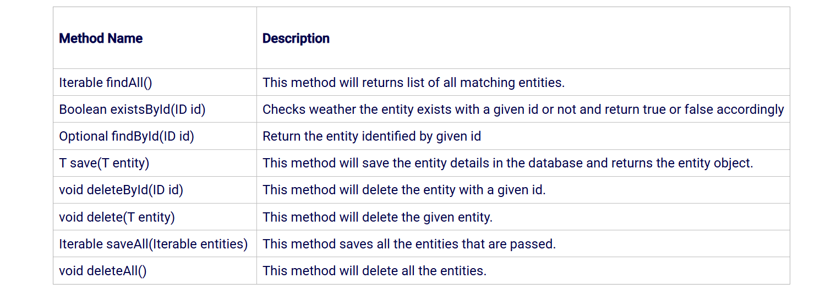

**Methods provided by repositories :**

**Itrerable findAll()** returns the list of entities

Eg: public List<Customer> findAll();

**Optional findById(ID id)** – returns the entity identified by the given id.

Eg: public Optional findById(Long phoneNo);

**Boolean existById(ID id)** - returns true or false based on whether an entity with the given id exists or not.

Eg: public Boolean existsById(Long phoneNo);

**T save (T entity)** – Persists the given entity

public Customer save(Customer customer);

**Iterable saveAll(Iterable entities)** – saves all the entities passed

Public List<Customer> saveAll(List<Customer> list);

**void deleteById(ID id)** – Deletes the entity corresponding to the id provided.

Public void deleteById(Long phoneNo);

**Void deleteAll()** – Deletes all the entities

Public void deleteAll();

**spring.jpa.database-platform=org.hibernate.dialect.H2Dialect**:: This specifies that you're using the **H2 database**. Hibernate uses a specific dialect for each database to properly translate its own internal queries (HQL) to SQL that the target database understands. For example:

* + For MySQL, you'd use org.hibernate.dialect.MySQLDialect.
  + For PostgreSQL, you'd use org.hibernate.dialect.PostgreSQLDialect.
  + For Oracle, you'd use org.hibernate.dialect.Oracle12cDialect.

In this case, you're using H2, so you specify H2Dialect to ensure that Hibernate generates queries compatible with the H2 database.

• **spring.jpa.hibernate.ddl-auto=update**: Automatically updates the schema in the database to match the Java entities without deleting any data.

**QUERY METHODS:**

The methods provided by CrudRepository operate on primary key attribute. To fetch the details of customer based on a non-primary key attribute  we need to generate queries using different approaches.

Spring Data provides three different approaches:

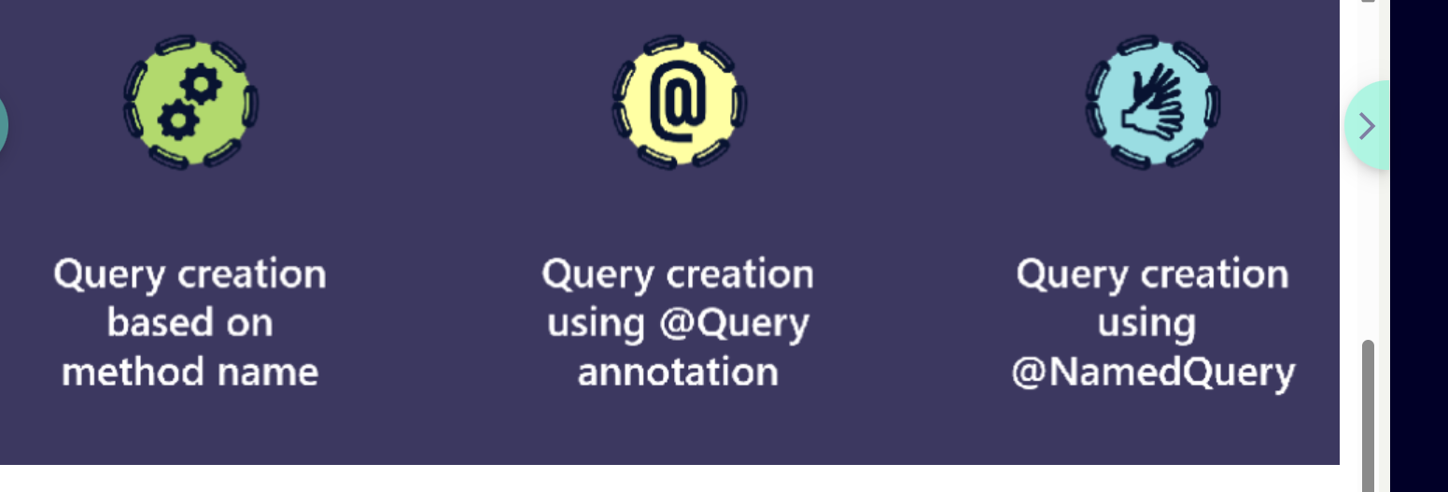

In this approach, we add methods in the interface which extends CrudRepository to implement custom requirements and Spring Data can automatically generate the appropriate JPQL (Java Persistence Query Language) queries based on the name of methods and thereby eliminating the need for manual query writing. These methods are called as ***query methods*** and are named according to some specific rules.

Some basic rules for naming these methods are as follows:

1. The method name should start with a predefined set of keywords, such as "find...By", "get...By", "read...By", "count..By" or "query...By" followed by search criteria. The search criteria are specified using attribute name of entity class and some specified keywords.

For example, to search customer based on emailId, the following query method has to be added to repository interface:

* 1. Customer findByEmailId(String emailId);

When this method is called, it will be translated to the following JPQL query:

* 1. Select c from Customer c where c.emailId = ?1

The number of parameters in query method must be equal to number of search conditions and they must be specified in the same order as mentioned in search conditions.

1. To fetch data based on more than one condition, you can concatenate entity attribute names using "And" and "Or" keywords to specify search criteria.

For example, to search customers based on email address or name, the following method has to be added to repository interface:

* 1. List<Customer> findByEmailIdOrName(String emailId, String name);

When the above method is called, it will be translated to following JPQL query:

* 1. Select c from Customer c where c.emailId = ?1 or c.name=?2

1. Some other keywords that can be used inside query method names are Between, Is, Equals, Not, IsNot, IsNull, IsNotNull, LessThan, LessThanEqual, GreaterThan, GreaterThanEqual, After, Before, Like, etc.
2. To sort the results by a specified column, you can use "OrderBy" keyword in the method name. By default, results are arranged in ascending order.

For example, the following method searches customers by name and also orders the result in ascending order of date of birth:

* 1. List<Customer> findByNameOrderByDateOfBirth(String name);

For sorting the results in descending order you can use "Desc" keyword after the property name as follows:

* 1. List<Customer> findByNameOrderByDateOfBirthDesc(String name);

1. To limit the number of results returned by a method, you can add "First" or "Top" keyword before the first 'By' keyword. To fetch more than one result, you can add a numeric value to the "First" and the "Top" keywords.

For example, the following methods returns the first 5 customers whose emailId is given as method parameter:

* 1. List<Customer> findFirst5ByEmailId(String emailId);
  2. List<Customer> findTop5ByByEmailId(String emailId);

These are some of the rules used by Spring Data to automatically generate the appropriate query based on the method name.

**Common Query Method Patterns**

**1. Find by single field (Equals)**

List<User> findByLastName(String lastName);

This query generates:

SELECT * FROM User WHERE last_name = ?;

**2. Find by multiple fields (AND)**

List<User> findByFirstNameAndLastName(String firstName, String lastName);

This query generates:

SELECT * FROM User WHERE first_name = ? AND last_name = ?;

**3. Find with GreaterThan / LessThan (Comparison)**

List<User> findByAgeGreaterThan(int age);

List<User> findByAgeLessThan(int age);

These queries generate:

SELECT * FROM User WHERE age > ?;

SELECT * FROM User WHERE age < ?;

**4. Find with Like (Pattern matching)**

List<User> findByFirstNameLike(String firstName);

This query generates:

SELECT * FROM User WHERE first_name LIKE ?;

If you pass "%John%" to the method, it will search for any firstName containing John.

**5. Find with Not (Negation)**

List<User> findByAgeNot(int age);

This query generates:

SELECT * FROM User WHERE age != ?;

**6. Find with Between (Range)**

List<User> findByAgeBetween(int startAge, int endAge);

This query generates:

SELECT * FROM User WHERE age BETWEEN ? AND ?;

**7. Find with OrderBy (Sorting)**

List<User> findByLastNameOrderByFirstNameAsc(String lastName);

This query generates:

SELECT * FROM User WHERE last_name = ? ORDER BY first_name ASC;

For descending order:

List<User> findByLastNameOrderByFirstNameDesc(String lastName);

**8. Find with In (Multiple values)**

List<User> findByAgeIn(List<Integer> ages);

This query generates:

SELECT * FROM User WHERE age IN (?, ?, ?, ...);

**9. Find with Exists (Check if a record exists)**

boolean existsByEmail(String email);

This query generates:

SELECT 1 FROM User WHERE email = ? LIMIT 1;

**10. Count Query**

long countByLastName(String lastName);

This query generates:

SELECT COUNT(*) FROM User WHERE last_name = ?;

**Combining Multiple Conditions (AND/OR)**

You can combine conditions using And and Or:

List<User> findByFirstNameAndLastNameOrAge(String firstName, String lastName, int age);

This query generates:

SELECT * FROM User WHERE first_name = ? AND last_name = ? OR age = ?;

**Special Keywords for Query Methods**

* **And**: Combine conditions (e.g., findByFirstNameAndLastName).
* **Or**: Combine conditions with an OR logic (e.g., findByFirstNameOrLastName).
* **Not**: Negate a condition (e.g., findByAgeNot).
* **Between**: Filter by a range of values (e.g., findByAgeBetween).
* **Like**: Use SQL LIKE for pattern matching (e.g., findByFirstNameLike).
* **IsNull/IsNotNull**: Check for null values (e.g., findByLastNameIsNull).

**Custom queries using Annotation**

**@Query –>**

Spring Data provides an option to write the custom queries, whether JPQL or native SQL directly on repository methods using @Query.

You can write complex queries that Spring Data JPA can't automatically derive, including SELECT, UPDATE, DELETE, and INSERT.

For modifying operations (like UPDATE, DELETE), **@Modifying** *must* be used in conjunction with **@Query** along with **@Transactional**.

For a simple SELECT query, **@Transactional** is typically not required, but it won't hurt if you want to ensure the operation happens within a transaction:

**Positional Parameters** (?1, ?2) and **Named Parameters** (:paramName) are both supported.

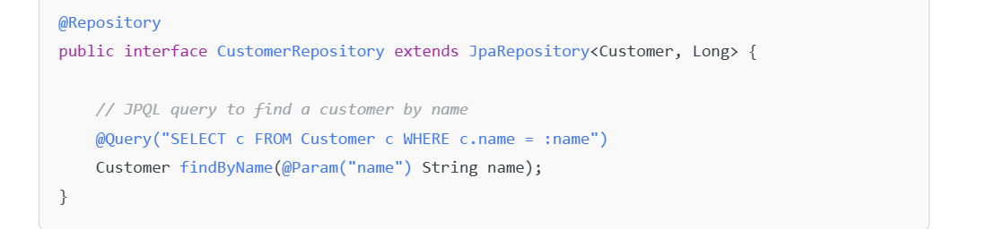

Here, the query finds a Customer entity based on the name field. The **@Param** annotation binds the method parameter to the named parameter in the JPQL query (:name).

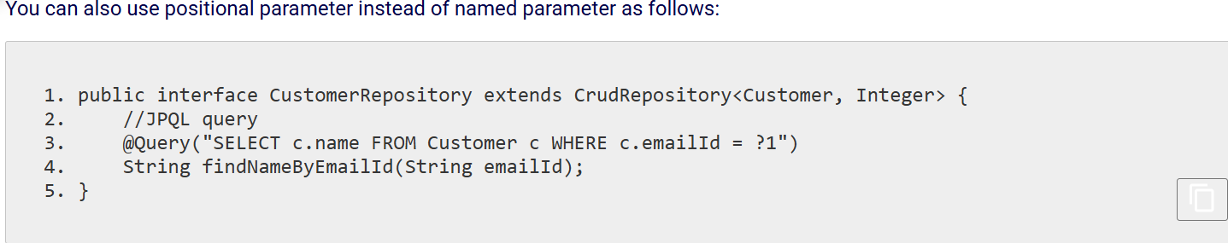

The **default behavior of @Query is to use JPQL,** which is an object-oriented query language. JPQL queries are similar to SQL but operate on entities and their fields instead of database tables and columns.

**@Modifying** 🡪

annotation in Spring Data JPA is used on method to indicate that a query will modify the database (i.e., it performs an **update**, **insert**, or **delete** operation). This annotation is typically used in conjunction with **@Query** to perform custom queries that alter the state of the database.

Without the @Modifying annotation, Spring Data will assume the query is a read-only query and will not correctly execute the data modification operation.

**Requires @Transactional**: Since modifying queries alter the state of the database, you typically need to make the method transactional to ensure that the operation is committed or rolled back based on success or failure.

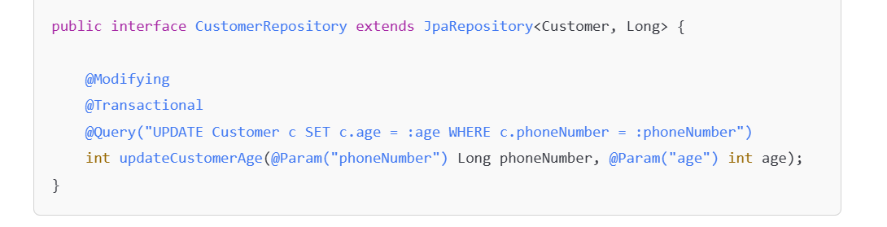

**@Transactional - >**

is used to define the scope of a transaction, allowing you to perform multiple database operations as a single unit of work.

It marks a method or class to indicate that a transaction should be applied.

**1. Transactional on a Method:**

* When you annotate a method with @**Transactional**, the method will run with in a transaction context and all db operations inside a method will be part of transaction..
* If the method completes successfully, the transaction will commit.
* If an exception occurs during the method execution, the transaction will roll back.

**2. Transactional on a Class:**

* When you annotate a class with @**Transactional**, all public methods in the class will be executed within a transaction.

The purpose of transactions is to ensure **data consistency** and **integrity** in cases where multiple database operations are involved, and you need them to either succeed together or fail together (all-or-nothing principle).

**Query creation using @NamedQuery annotation ->**

Generating query using query method name approach and defining JPQL query using @Query annotation In these approaches, the queries are scattered across different repository interfaces. The **@NamedQueries** are specified at the entity level and can be utilized by multiple repository methods. This enhances maintainability, particularly **when the same query logic is required in various parts of the application or prefer not to write the same query repeatedly in different places.**

These namedqueries are executed later by name in the methods.

The named queries are queries with a name and are defined in entity classes using **@NamedQuery** annotation. Spring data uses a default naming strategy of named query. It starts with the name of the entity class followed by a dot and then the name of the repository method to be invoked.

For Example:

The name of the query for the repository method, findNameByEmailId and entity class Customer would be:

Customer.findNameByEmailId

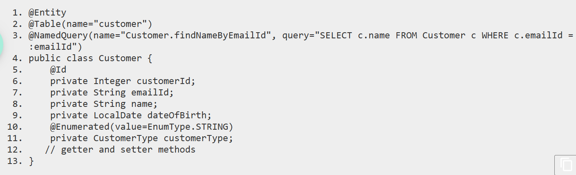

To use this named query in a repository, you need to add a query method in repository interface with the same name as defined in named query and the return type of method should be specified according to named query.

For example, the following method has to be added to repository to invoke named query.



Named Query approach has the advantage as maintenance costs are less as the queries are provided through the class. However, the drawback is that for every new query declaration domain class needs to be recompiled.

While both @NamedQuery and @Query serve the purpose of defining custom queries in Spring Data JPA, the choice between @NamedQuery and @Query often depends on the specific requirements of your application.

*\*\*\*\*\*\*\*\*\*\*\*\*\*\*\*\*\*\*\*\*\*\*\*\*\*\*\*\*\*\*\*\*\*\*\*\*\*\*\*\*\*\*\*\*\*\*\*\*\*\*\*\*\*\*\*\*\*\*\*\*\*\*\*\*\*\*\*\*\*\*\*\*\*\*\*\*\*\*\*\*\**

***STEPS TO FOLLOW WHILE CREATING PROJECTS :::***

In **Spring Boot**, the process of interacting with the database using **Spring ORM (JPA)** becomes even more streamlined and simplified due to the auto-configuration and conventions Spring Boot provides. Here's how you would write and configure Spring Boot to use **JPA** (often backed by Hibernate) for database operations:

**1. Set up Spring Boot Project**

When you're using **Spring Boot**, you typically use **Spring Data JPA** along with **H2** or **MySQL** or other databases, and Spring Boot automatically configures most of the necessary components for you.

**Spring Data JPA** automatically configures **repositories**, **entity management**, and **transaction management**, so you don’t need to worry about setting up those pieces manually.

Hibernate is automatically included as the default JPA provider.

**Spring Boot** will automatically configure:

* + The **EntityManagerFactory** using Hibernate as the JPA provider.
  + The **JpaTransactionManager** for handling transactions.
  + The **DataSource** for database connections.
  + It will also create **repositories** (for CRUD operations) when you create interfaces extending JpaRepository or CrudRepository.

**Add dependencies in pom.xml** (for Maven):

<dependencies>

<!-- Spring Boot Starter Data JPA: Provides JPA and Hibernate support -->

<dependency>

<groupId>org.springframework.boot</groupId>

<artifactId>spring-boot-starter-data-jpa</artifactId>

</dependency>

<!-- Spring Boot Web (only needed if you're building a web app or Rest API’s) -->

<dependency>

<groupId>org.springframework.boot</groupId>

<artifactId>spring-boot-starter-web</artifactId>

</dependency>

**<!--Database driver** must be included based on the DB 🡪

<dependency>

<groupId>com.h2database</groupId>

<artifactId>h2</artifactId>

<scope>runtime</scope>

</dependency>

</dependencies>

If you are using **MySQL** instead of H2, replace the h2 dependency with:

<dependency>

<groupId>mysql</groupId>

<artifactId>mysql-connector-java</artifactId>

</dependency>

**2. Configure Database in application.properties or application.yml**

Spring Boot auto-configures a lot of things, but you still need to specify your database connection details.

In application.properties (for example, with H2 database):

# DataSource Configuration

spring.datasource.url=jdbc:h2:mem:testdb #use this if **the schema *and* data were wiped the moment the application shut down/stopped. H2 in-memory database disappears on restart** since database is created and stored in RAM(the testdb database is **stored in memory**)

Or

spring.datasource.url=jdbc:h2:file:./data/mydb **#**To persist data and schema, you just need to switch to this

spring.datasource.driverClassName=org.h2.Driver

spring.datasource.username=sa

spring.datasource.password=password

# JPA Configuration

spring.jpa.database-platform=org.hibernate.dialect.H2Dialect

spring.jpa.hibernate.ddl-auto=update

spring.jpa.show-sql=true # Show SQL queries in the console

For **MySQL**:

# DataSource Configuration

spring.datasource.url=jdbc:mysql://localhost:3306/your_db

spring.datasource.driver-class-name=com.mysql.cj.jdbc.Driver

spring.datasource.username=root

spring.datasource.password=root_password

# JPA Configuration

spring.jpa.hibernate.ddl-auto=update # Options: none, update, create, create-drop

spring.jpa.database-platform=org.hibernate.dialect.MySQL5Dialect

spring.jpa.show-sql=true # Show SQL queries in the console

**3. Create Entity Classes**

You define **JPA entities** which map to tables in your database. Each entity represents a table, and the fields represent columns in the table.

Example: User.java (entity class):

import javax.persistence.Entity;

import javax.persistence.GeneratedValue;

import javax.persistence.GenerationType;

import javax.persistence.Id;

@Entity

public class User {

@Id

@GeneratedValue(strategy = GenerationType.IDENTITY) // Auto-increment ID

private Long id;

private String name;

private String email;

// Getters and Setters

}

* @Entity: Marks the class as an entity.
* @Id: Marks the primary key field.
* @GeneratedValue: Tells JPA how the primary key is generated (e.g., auto-increment).

**4. Create Repository Layer**

Spring Boot simplifies the data access layer through **Spring Data JPA**. You create a **repository interface** that extends JpaRepository, and Spring Boot will provide the implementation at runtime.

Example: UserRepository.java (repository interface):

import org.springframework.data.jpa.repository.JpaRepository;

import java.util.List;

public interface UserRepository extends JpaRepository<User, Long> {

List<User> findByName(String name);

}

* JpaRepository<User, Long>: User is the entity type, and Long is the type of the primary key.
* The repository interface comes with built-in methods like save(), findById(), findAll(), deleteById(), etc.
* You can also define custom query methods, like findByName(String name).

**5. Service Layer (Business Logic)**

In the service layer, you interact with the repository to perform business logic and transactions. Spring Boot’s auto-configuration makes this very simple.

Example: UserService.java:

import org.springframework.beans.factory.annotation.Autowired;

import org.springframework.stereotype.Service;

import org.springframework.transaction.annotation.Transactional;

import java.util.List;

@Service

public class UserService {

@Autowired

private UserRepository userRepository;

@Transactional

public User createUser(String name, String email) {

User user = new User();

user.setName(name);

user.setEmail(email);

return userRepository.save(user);

}

public List<User> findUsersByName(String name) {

return userRepository.findByName(name);

}

}

* @Service: Marks the class as a Spring service, which holds business logic.
* @Transactional: Ensures that the method is wrapped in a database transaction.
* userRepository.save(user): This method will either **insert** a new record or **update** an existing record based on the entity's state.

**6. Controller Layer (Web Layer)**

In the **controller layer**, you expose the endpoints that allow interaction with your service layer. Spring Boot simplifies this with the use of @RestController and @RequestMapping annotations.

Example: UserController.java:import org.springframework.beans.factory.annotation.Autowired;

import org.springframework.web.bind.annotation.*;

import java.util.List;

@RestController

@RequestMapping("/users")

public class UserController {

@Autowired

private UserService userService;

@PostMapping("/create")

public User createUser(@RequestBody User user) {

return userService.createUser(user.getName(), user.getEmail());

}

@GetMapping("/find")

public List<User> findUsersByName(@RequestParam String name) {

return userService.findUsersByName(name);

}

}

* @RestController: Marks this class as a controller for REST APIs.
* @PostMapping and @GetMapping: Map HTTP methods (POST and GET) to methods in the controller.
* @RequestBody: Maps the incoming request body to a Java object.
* @RequestParam: Extracts query parameters from the URL.

**7. Run the Application**

Once everything is configured, you can run the Spring Boot application. Spring Boot will auto-configure everything for you, including the database connection, JPA configuration, and transaction management.

To run the application, simply execute:

mvn spring-boot:run

Or run the main application class that contains @SpringBootApplication.

**Summary of Spring Boot ORM Workflow:**

1. **Define Entity Classes**: Represent tables in the database with @Entity and other annotations.
2. **Configure Database**: In application.properties, provide connection details.
3. **Create Repository Interfaces**: Use Spring Data JPA to auto-generate database access logic.
4. **Write Service Logic**: Implement business logic in service classes, using repositories to interact with the database.
5. **Expose REST Endpoints**: Use @RestController to expose API endpoints.
6. **Run the Application**: Spring Boot manages everything, including the data source, transaction management, and JPA configuration.

**Use** [**http**://localhost:8080/h2-console](http://localhost:8080/h2-console) to make connection to h2 db

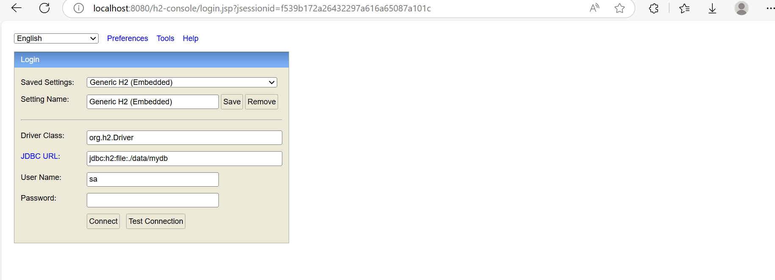

• **localhost:8080** is the **port your Spring Boot application is running on** (default is 8080 unless you've configured it differently).

• **/h2-console** is the path Spring Boot exposes for the **H2 web console**

• This web interface allows you to interact with your **in-memory or file-based H2 database** through a browser.

• It is only accessible **after your Spring Boot application starts**, because the H2 console is served by the Spring Boot web server.

By leveraging **Spring Boot** with **Spring Data JPA**, you can easily build and interact with databases without writing much boilerplate code, making it perfect for rapid development.

**SPRING REST**

Web services(are pieces of code) makes applications communicate/interact with each other irrespective of the differences in terms of programming language/technologies and platform.

They provide a standardized way for applications to exchange information over the internet.

There are two major types of web services:

1. **SOAP (Simple Object Access Protocol)** Web Services
2. **REST (Representational State Transfer)** Web Services

**REST Web Services**

REST is an architectural style that uses standard HTTP methods (GET, POST, PUT, DELETE, etc.) to perform operations on resources, Each **resource** is accessed using a **URL** (Uniform Resource Locator). REST is lighter, simpler, and more flexible compared to SOAP and is typically used in web applications.

 REST, which means**Representational State Transfer**, which is an architectural style that helps developing loosely coupled services.

A **resource** refers to any object or entity or record or document/file or functionality that can be accessed and manipulated through the API. Eg: Product, User.

And resources can take any representational form such as json, xml, html while sending to the client.

**Actions on Resources:**

Each resource can be accessed or modified using standard HTTP methods:

* **GET**: Retrieve information about a resource (e.g., get user details).
* **POST**: Create a new resource (e.g., create a new product or order).
* **PUT**: Update an existing resource (e.g., update user information).
* **DELETE**: Delete a resource (e.g., delete an order or product).

**user resource** might look like this in JSON format

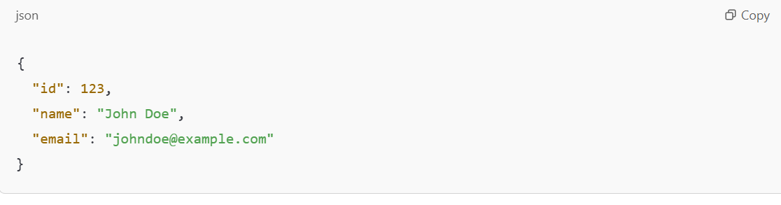

**Key Features of REST**:

* REST can use any transport layer protocol for communication, but the most popular and commonly used is HTTP(lightweight and easier to use).
* REST promotes lightweight communication between the client and the server.
* Data can be transferred in various formats, like JSON, XML, HTML, or plain text. JSON is most commonly used.
* Anything that can be identified with a unique URI is a ‘resource’. Resource can be document/file, Functionality, Entity/Data. Resource can be represented in many formats like (Json, xml etc).
* In REST, anything that can be identified using a unique URI is termed as a resource and the resource can be a **file, functionality or even data**. These resources can get represented in many formats. For example JSON and XML.
* Stateless: Each request from the client to the server must contain all the information necessary to understand the request.
* Can perform CRUD operations (Create, Read, Update, Delete) using HTTP methods:

Some of the **REST principles** are.

* **Uniform Interface**(Client and server share same interface)
* **Client-Server**(loose coupling)
* **Stateless**,(each request from a client to the server must contain all the information the server needs to understand and process the request)
* **Layered system**(client remains abstract about the connection information, whether it is with server or with any other intermediate like going through a proxy, or being routed by a load balancer.),
* **Cacheable**( client is not required to call server for the same kind of request that was triggered in the past.The response can be picked up from the cache as caching improves the performance),
* **Code on demand**(It is optional. The server can enhance the functionality of the client by sending code in the response. For example, JavaScript code that can be executed at the client end)

**Client:**

* The **client** is the application or system that **requests** data or services from the **server**.
* It can be a **web browser**, **mobile app**, or any other software that interacts with a server over the internet or a network.
* The client sends **HTTP requests** (GET, POST, PUT, DELETE, etc.) to the server, asking for specific resources or data.

**Server:**

* The **server** is the system that **responds** to requests from the **client**.
* It hosts the resources or data and makes them available for clients to access. When the client sends a request, the server processes it and sends back the appropriate **response** (usually in formats like JSON, XML, or HTML).
* The server listens for incoming requests, handles them, and returns data, often in the form of a web page, API response, or other types of data.

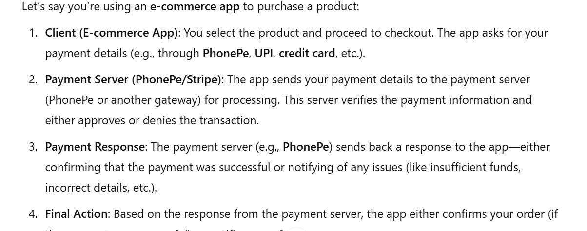

**PhonePe** is an example of a **payment gateway** that acts as a **payment server** in the above flow. It provides APIs that allow merchants (e-commerce websites, mobile apps) to process payments using UPI, debit/credit cards, or wallets.

**Client (Flight booking app)**: This is the application where users interact, for example, a mobile or web app where customers can search for available flights, book tickets, etc.

* When a user wants to see the available seats for a specific flight, the client (app) sends a request to the server (airline's system).
* The client sends an HTTP request using the GET method, asking the server for a list of available seats (or available flights) for specific criteria (like date, time, origin, destination).

• **Server (Airline's system)**: The server is responsible for handling the requests made by clients. It has various services, such as checking seat availability, booking a ticket, processing payments, etc.

* In response to the client’s request (e.g., asking for available seats), the server processes this request, checks the database and sends back the data(in JSON), such as a list of available seats on the flight.

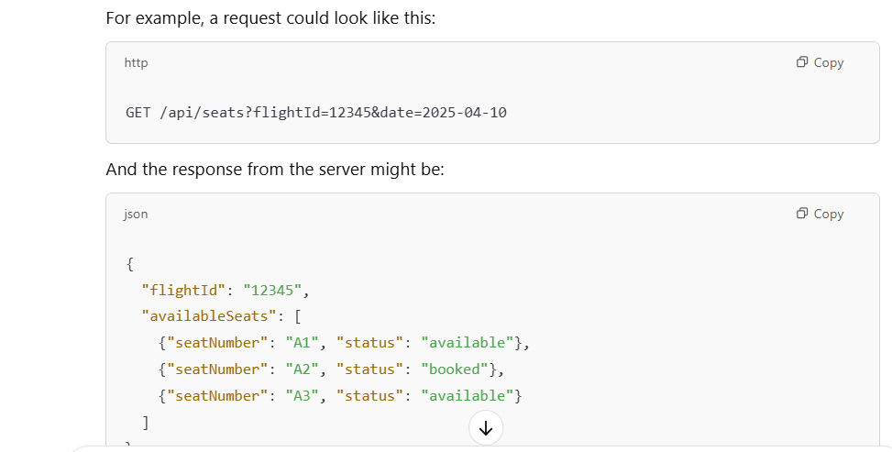

Then Client app then processes the JSON and converts it into a human-readable format (like a graphical user interface) that the user can interact with.

The client app doesn’t need to know about the internal details of the server but just needs to send a request and process the response.

Spring Web module( Spring MVC ) - supports for building and consuming RESTful services

the process of developing the Spring MVC application is the same as that of developing spring REST applications but with certain modifications

**@RestController** - you are building an API and want to return JSON or XML responses instead of views, you can use @RestController.

@**RestController** is a combination of @**Controller** and @**ResponseBody**.

Every method in a @RestController automatically serializes the returned objects into JSON (or XML, depending on configuration) without needing the @ResponseBody annotation.

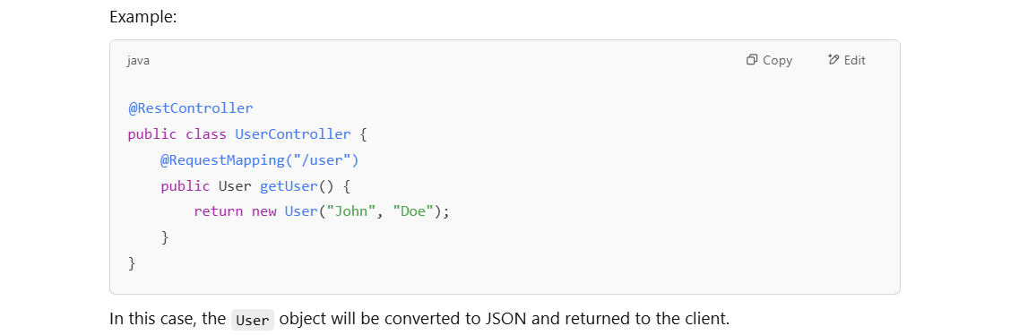

**@Controller** - It's used to define a controller class for traditional Spring MVC apps which is responsible for handling incoming HTTP requests, processing them (including interacting with services, performing logic, etc.), and returning views (usually a JSP, HTML, or other template).

the @Controller annotation by itself does not map any requests; it's just a way to define a controller component.

• It generally returns **views** (HTML, JSP, Thymeleaf templates) to the client.

• The return type of methods in a @Controller is typically a **view name**, which is resolved by the view resolver to render the page.

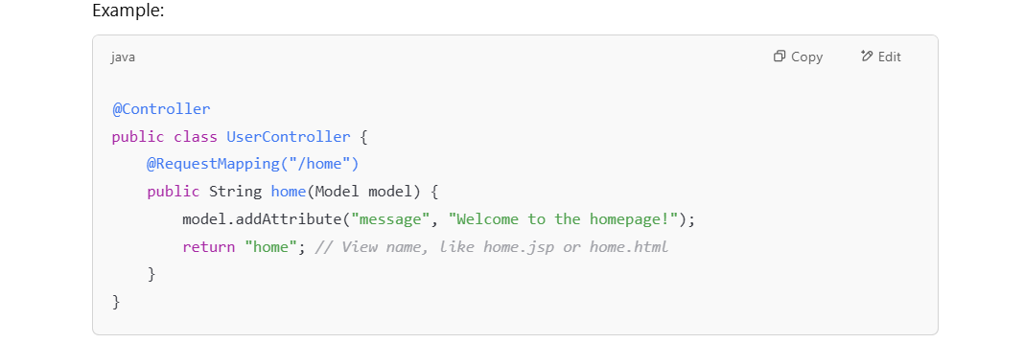

**Use of @ResponseBody:**

* **@Controller:**
  + **Does not** automatically apply @ResponseBody to methods.
  + If you need to return a response body (e.g., JSON or XML), you have to explicitly annotate individual methods with @ResponseBody.

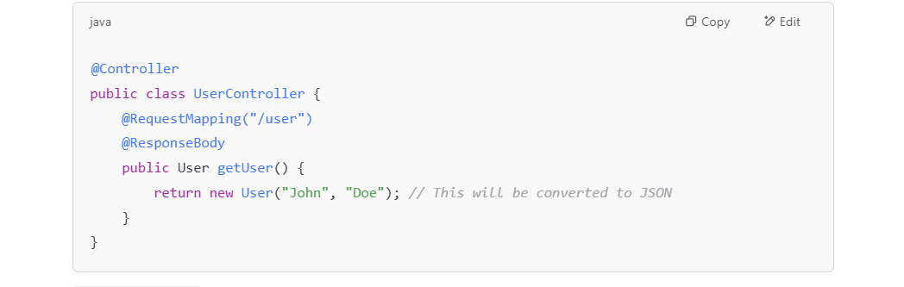

* **@RestController:**

**Automatically applies** @ResponseBody to all methods in the controller.

Every method in a @RestController is treated as if it is annotated with @ResponseBody, meaning the return value will be serialized directly into the response body (usually as JSON or XML).

**Typical Use Case:**

* **@Controller:**
  + Used in **traditional web applications** where the server returns views (HTML pages) rendered by the server (e.g., with Thymeleaf, JSP).
  + Suitable for handling HTML responses, form submissions, and rendering dynamic pages.
* **@RestController:**
  + Used in **RESTful APIs** where the server returns data (JSON/XML) instead of HTML views.
  + Typically used in back-end services where communication is done via APIs (e.g., mobile apps, single-page applications, microservices).

**Response Type:**

* **@Controller:**
  + It usually returns a **view name** (a reference to a JSP, HTML, or other templates).
  + The returned data is typically rendered using a **view resolver** (like JSP or Thymeleaf).
* **@RestController:**
  + It returns **data objects**, which are automatically serialized into the desired format (usually JSON or XML).
  + No need for view resolvers, as it's typically for APIs.

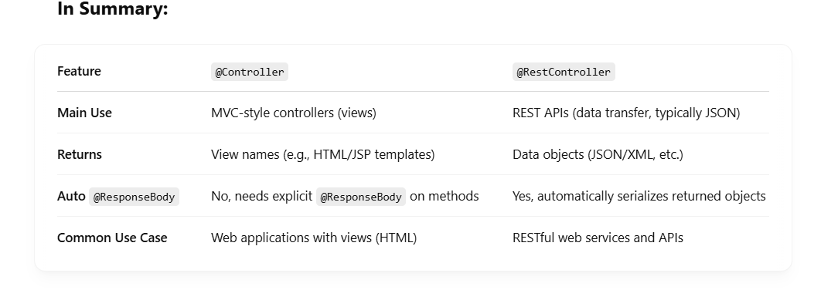

**In Real life scenario::**

**When you search for Levi's jeans** on Amazon’s mobile app:

**URL**: https://api.amazon.com/api/products/search?q=levi's+jeans

The app uses a **REST API** to fetch product details (including images, descriptions, prices, etc.) in JSON format, which the app then uses to display the results in a user-friendly way."

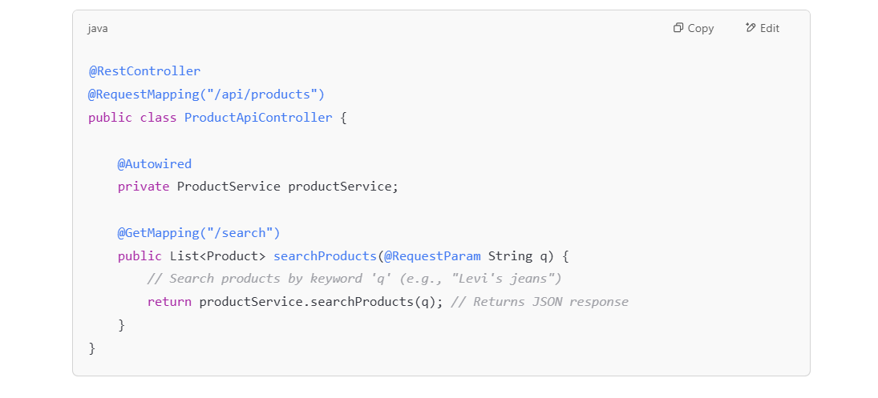

**When you search for Levi's jeans** on Amazon’s website:

**@Controller** is typically used in **web applications** (for rendering HTML views). Since a mobile app doesn't render HTML directly but instead works with data (JSON), **it would not use @Controller** for this search operation.

* The **request** goes to a backend controller.
* The backend uses @Controller to **render HTML**, fetching product details (name, price, image URL, description, etc.) and populating them in a view.
* Once the initial page is loaded, Amazon likely uses **AJAX requests** (asynchronous JavaScript) are likely used to **fetch more data**, like additional product listings or filtered results (this could involve a REST API) without refreshing the entire page.
* But the **first page load** that you see when you search for a product on Amazon would **not be using REST APIs directly** to render that HTML page.

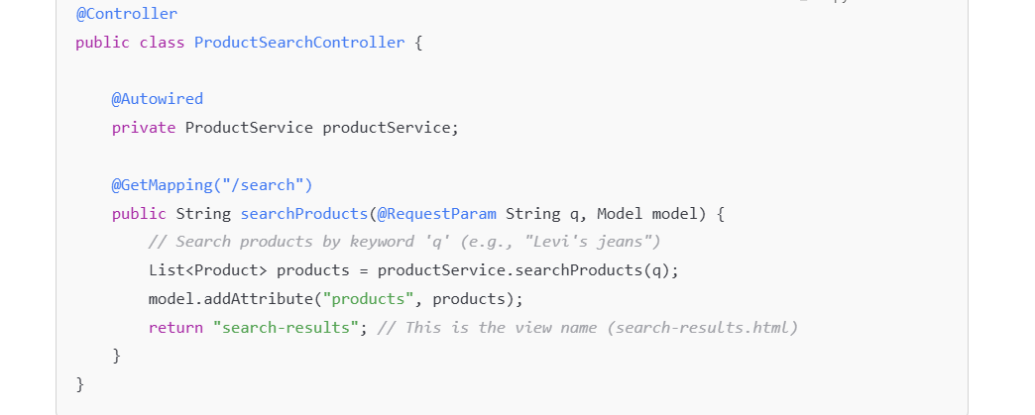

**@RequestMapping at method level:** The @RequestMapping annotation is used to map **HTTP requests** to handler methods of MVC controllers. It specifies which URL path and which HTTP method (GET, POST, etc.) should trigger the method in the controller.

**@RequestMapping at the class level -**  Used to define a **base URL path** for all the handler methods inside that class. This allows you to avoid repeating the same part of the URL path in every method so that each method only needs to specify the remaining path.

Eg: 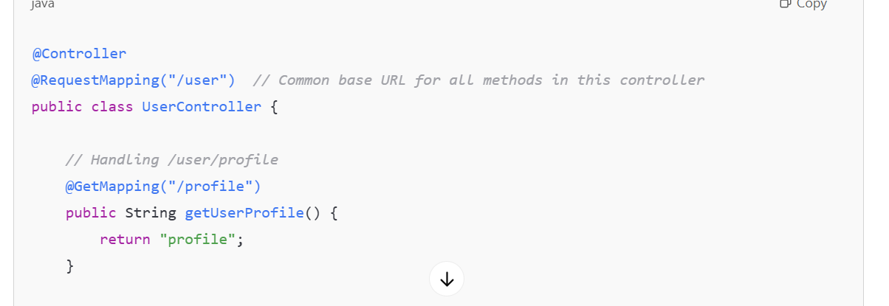

While @RequestMapping is a more general-purpose mapping annotation, Spring 4 introduced specialized annotations that provide more specific mappings:

* **@GetMapping**: Maps HTTP GET requests.
* **@PostMapping**: Maps HTTP POST requests.
* **@PutMapping**: Maps HTTP PUT requests.
* **@DeleteMapping**: Maps HTTP DELETE requests.
* **@PatchMapping**: Maps HTTP PATCH requests

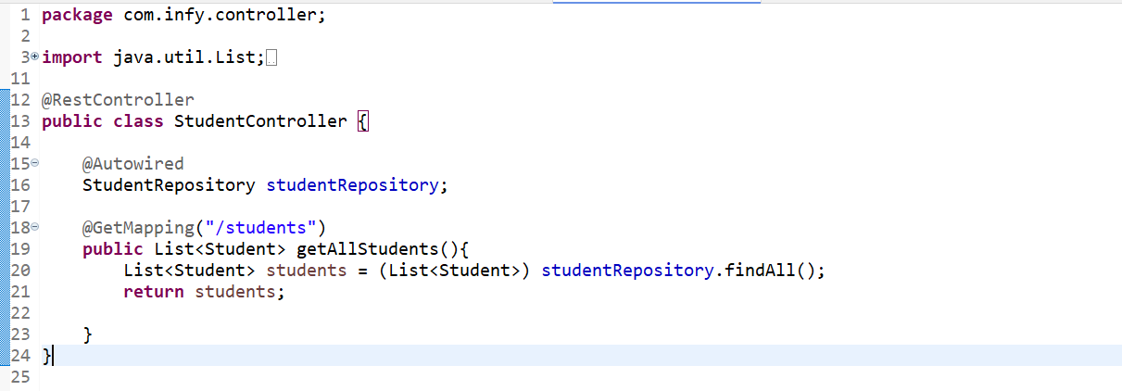

Here , What hibernate does is :::

**Query Execution:** Hibernate runs the SQL query (SELECT * FROM STUDENT) and gets a ResultSet containing the rows.

**Hibernate maps each row to a Java object**

For every row in the ResultSet:

* Hibernate creates a new instance of Student with default(no args) constructor.
* Uses **Java Reflection** to:
  + Find matching fields.
  + Call corresponding **setter methods to** assign valuesfrom **rs**.
* Hibernate will use the **default constructor** (the no-argument constructor) to create an instance for the entity classes.
* After creating the entity object, Hibernate will **use reflection** to set the values on the instance variables of the entity class.
* The setter methods (like setId(), setName(), etc.) will be invoked to populate the fields from the resultset.

Hibernate does **not call parameterized constructors** to assign the values like: new Student(1, "Alice", 21); // ❌ No

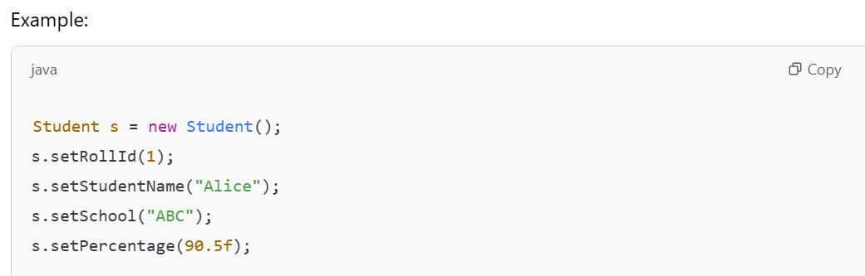

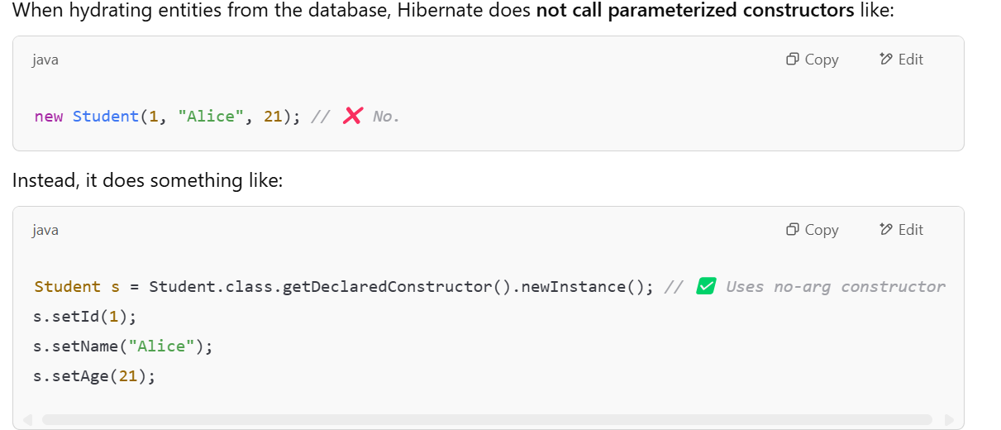



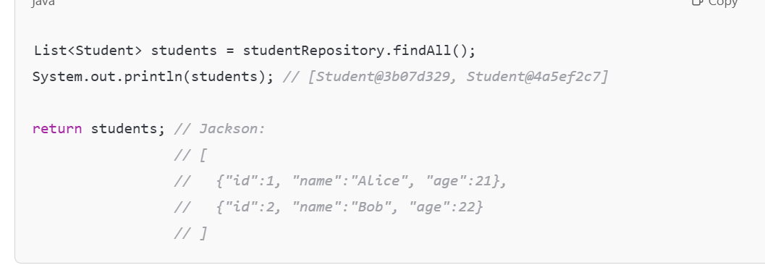

**Q:** If toString() is not written, will JSON still be correct?  
**A:** ✅ YES — Jackson uses reflection, not toString(). There is nothing to do with toString() for jackson.

**Q:** Does that hashcode-looking string get used in JSON?  
**A:** ❌ NO — that’s only shown in System.out.println() and logs

**Hibernate adds each object to a list**

* All Student objects are collected into a List<Student>.
* This list is returned by findAll() to your controller.
* • Spring Boot uses **Jackson** to convert the List<Student> to **JSON**.
* • Sends the JSON as the HTTP response.

**How to map in the request body to a Java object?**

* Most of the time the client's request through a rest endpoint is associated with the request body and an appropriate header.

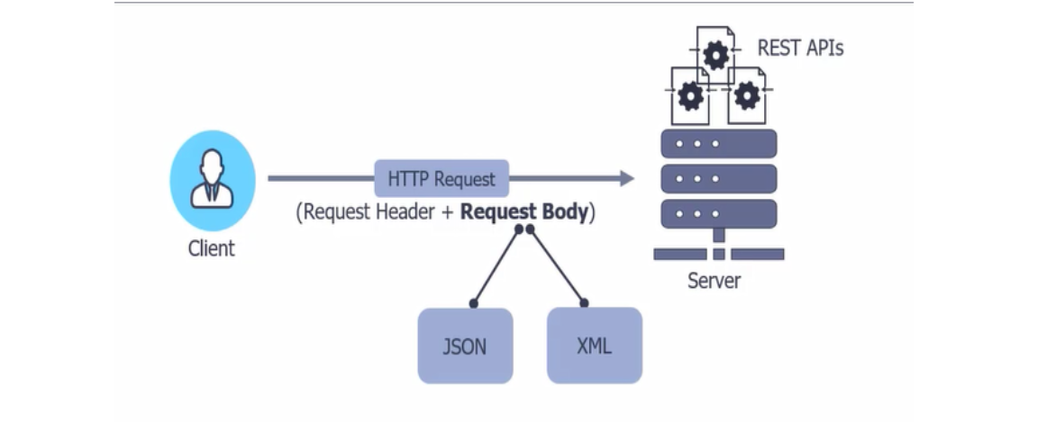

* The request body holds the data being sent by the client, either in the form of JSON or XML. If the request body is in JSON format, the content type header will be **Content-type: application/json.**If the request body is in XML format, then the content type header will be  **Content-type: application/xml**, *Be it JSON or XML, the request body needs to get mapped to a Java object for further processing. So how can this mapping be done in spring REST?*

**@RequestBody** annotation maps the incoming HTTP RequestBody to the Java object. Thus it helps deserialize the incoming request body into a Java type.

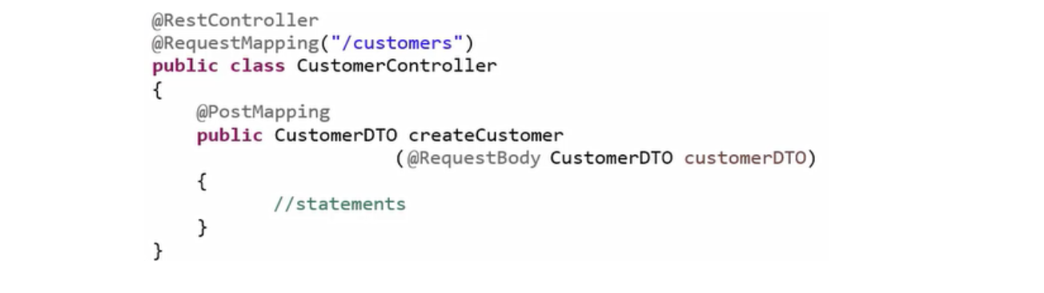

*Working of @RequestBody Annotation?*

Request body maps attributes of JSON object to attributes of Java DTO and then populates a Java object. JSON objects can be deserialized in the same manner.

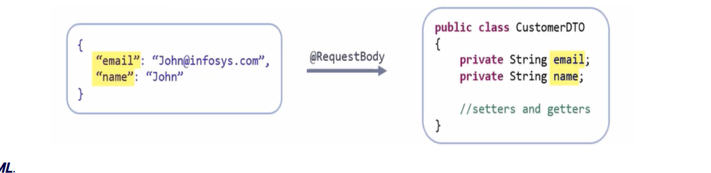

*What about other type? like****XML****.*

You'll need an extra annotation called **@XmlRootElement** and the same which was applied on the Java class and a DTO whose object gets mapped against the incoming @Request body.

*Why is theren't a need of new extra annotation for JSON?*

Spring REST can deal with JSON data without any extra info as it is the default format. here still @RequestBody annotation is mandatory just to map the incoming request body to Java type.

if you want to represent a class as XML, you can annotate it with @XmlRootElement to define the root element of the XML representation. Here’s an example of how you would do that:

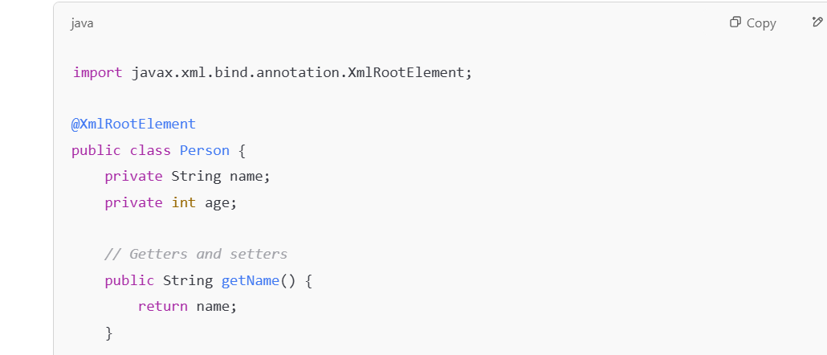

With this annotation, you can use JAXB (Java Architecture for XML Binding) to convert the Person object into an XML structure.

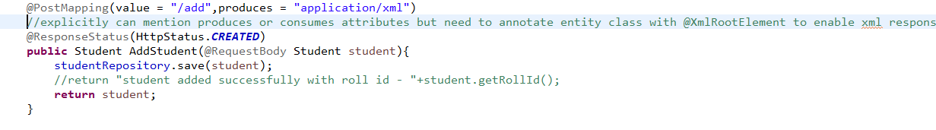

How to make the REST methods handle data in different formats like JSON and XML?

  There are two attributes called **produces and consumes**, which is part of method mapping annotations like GET mapping, POST mapping, etc. consumes attribute Determines the format that can be consumed by the service method and produces Decides a format in which the data can be sent back to the client.

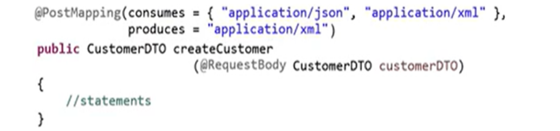

But these attributes will make the code look more readable, though these are **not mandatory** to deal with the appropriate formats. When there are no special serializing or deserializing annotations available on the corresponding Java class, a DTO that receives the incoming RequestBody, which is the default format to be considered by spring rest is JSON.

If the Java class or DTO has @XmlRootElement in place and if the client prefers sending and receiving data in XML format then. Spring REST will go with XML for serializing and deserializing.

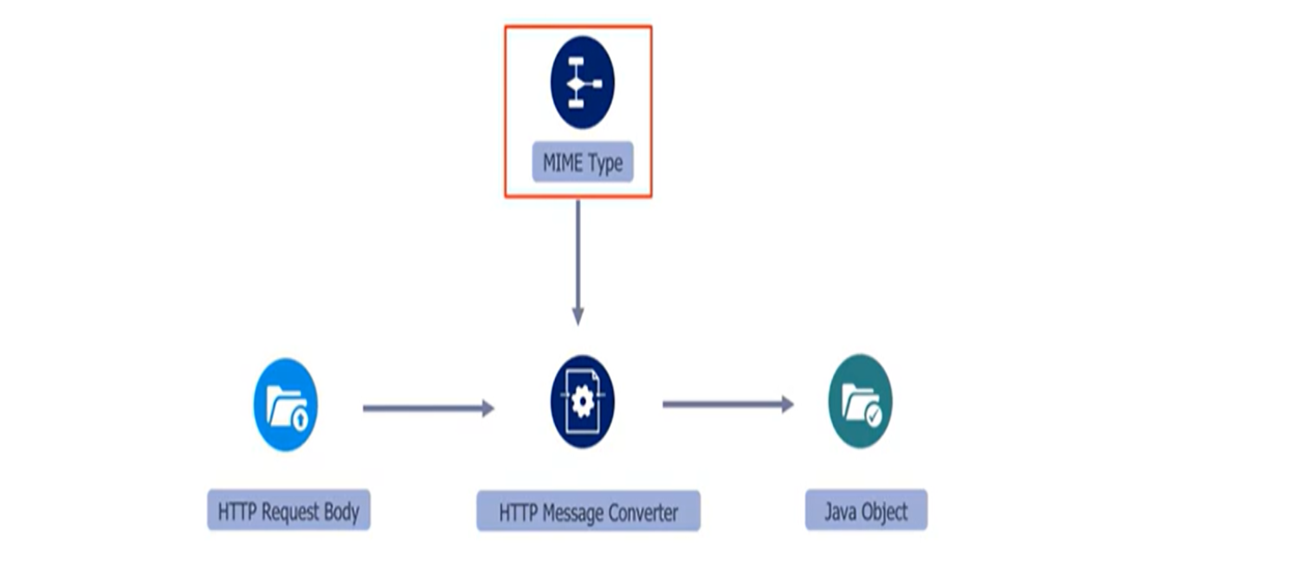

 Whenever Spring encounters @RequestBody annotation it takes the help of the registered HTTP message converters Will help convert the HTTP RequestBody to a Java object based on the MIME type being set in the consume attributes.

What if the consumes attribute is not set with the MIME type for a service method?

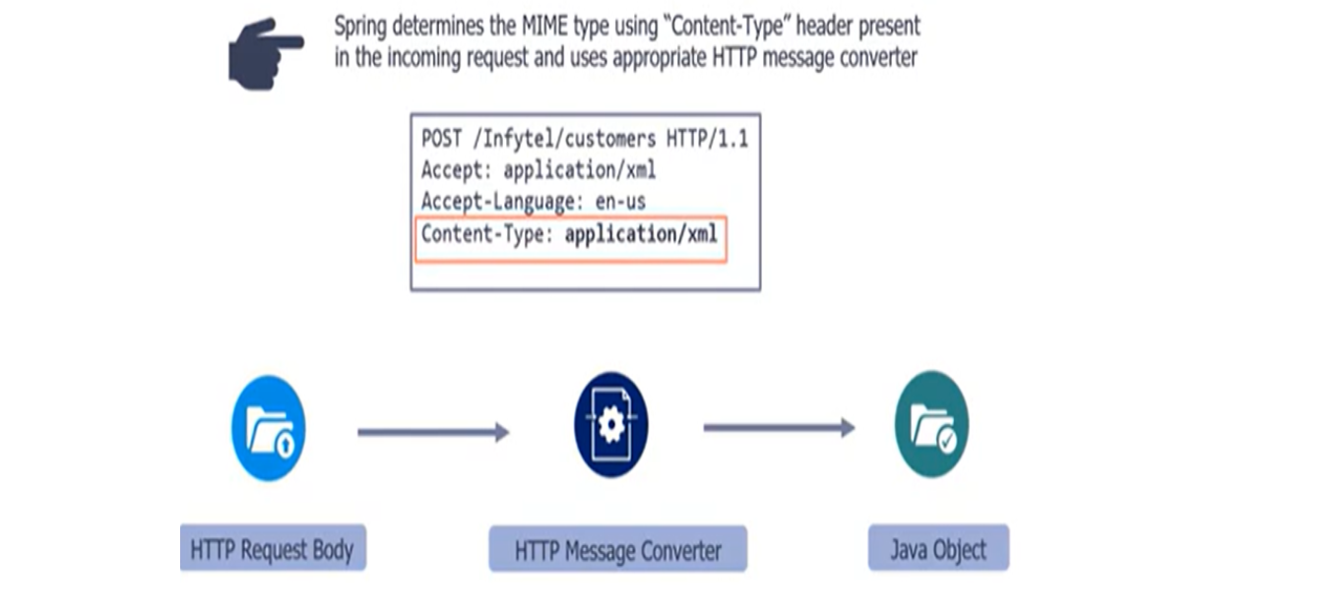

The MIME  type available in the request header will be taken into consideration.

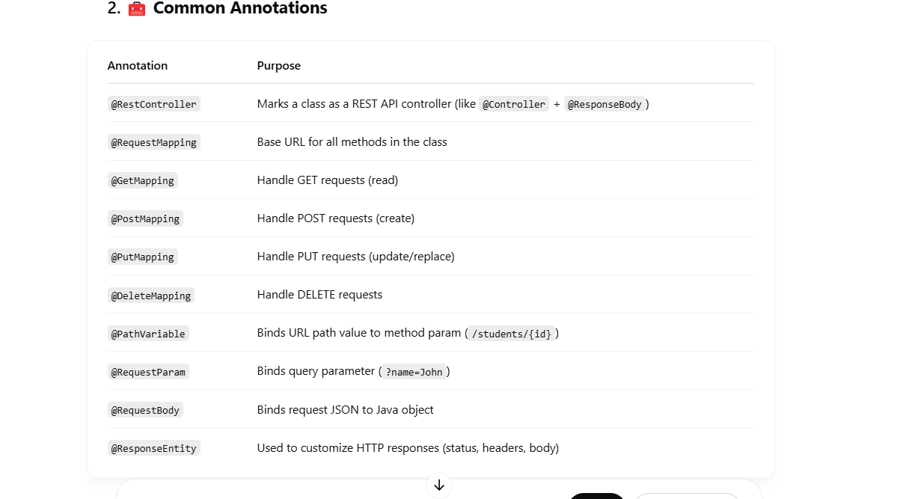

@ResponseStatus lets you set a specific **HTTP status code** that the method should return — **without needing to use ResponseEntity**.

Eg: 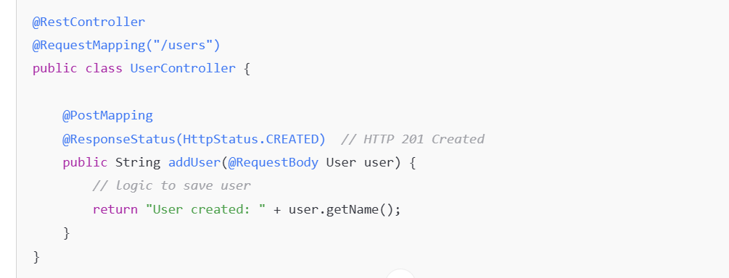

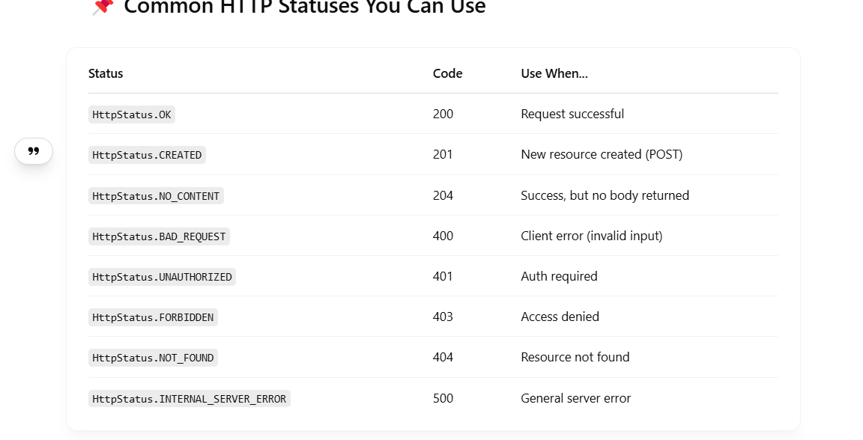

**ResponseEntity** is a Spring class that represents the full HTTP response, including**:**

* **Status Code (e.g. 200, 404, 201)**
* **Headers**
* **Body (data)**

It gives you full control over the response that is returned from your REST API.

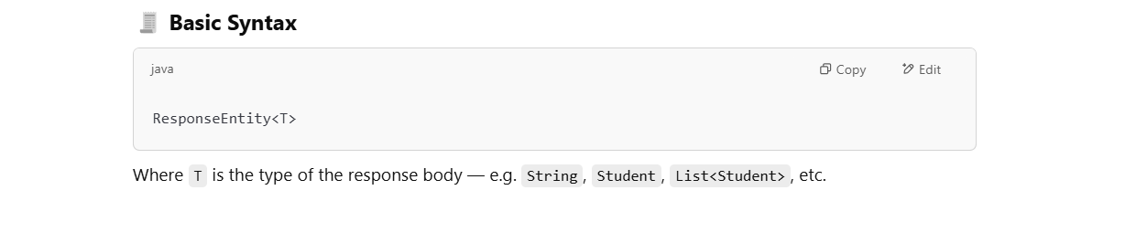

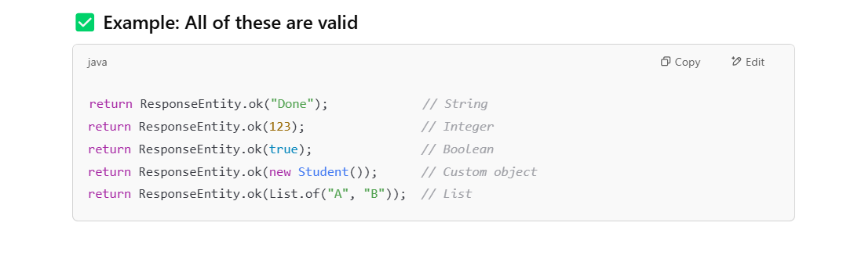



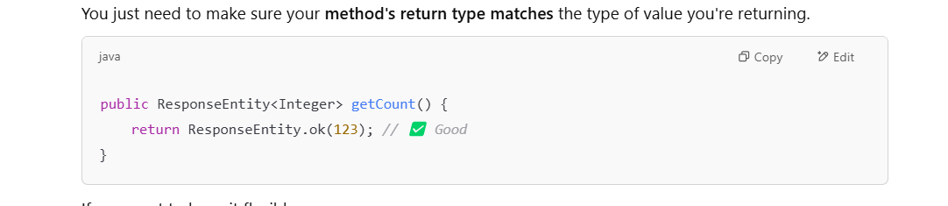

**✅ What exactly is ok(...) in ResponseEntity.ok(...)?**

It's a static helper method that:

* Sets the HTTP status to 200 OK
* Builds a ResponseEntity
* Attaches a body (whatever you put inside)

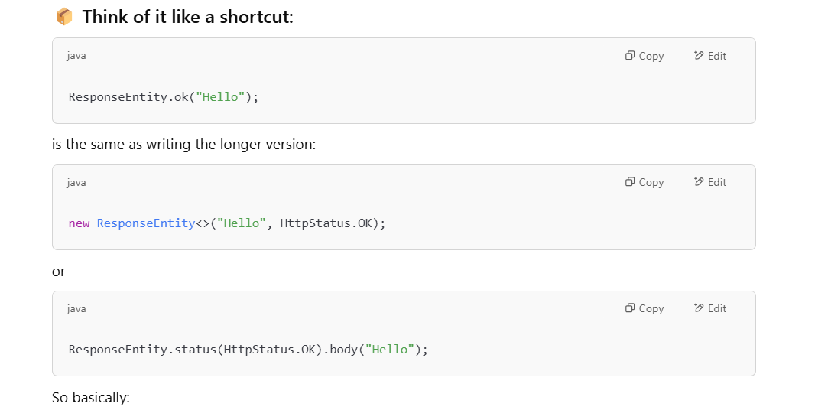

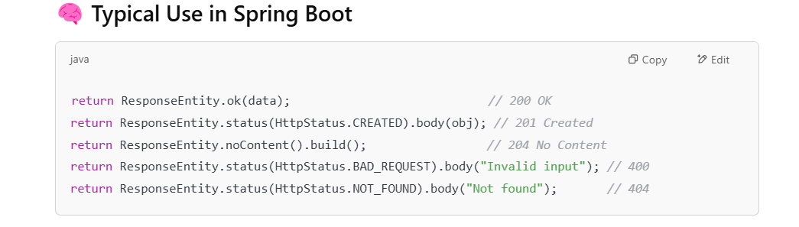

@PathVariable is an annotation in Spring (Java framework) that **binds a variable from the URL path to a method parameter**.

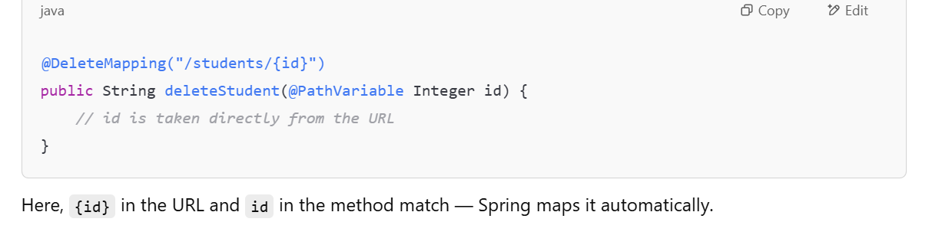

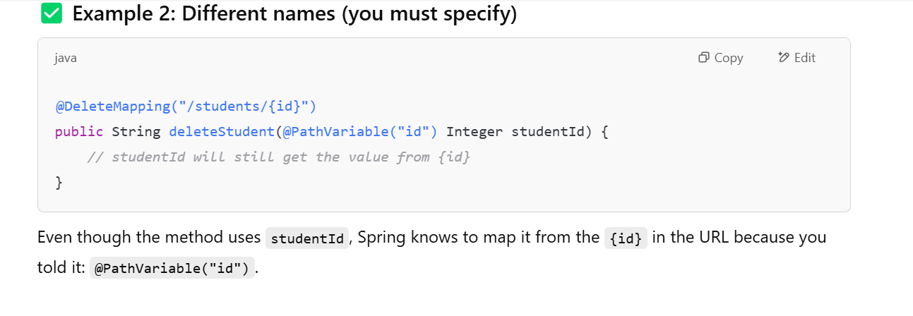

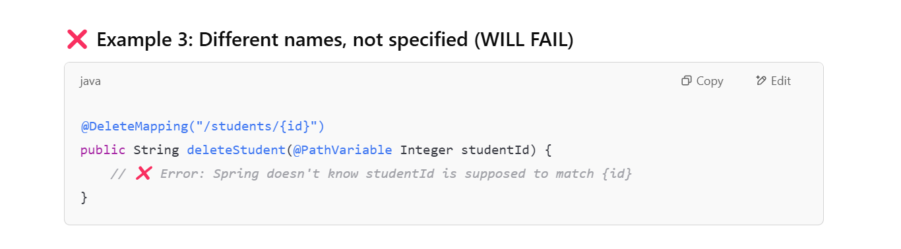

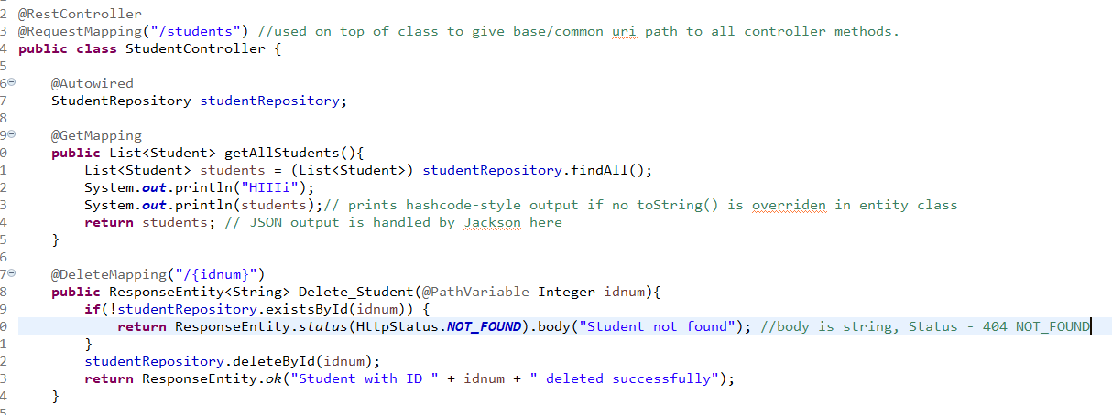

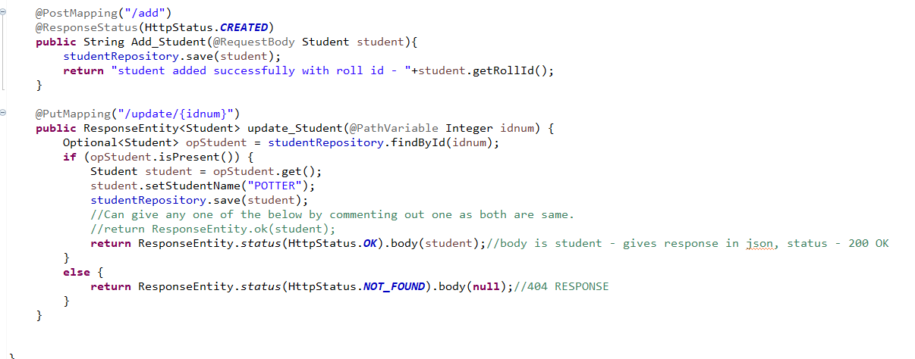

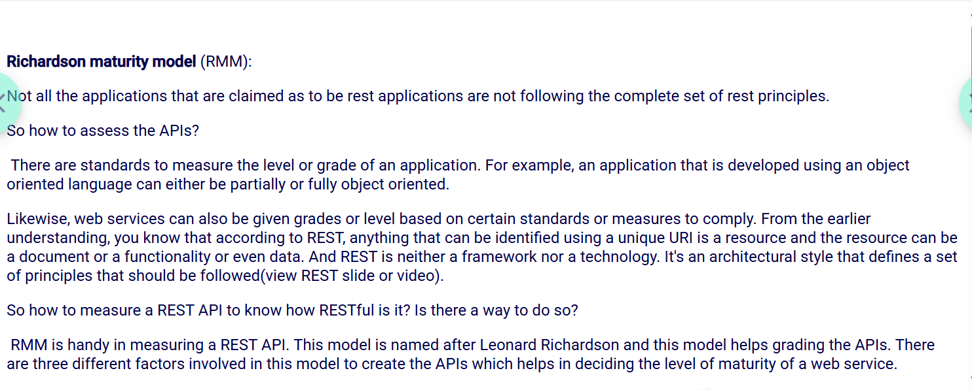

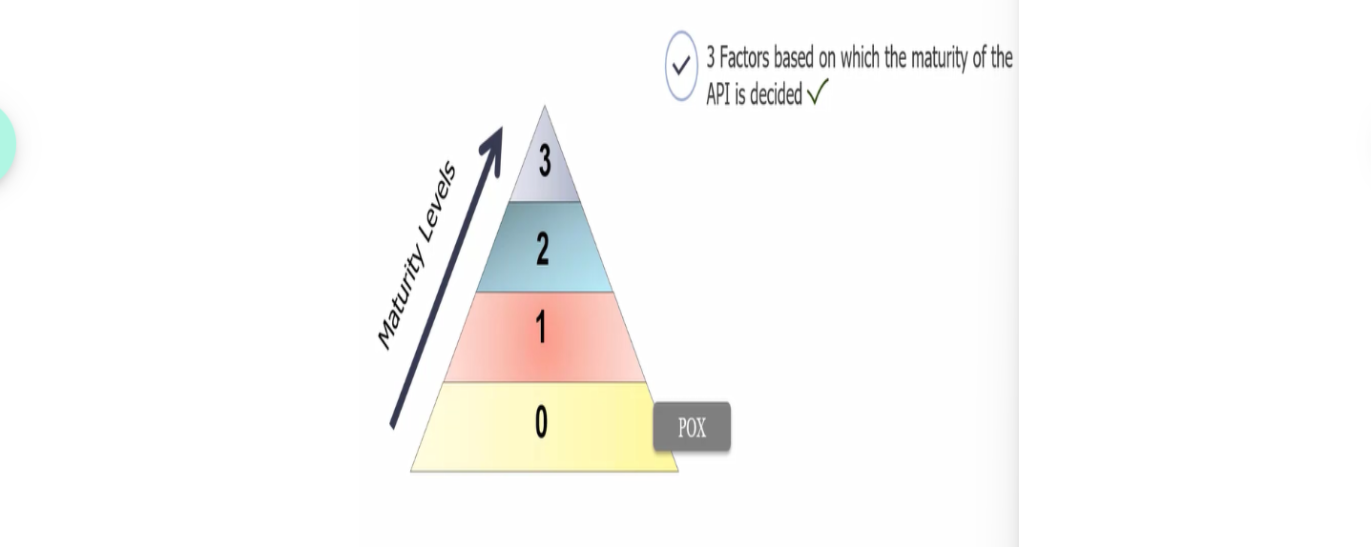

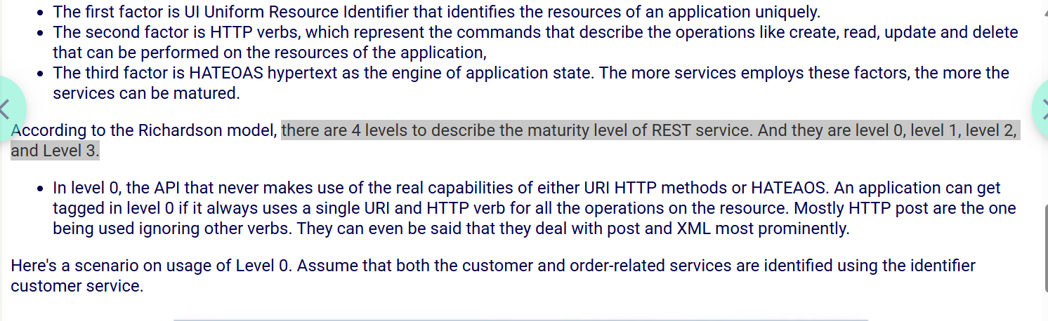



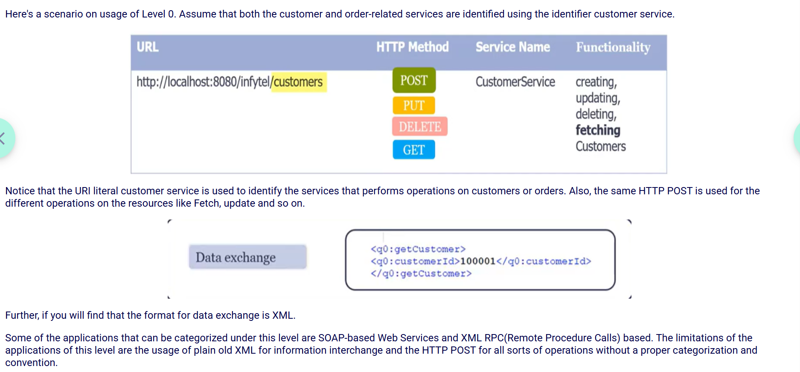

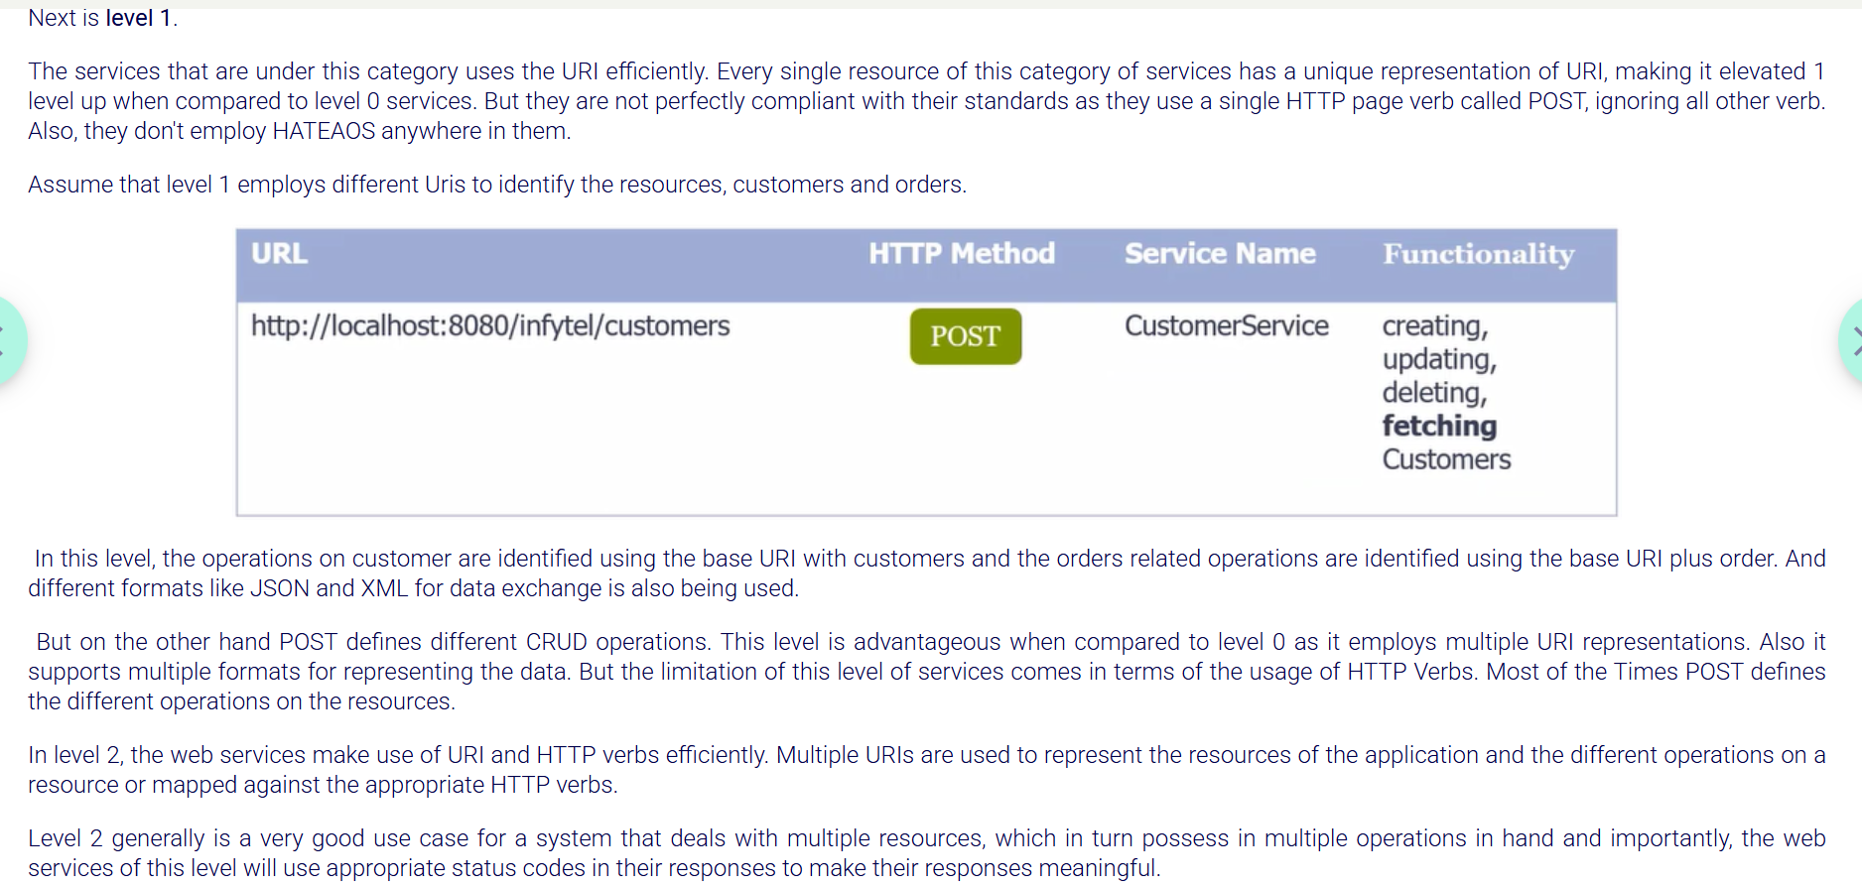

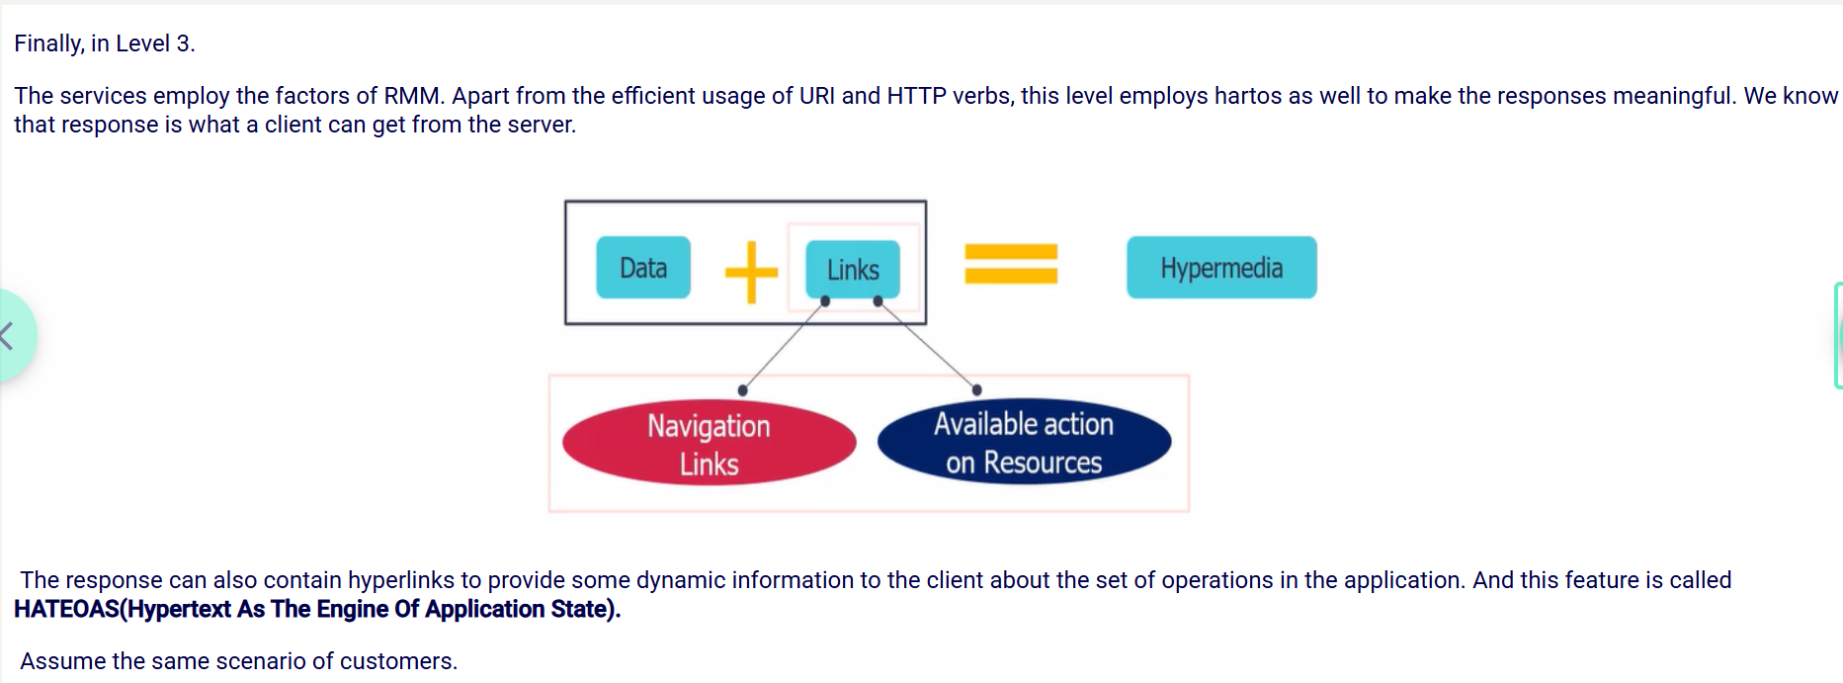

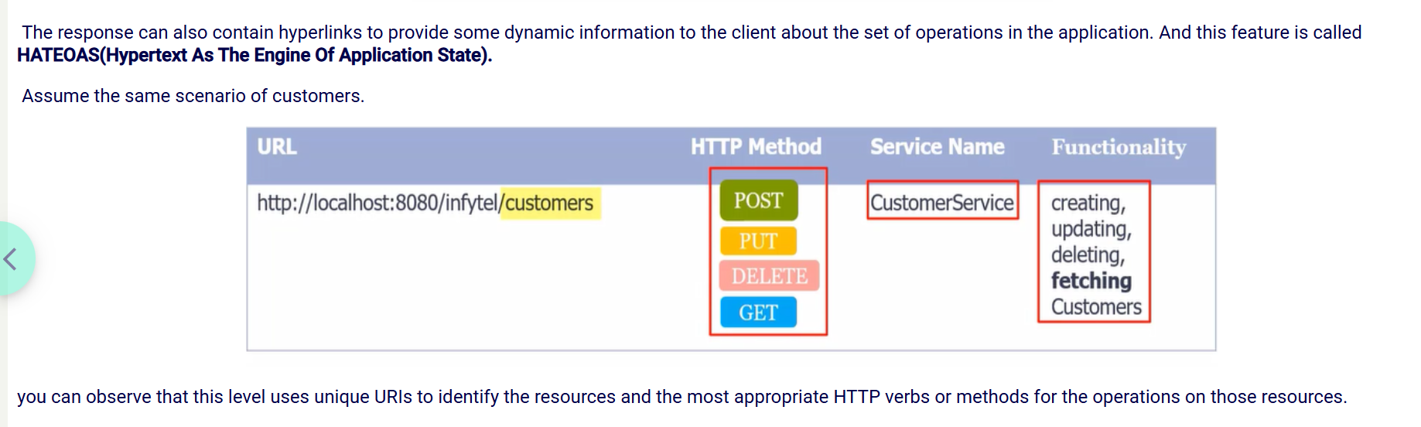

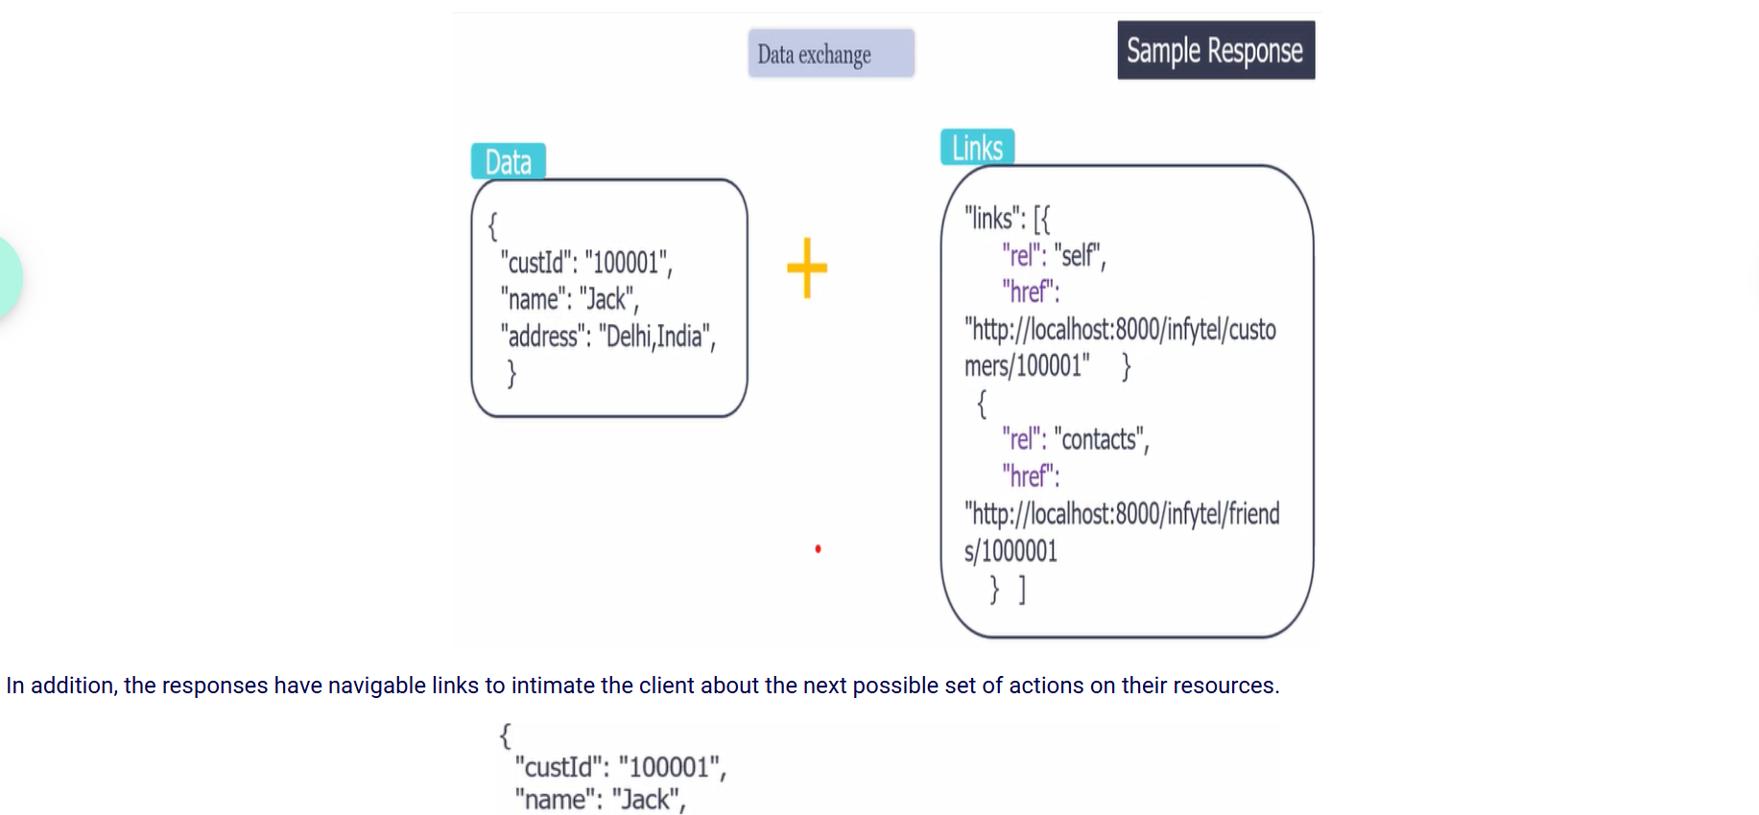

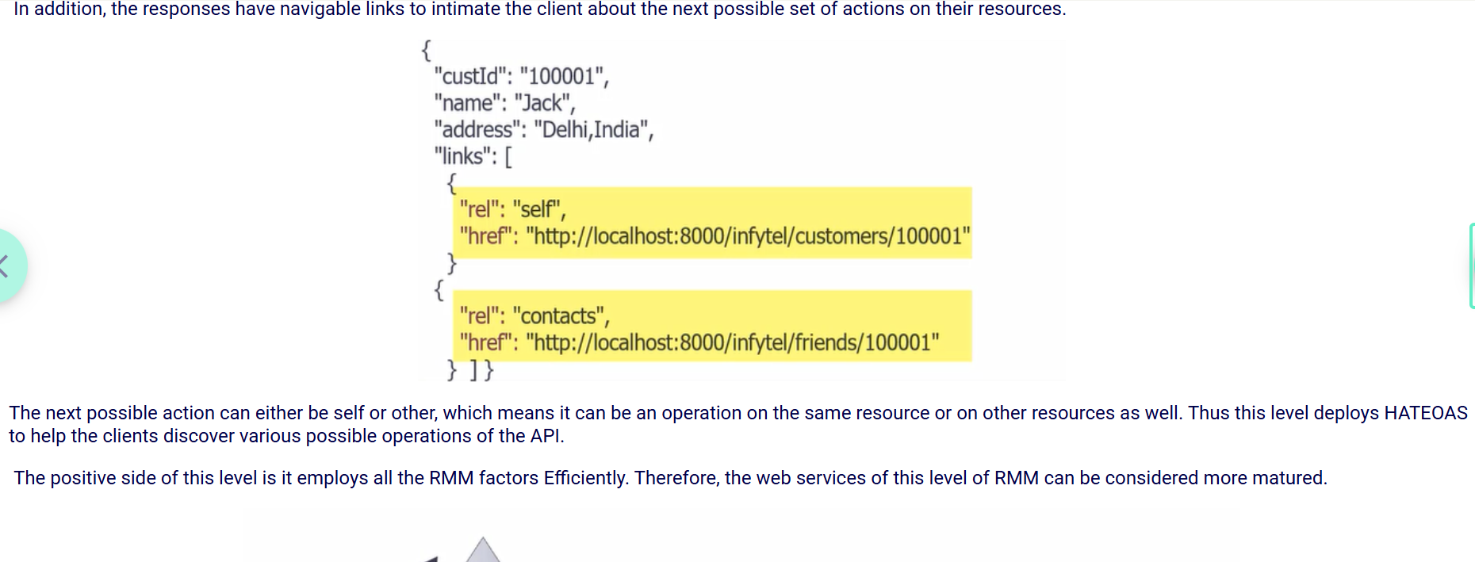

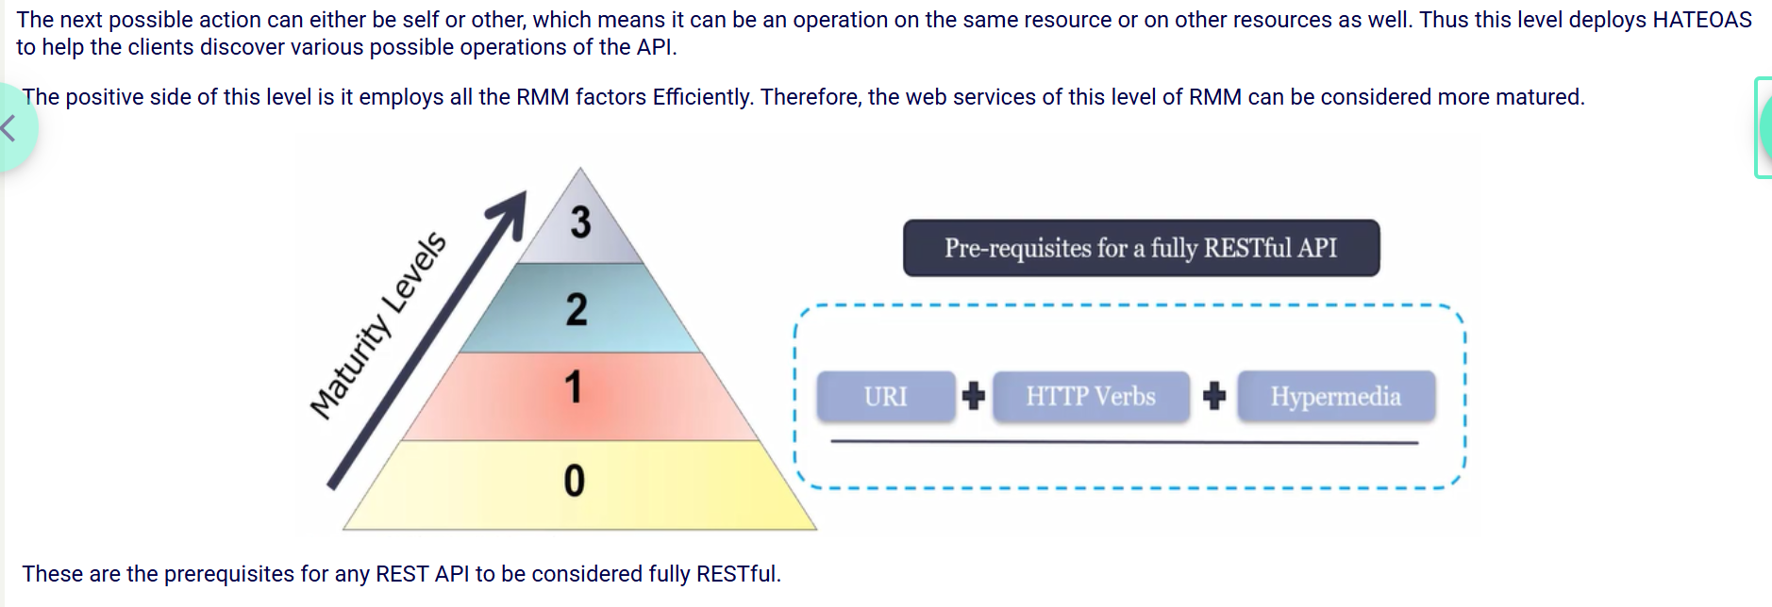

**Global Exception Handling :**

Global exception handling is a way to handle exceptions in a centralized manner, so we don’t have to repeat try-catch blocks throughout the code.

For example, in Spring Boot, we can use **@ControllerAdvice** along with **@ExceptionHandler** methods to catch specific exceptions or general ones and return appropriate responses. This improves code readability, maintainability, and ensures consistent error handling across the app."

Below is Method in actual Controller:

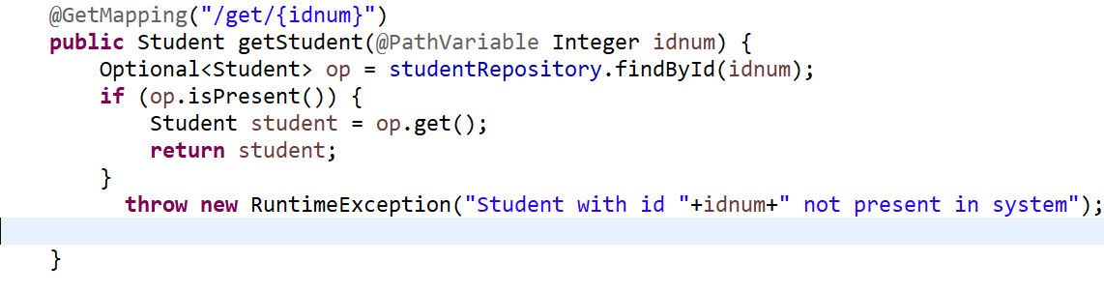

Below is the handler method in class GlobalExceptionHandlerController in package controller itself :

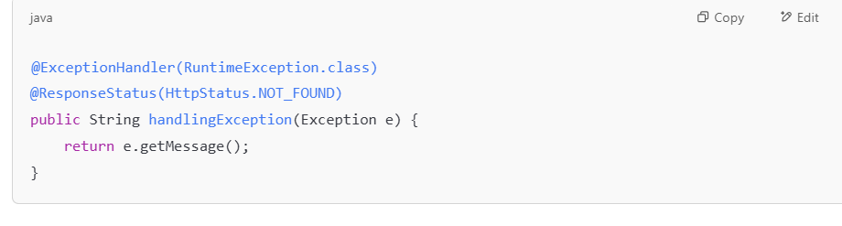

Eg:2

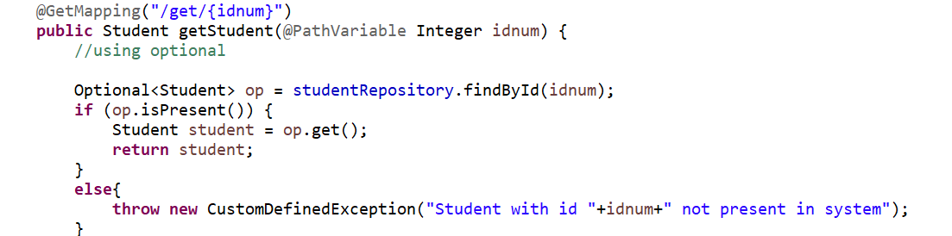

We need to create a CustomDefinedException class which must extends RuntimeException

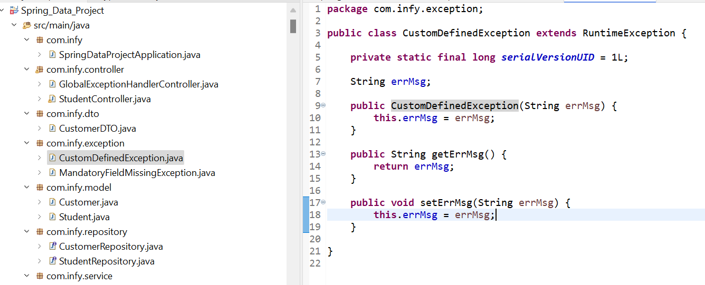

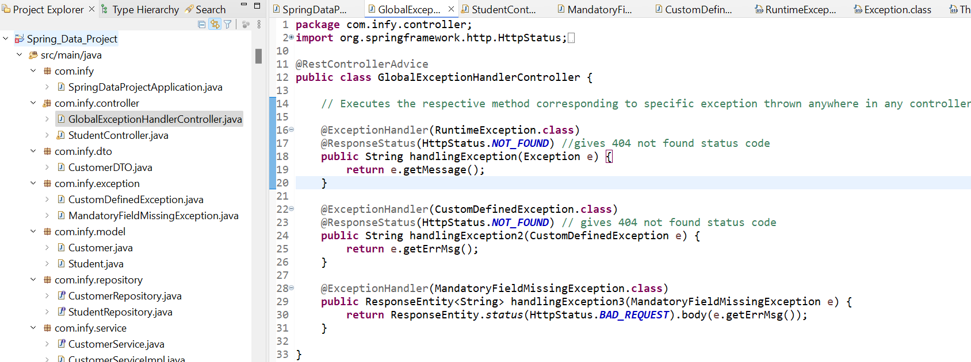

This method is part of a Spring **@ControllerAdvice** or a **@RestController** that handles exceptions globally or per-controller.

@ExceptionHandler(RuntimeException.class) - This tells Spring: "Hey, if a RuntimeException (or a subclass) is thrown anywhere in this controller (or app), run this method."

So if something like:

throw new RuntimeException("Student with id 123 not present in system "); //thrown from controller method named getStudent

Spring will catch it and call your handlingException() method.

**public String handlingException(Exception e)**

This is the method that will run **when the exception is caught**.

* The Exception e parameter receives the thrown exception.
* It returns e.getMessage(), which is just the message from the exception — e.g., "Student with id 123 not present in system".

This message becomes the **body of the HTTP response**, unless you override it or return a full JSON object.

Instead of writing all handler methods in a controller, can put all handlers in a single class so that can be accessible by any controller in the application(global level handling) and that class should be annotated with @**RestControllerAdvice**

If the status is always the **same** in a method (like 201 CREATED), go with @ResponseStatus.

If you need **different response statuses** for **different situations** within the same method (like when validation fails), then ResponseEntity gives you that **flexibility**.

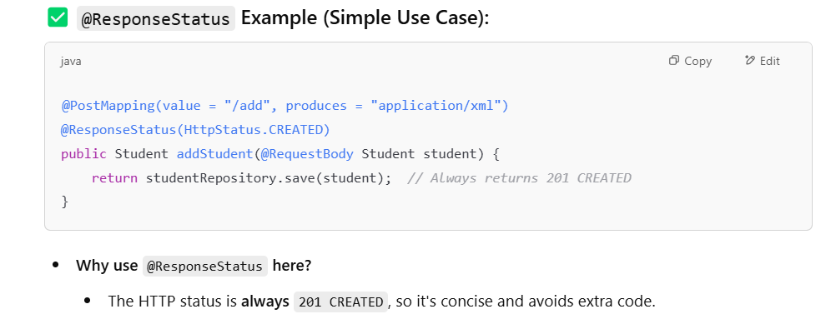

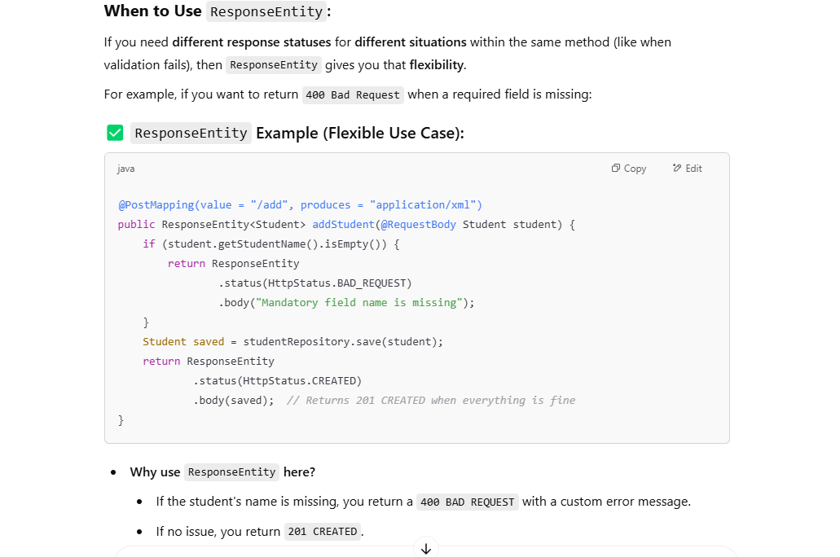

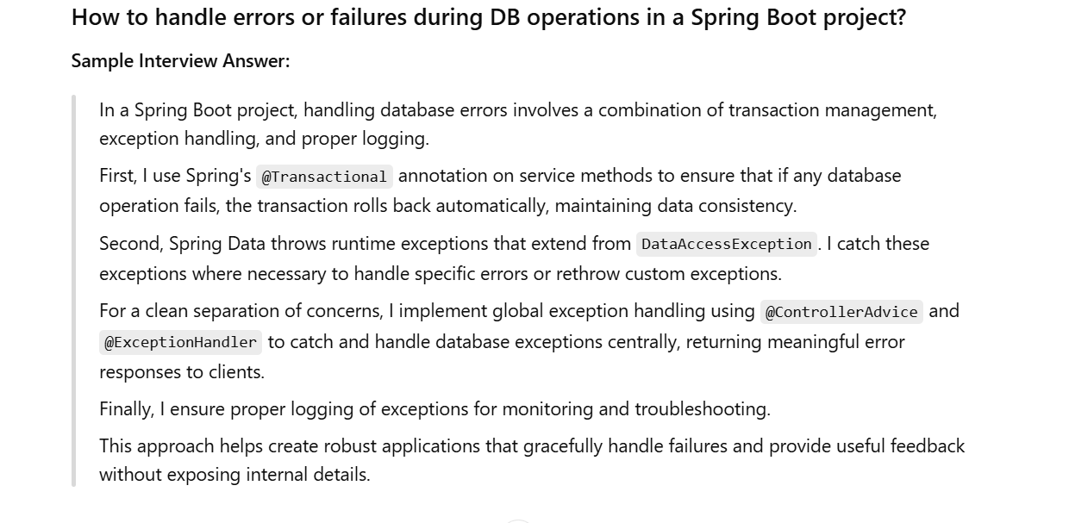

The main goal of Transaction is to provide ACID characteristics to ensure consistency and validity of a data.

ACID stands for Atomicity, Consistency, Isolation, Durability.

Atomicity – Describes All or Nothing principle (Either all operations executed with in a transaction or none of them)

Consistency – guarantee that a transaction will bring the database **from one valid state to another valid state**, maintaining all predefined rules and constraints. If a transaction violates a rule, it will be rolledback automatically.

Isolation – changes performed in a transaction are not visible to any other transactions until its committed.

Durability – Ensure that the committed changes are persisted.

***Spring Boot Actuator:***

Spring Boot Actuator is a powerful feature of the Spring Boot framework that helps you monitor and manage your application in production.

**It** adds a set of **built-in endpoints** to your application that let you:

* Monitor app health (/actuator/health)
* Check environment variables and configs
* Track metrics (CPU, memory, uptime)
* Manage beans, logs, caches, etc.
* Hook into Prometheus, Micrometer, Grafana

**🔧 Key Features of Spring Boot Actuator**

1. **Health Checks**  
   /actuator/health – Shows application health (e.g., database connectivity, disk space).
2. **Metrics**  
   /actuator/metrics – Exposes JVM, system, and custom application metrics (e.g., memory, garbage collection, HTTP requests).
3. **Info**  
   /actuator/info – Displays arbitrary application info (e.g., version, description).
4. **Environment**  
   /actuator/env – Shows properties from the Spring Environment.
5. **Beans**  
   /actuator/beans – Lists all Spring beans in the context.
6. **Thread Dumps**  
   /actuator/threaddump – Returns a thread dump of the JVM.
7. **Loggers**  
   /actuator/loggers – Manage and view log levels of loggers in real time.

